GEOSS Architecture for the Use of Remote Sensing Products in Disaster Management and Risk Assessment

Draft #1 – revised February 28, 2012
John Evans (GST), Karen Moe (NASA ESTO)

1. Introduction / Overview / Motivation
International efforts in disaster management and risk assessment involve activities by many players, linked by complex, often ad hoc arrangements. This makes it hard for new suppliers of data or services to participate, or for new would-be users to tap into these data or services. This complexity also limits the efficiency and effectiveness of disaster management and risk assessment: simply trying to ascertain what resources are shared (by different entities, different kinds of disasters, or different jurisdictional levels) can require lengthy inquiry. Determining what resources are missing (i.e., in clear demand but absent or scarce); interdependent; or isolated; can be a challenge as well. Efforts to coordinate or collaborate are also hampered by a lack of shared technical standards, common vocabulary, or jointly understood models of disaster management and risk assessment processes, and their use of satellite and other observations and related systems and services. In order to address and respond to disaster events in a timely, streamlined fashion, stakeholders need to establish these kinds of shared “infrastructure” in advance of disaster events.
For these reasons, the Committee on Earth Observing Satellites (CEOS) Working Group on Information Systems and Services (WGISS) has set out to describe and document a high-level reference model for the use of satellites, sensors, models, and associated data products to support disaster response and risk assessment. This effort is based on real-life experience of practitioners in these areas, and draws on results of the Group on Earth Observations (GEO) task for the Disasters Societal Benefit Area (SBA) and the GEO Global Earth Observation System of Systems (GEOSS) Architecture Implementation Pilot (AIP). Using this model, CEOS-WGISS aims to streamline the efforts of GEOSS and other organizations to give decision makers access to disaster and risk assessment information from global data and service providers.
The architecture defined here is only a starting point; it will undergo ongoing changes to reflect evolving insights, additional experience, or new technologies.

1.a. Audience and scope
The intended audience for this architecture consists of the following (overlapping) categories of people:
- Providers of satellite and other data relevant to disaster management / risk assessment;
- Providers of value-added services that process (interpret, transform, summarize, filter, combine) data to produce information products for end users;
- Distributors of original or processed data;
- Users of original or processed data;
- Planners and decision-makers who prioritize investments in data sensing, distribution, or use.
This architecture is focused on areas that are peculiar to disaster management and risk assessment. Thus it omits topics that are either generic (much broader or more specific), or adequately treated elsewhere – e.g., in GEOSS-wide definitions or technical standards. Where such “outside” topics are relevant to the disaster management and risk assessment topics, this architecture document references appropriate documents; if none exist, then it includes short “stubs” to be replaced by external references at a later date.

1.c. Goals and Requirements
This reference model provides a high-level, enterprise perspective for managing distributed data systems and services for disaster management. In particular, it is intended to provide a common vocabulary to describe the system-of-systems building blocks and how they are composed in support of disasters.
This reference model is intended not as a set of prescriptions or policies, but as a tool to facilitate coordination among organizations (international, national, regional and local) and interoperability among technology implementations (data archives, processing services, catalogs, portals, and end-user applications). It is also intended to clarify the relationship between ongoing activities ― in particular, pilot studies and proof-of-concept prototypes ― and the disaster management enterprise as a whole, so as to assist planners and decision-makers in prioritizing investments in data infrastructure, based on gaps or redundancies in data, metadata, functions, services, networks, etc. The goal is to improve both the effectiveness of disaster management efforts (doing the right things at the right times) and their efficiency (maximizing performance while minimizing costs).
The enterprise view provided by this model is intended to allow for significant regional differences – policies, economics, language, etc. – and for a variety of types of disasters. It also builds on and ties to existing GEOSS architectures and semantics, including those of the GEO 2012-2015 Work Plan and GEOSS Architecture Implementation Pilot (AIP).
Additional goals may be derived from the 2-, 6-, and 10-year targets for the GEOSS Disasters Societal Benefits Area. (See list on pp. 6-8 below).

1.d. Approach: Reference Model for Open Distributed Processing
Several frameworks exist for describing the structure and functions of an enterprise. This document employs the ISO / IEC Reference Model of Open Distributed Processing (RM-ODP) to structure its descriptions of disaster management operations and processes. RM-ODP is especially suited to an information-intensive set of activities that involve many diverse and dispersed data sources, services, providers, and users. RM-ODP structures descriptions of an enterprise according to five “viewpoints”:
- The Enterprise viewpoint describes the purpose, scope, and policies for the system. These are often articulated by means of scenarios or use cases.
- The Information viewpoint is concerned with the semantics of the information and the information processing performed.
- The Computation viewpoint is concerned with the functional decomposition of the system, and models it as objects interacting at interfaces.
- The Engineering viewpoint describes the mechanisms and functions required for distributed interaction between objects.
- The Technology viewpoint pinpoints technology choices for implementing the system.
RM-ODP is also the basis for numerous other reference models in related areas, including the GEOSS Architecture Implementation Pilot, the European Union's INSPIRE Spatial Data Infrastructure and ORCHESTRA disaster management framework, and the OGC Reference Model. This common structure may facilitate comparisons or links with these other communities.

3.c. Approach: practitioner case studies
This document aims to synthesize a general understanding of disaster management processes, and their use of satellite data streams, from real-world experience. So, rather than work from abstract / hypothetical use cases as enterprise-modeling efforts often do, this synthesis relies on documenting and analyzing how practitioners went about managing real disaster events or assessing or mitigating risks from actual hazards. Inputs for this come from a number of use cases:
Disaster response scenarios and lessons from WGISS members (via email questionnaire(s)):
- China earthquake 2008 (Densheng Liu)
- Japan tsunami 2011 (ask Satoko for a contact)
- Thailand flood 2011 (ask Pakorn)
NASA technology pilots (via the AIST template):
- Namibia flood sensor web/dashboard (Dan Mandl, Guido van Langenhove)
- Caribbean disasters task for CEOS (Stuart Frye)
- Thailand wildfire sensor web (Steve Chien/JPL)
- VMOC support to USGS HDDS (Will Ivancic/GRC)
Experience with the International Charter:
- USGS member view (Brenda Jones - June 2011 interview)
- NOAA member view (Yana Gevorgyan)
- NASA support view (Michael Goodman - 2011 interview)
- UK member view (ask Wyn Cudlip for a contact)
- NASA EO-1 provider view (Stuart Fry)
- Namibia end user view (Guido van Langenhove - 2011 email)
- Japan earthquake data for E-DECIDER (Maggi Glasscoe/JPL)
Decision Support Systems:
- NASA SERVIR (D. Irving/MSFC)
- NASA E-DECIDER (Maggi Glasscoe/JPL)
- Other (?)
This architecture process ties findings and analysis from the use cases to the broader picture of Disaster Management work through ongoing review of conferences, published literature, and activities by international groups such as UN-SPIDER, the World Bank, EU ORCHESTRA, GEMS, and Sentinel Asia for Environment (SAFE).
GEOSS AIP-3 also references the European Union SAFER project, which implements a preoperational emergency management service for the Global Monitoring for Environment and Security (GMES) initiative.

2. Enterprise Viewpoint

2.a. Purpose and scope
The Enterprise viewpoint emphasizes the scope of the activities of interest; and the stakeholders for these activities.
The enterprise of concern here is the use of data streams from satellites in disaster management and risk assessment processes (decisions, operations, etc.). In keeping with the CEOS WGISS charter to “enhance international coordination and data exchange and optimize societal benefit,” the emphasis is on the systems and services needed to streamline access to earth-observing satellites operated by CEOS members.
This architecture supports the following GEOSS Strategic Target:
By 2015, GEO aims to enable the global coordination of observing and information systems to support all phases of the risk management cycle associated with hazards (mitigation and preparedness, early warning, response, and recovery).
In support of this target, this architecture serves GEO Task DI-01, “Informing Risk Management and Disaster Reduction,” which has the following objectives:
- Improved use of observations and related information to inform policies, decisions and actions associated with disaster preparedness and mitigation.
- More effective access to observations and related information to facilitate warning, response and recovery to disasters.
- Increased communication and coordination between national, regional and global communities in support of disaster risk reduction, including clarification of roles and responsibilities and improved resources management.
- Improved response to natural and man-made disasters through delivery of space-based data, resulting from strengthened International Charter on Space and Major Disasters.
- Support to the implementation of the Hyogo Framework for Action 2005-2015.
The GEO 2012-2015 Work Plan defines four focus areas for Task DI-01:
- Provide support to operational systems;
- Enable and inform risk and vulnerability analyses;
- Conduct regional end-to-end pilots with a focus on building institutional relationships;
- Conduct gap analyses in order to identify missing data, system gaps, and capacity gaps.
The Workplan also defines five components of Task DI-01:
- Disaster Management Systems;
- Geohazards Monitoring, Alert, and Risk Assessment;
- Tsunami Early Warning and Hazard Assessment;
- Global Wildland Fire Information System;
- Regional End-to-End Pilots.
Finally, the Workplan tentatively identifies 18 resources available for implementing DI-01, including the International Charter, the CEOS Geohazard Supersites, catalog and metadata efforts by JAXA, and technology pilot projects at regional and global scales.
Further details on DI-01 and GEO objectives may be found in the GEO 2012-2015 Work Plan and in “GEOSS Strategic Targets,” GEO-VI Plenary Document 12 (Rev 1), 17-18 Nov. 2009.
Fulfilling these goals collaboratively requires a precise, shared understanding of the processes involved in disaster-related decision-making, operations, planning, etc.; of the satellite observations used (or usable) by these processes; and of the data access methods -- either direct (from data suppliers) or indirect (through intermediate value-added services).

2.b. Stakeholders of the Disaster Management Enterprise
Many documents and plans by CEOS, GEOSS, and others refer to the stakeholders for Disaster Management and Risk Assessment and the Use of Satellite Data in such activities; but these stakeholders are seldom enumerated or characterized. One exception is the recent GEOSS Architecture Implementation Pilot report (AIP-3, Jan. 2010), which calls out several “targeted or supported communities”: flooding and coastal hazards (national agencies concerned with disaster management, meteorology, hydrology, and emergency response, and their supporting providers of data, services, research, and analysis); CEOS's Strategic Implementation Team (SIT) and WGISS; GEOSS' DI-06-09 Task, and the United Nations Platform for Space-based Information for Disaster Management and Emergency Response (UN-SPIDER).
Furthermore, the GEOSS AIP-3 “reference scenario” on Disaster Management highlights four kinds of “actors”: Initiators (who trigger and coordinate the disaster response), Actuators (who carry out the disaster response – e.g., regional civil protection, insurance companies, NGOs), Processors (providers of raw data or derived information), and Coordinators (who facilitate interactions among the other actors).
Need to consider a broad set of stakeholders BUT prioritize their requirements.
The GEOSS AIP Architecture includes a Disaster Management Scenario with 4 actors (Initiator, Actuator, Processor, and Public), 4 phases (Mitigation, Warning, Response, and Recovery), and 4 requirements (Target / data, revisit frequency, timeliness, and end use).

2.c. Enterprise view: initial inputs
In advance of more detailed interactions with practitioners in the case studies, a few initial findings are available already. One example is a process diagram for the work of the International Charter on Space and Major Disasters (Figure 1), which will serve as a point of comparison when gathering additional data from case studies and detecting patterns or gaps.
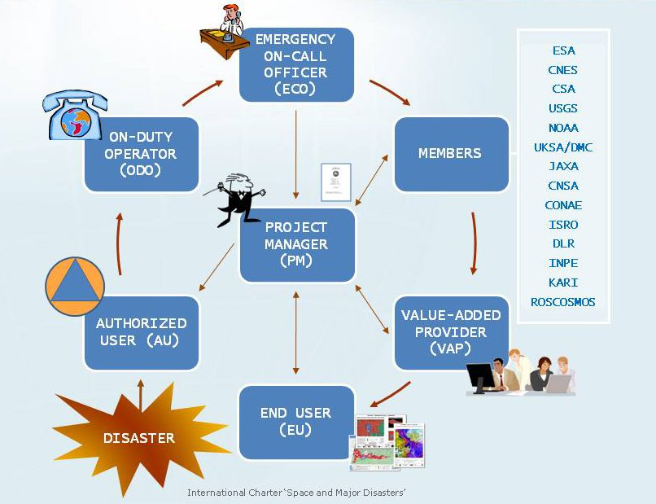
Figure 1. International Charter process sketch

3. Information Viewpoint

3.a. Overview
With the above enterprise definition as a basis, the information viewpoint emphasizes the information used or produced by the enterprise. The GEOSS AIP Architecture, Part 3 (“Information Viewpoint: Earth Observations”), provides starting points for this section. It defines location and reference frames; geophysical observations, measurements, sensors, and products; geographic features; environmental models; registries and metadata; data policy (including rights management and licensing); data quality; metadata; and semantics.
These definitions provide a sound basis for any discourse about location-based information. In the specific area of Disaster Management and Risk Assessment, the case studies shed light on additional topics of concern:
- The observations or parameters needed to respond to different kinds of disasters (or to assess their risk);
- The metadata that enable effective data search and maximize its usefulness in a disaster management context;
- The interdependencies among these data and metadata;
- The key concepts and vocabulary in use by organizations and communities;
- The data transformations, interpretations, extractions, syntheses, etc. operating (or needed) between sensors and users.
(The information viewpoint is concerned with the semantic or conceptual aspects of these matters: details on the syntax, encoding, or transport of information appear in the engineering and technology viewpoints.)
The first topic highlighted above, observation requirements for disaster types, merits special emphasis; the next subsection provides more detail.

3.b. Information view: initial sketches
The case studies are intended to reveal richly detailed views of the information needs and usage of disaster managers and responders. But in advance of these inquiries, a few useful details are available already; for example, the GEOSS 10-year implementation plan (Section 4.1.1, "Disasters: Reducing loss of life and property from natural and human-induced disasters") states that
Disaster losses can be reduced through observations relating to hazards such as: wildland fires; volcanic eruptions; earthquakes; tsunamis; subsidence; landslides; avalanches; ice; floods; extreme weather; and pollution events. GEOSS implementation will bring a more timely dissemination of information through better coordinated systems for monitoring, predicting, risk assessment, early warning, mitigating, and responding to hazards at local, national, regional, and global levels.
The GEO report on Critical Earth Observations Priorities (Oct. 2010) highlights the 15 most critical observations for the Disasters Societal Benefit Area: land-related parameters such as Elevation/Topography, Surface Deformation, Seismicity, and Soil Properties dominate the list.
The GEOSS 10-Year Implementation Plan Reference Document includes a tabular depiction of what observation types are needed for various kinds of disasters. (An excerpt appears in Figure 2 below; the full table appears under Background Information in the Appendix.) The use cases serve to confirm, update, and refine this table; and to identify gaps or weaknesses in information supply.

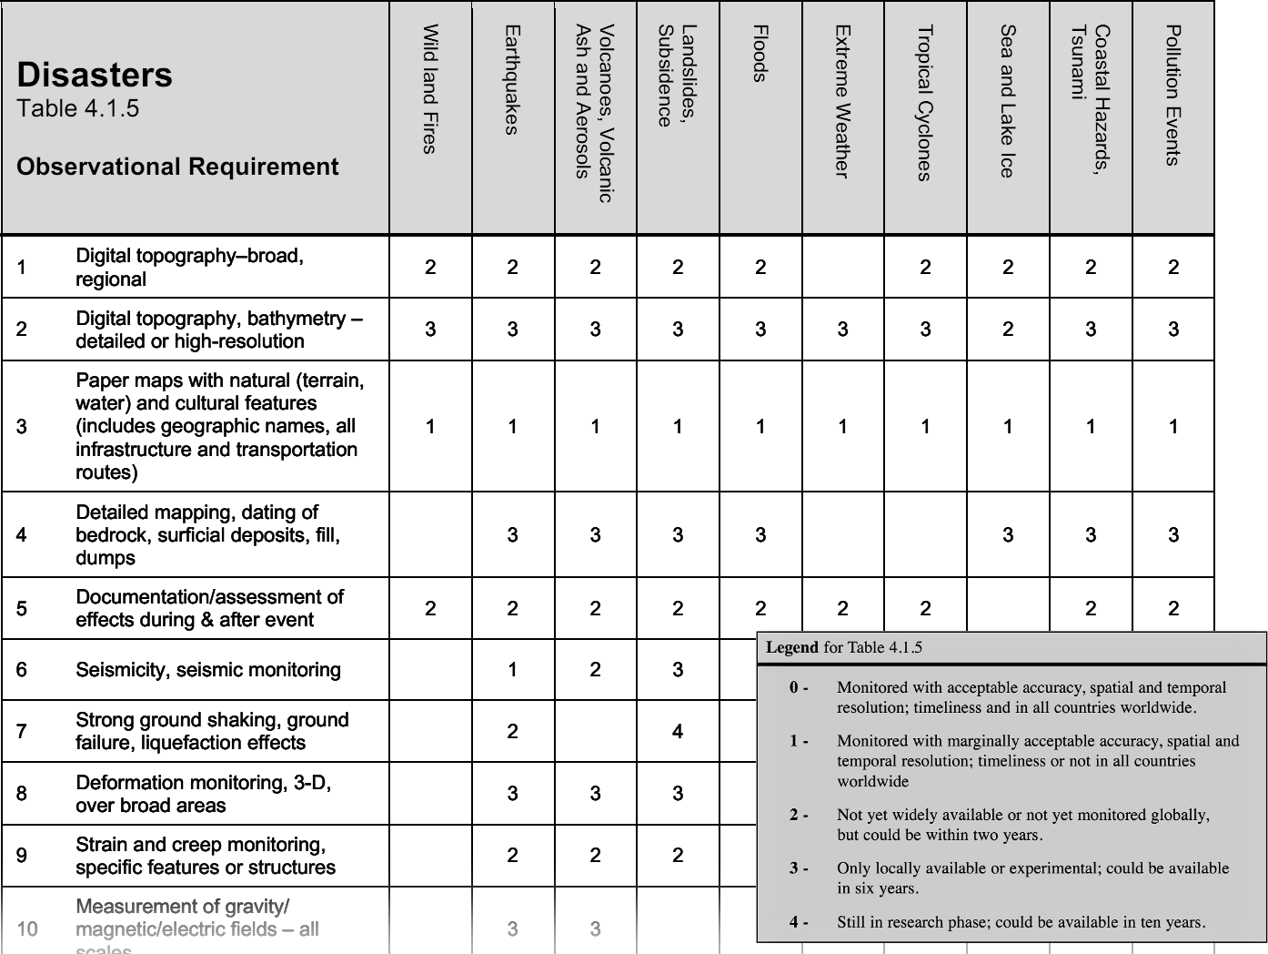
Figure 2. Types of observations vs. types of disasters

4. Computation viewpoint

4.a. Overview
Similarly, The GEOSS AIP Architecture, Part 4 (Computational Viewpoint) defines a Service Oriented Architecture (SOA) featuring services for catalog registration and search; portrayal and display; data access and ordering; data processing; sensor access and control; and user management.
These generic definitions form a sound basis for addressing the following topics specific to Disaster management and Risk Assessment:
- The service types employed (or needed) to make the necessary information available to decision-makers and users (e.g., data access, visualization, catalog search);
- These role of these services in performing data transformations, interpretations, extractions, syntheses, etc. between sensors and users;
- Constraints and requirements that apply to these services and their interfaces (e.g., near-real-time performance, cross-community interoperability)
The GEOSS AIP Architecture strongly emphasizes GEOSS functions mediated via user-driven services; but also mentions broadcasts (e.g., GEONETCAST) or distribution of physical media. These latter kinds of services may be especially important for distributed data handling and distribution in a Disaster management context. The case studies aim to characterize these service types and gauge their importance in international Disaster Management and Risk Assessment.

4b. Computation view: initial sketches
Here again, the case studies will provide a richer understanding of the information services involved in supporting disaster-related efforts; however we can gain insight from initial findings such as the NASA Flood Sensor Web Concept, which describes the information flows and services involved in the Namibia Flood Pilot Project (Figure 3).

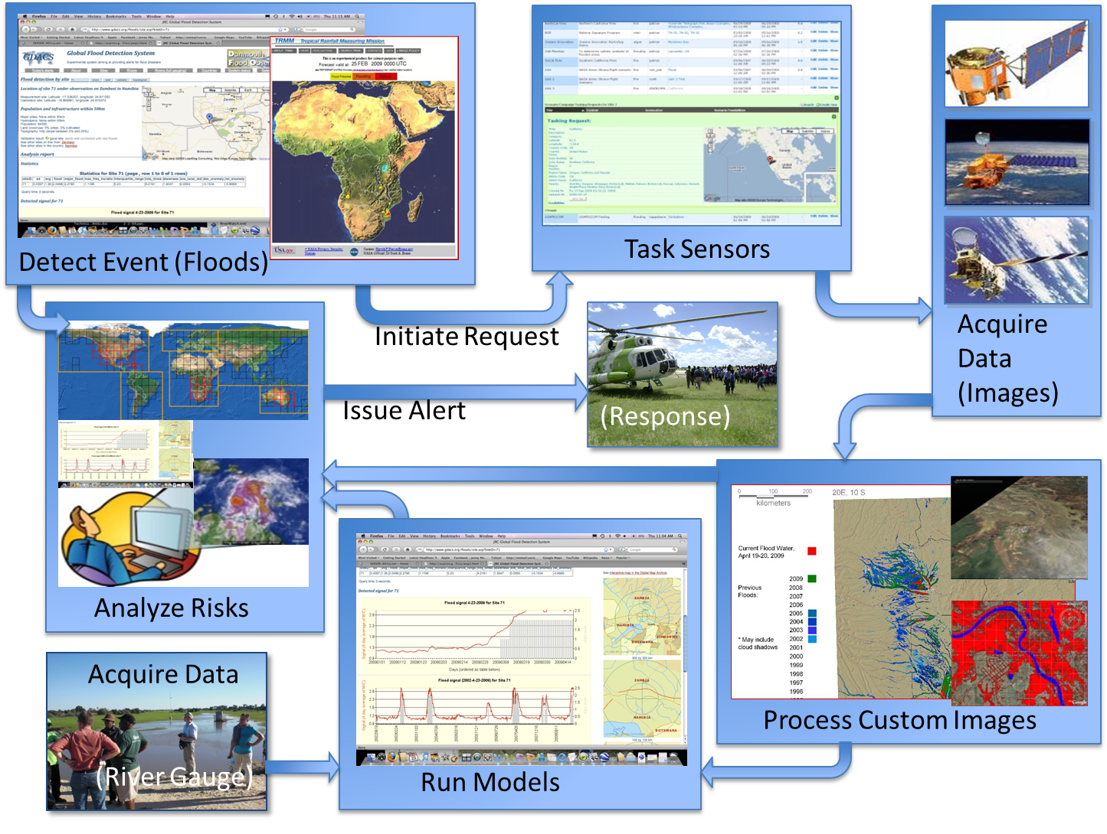
Figure 3. NASA Flood Sensor Web Concept

6. Engineering Viewpoint
This part of the architecture describes the classes of components (that is, bundles of services with information flowing in & out through interfaces) needed to perform the computations and information interchanges described in the previous viewpoints. Examples of such component types include data servers, registries / clearinghouses, visualization services, alert services, data access clients, end-user applications, etc. The GEOSS AIP Architecture, Part 5 (“Engineering Viewpoint”) distinguishes component types along three tiers: user interface, business processes, and data access.
The engineering viewpoint highlights the following kinds of topics in Disaster management and Risk Assessment:
- The types of components needed to provide useful information products to end users.
  - e.g., data access and catalog servers; end-user clients (esp. specialized portals) for catalog search and service invocation, and intermediating (“middleware”) services for user authentication, data processing, notification, etc.
- The interface standards needed to support interoperation between different communities, and ensure resilience of the system
The Disaster Response context may require particular types of clients and services over & above those listed in the AIP-3 Architecture, or it may impose requirements on the functions or performance of certain components. Here again, the use cases will shed light on how service components are being used, and suggest how they might be made more effective.
The engineering and technology viewpoints are not yet a major focus of this architecture; they will become more important once current practice in Disaster Management has been characterized at a conceptual level via the enterprise, information, and computation viewpoints.

7. Technology viewpoint
This last tier of the architecture deals with specific service instances (e.g., servers available at particular URLs) of the types described in the Engineering viewpoint. For international disaster management and response, this includes particular satellite sensors and data streams; data catalogs; forecasting facilities, etc. These resources may be provided in part by the GEOSS Common Infrastructure.
As with the Engineering viewpoint, the Technology viewpoint is not yet a major focus of the Disaster Management & Risk Assessment architecture.
Background material: Case Study Questionnaire
(Feb. 8, 2012 draft)

(Introductory paragraph indicating who's conducting the study, and for what purpose. An interview could be conducted to answer the questionnaire.)

1. Overview: Please summarize the disaster event in a few sentences, referring if possible to published or online articles (from news media, published articles, Wikipedia, or other sources).

= = = = = = = = = = = = =

2. Please indicate which organizations or individuals participated in
- Responding to the disaster
- Forecasting the disaster, or identifying high-risk times or places
(if forecasting was possible)
- Reducing the risk or impact of the disaster
(e.g., evacuating populations, operating alert systems; setting building codes;
operating sensor networks)

= = = = = = = = = = = = =

3. How did these organizations or individuals interact or collaborate with each other?

= = = = = = = = = = = = =

4. Who was involved in supplying satellite information to these activities?

= = = = = = = = = = = = =

5. What satellite information was used (or needed) to support these activities? In particular:

- What types of observations?
(e.g., meteorology / atmosphere; hydrology; seismic changes; vegetation...)
What other observations might have been useful?

- How frequent were the observations? Were they frequent enough?

- How much detail did these data show? (pixel size, spectral bands) Was it enough?

= = = = = = = = = = = = =

6. What processing was performed on the data before users obtained it?
(e.g., reformatting files; clipping / joining image scenes; contrast stretching; georectification; interpreting or classifying multispectral pixels, extracting graphics, etc.)
Background material: Observational requirements by type of disaster
from GEOSS 10-Year Implementation Plan Reference Document
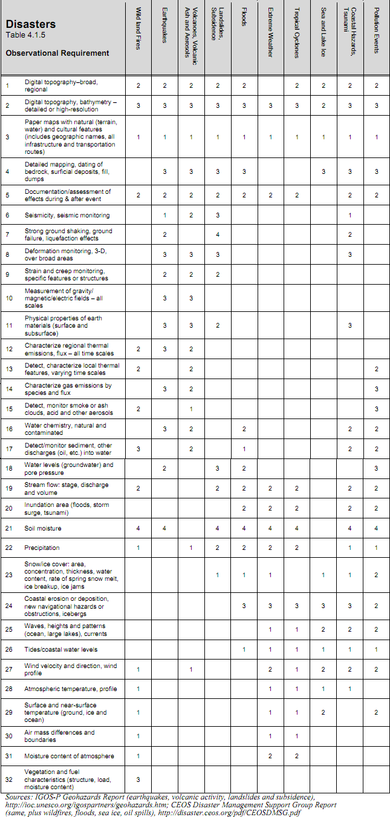
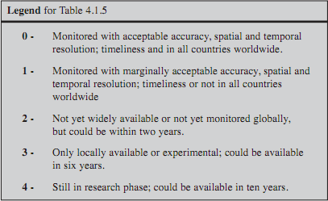

Background material: 2-, 6- and 10-year targets for GEOSS disaster-related work from the GEOSS 10-Year Implementation Plan (2005)

2-Year Targets
Advocate strengthening of the International Charter on Space and Major Disasters and similar support activities to enable better response to and documentation of effects of disasters, such as floods, earthquakes and oil spills. Its scope may be expanded to allow for pre-event tasking where forecasting is adequate to justify the effort (wildland fires, some floods and coastal disasters, volcanic eruptions). An expanded scope may also encompass Earth Observation training and capacity building of local users in affected areas, particularly in developing countries.
Facilitate global access to the 100-metre (C-band) and 30-metre (X-band) horizontal resolution digital terrain information produced during the Shuttle Radar Topography Mission (SRTM).
Advocate expansion of seismic monitoring networks, plus expansion of the present network of ocean-bottom pressure sensors, and upgrade existing global networks (e.g. the GSN) so that all critical instruments relay data in real time, in support of better tsunami warning worldwide.
Facilitate focused pilot studies in under-served hazardous areas, for example Japan’s Deployment of Asia-Pacific Hazard-mitigation Network for Earthquakes and volcanoes (DAPHNE).
Facilitate ongoing capacity building, with a focus on transferring technologies and best practices. Also essential are best practices for the dissemination of real-time information and early warnings to end users and the public. Specifically, improvements in real-time flood forecasting for developing countries should be a priority, in concert with efforts by UNESCO and WMO to expand and improve flood-related information systems.
Facilitate effective monitoring from existing geostationary satellites, launched primarily for weather monitoring, for non-weather applications such as volcanic eruptions and volcanic ash clouds, forest fires, aerosols, and other hazards that require a high observation frequency.
Advocate integration of InSAR technology into disaster warning and prediction systems, in particular related to floods, earthquakes, landslides and volcanic eruptions. The ERS (European Remote Sensing) and Envisat missions of the European Space Agency have pioneered these applications and should be continued for global, long-term applications. Also, the Canadian Space Agency’s Radarsat-1 mission with its InSAR capability contributed significantly to the development of applications related to geohazard monitoring and research. In this respect, Radarsat-2 should be a data source for geohazard InSAR applications. As part of this effort, efficient exploitation of data from Japan's upcoming Advanced Land Observation Satellite (ALOS) should also be facilitated. Its L-band SAR sensor is the first such sensor since 1998.
Produce an inventory of existing geologic and hazards zonation maps and identify areas and types of hazards where they are most critically lacking, or where maps need to be digitized.
Advocate further development of the Global Spatial Data Infrastructure (GSDI) and draw on GSDI components as institutional and technical precedents.
Produce a comprehensive gaps analysis to assess the status and regional distribution of existing disaster management capacity-building programmes and initiatives.
Facilitate widespread use of LiDAR and InSAR technologies for topography in areas of low relief. For floods and coastal hazards, the most crucial need is for high vertical resolution (less than 1 metre) topographic data, plus good shallow-water bathymetry.

6-Year Targets
Advocate continuity and interoperability of all satellite systems providing global positioning, such as the United States Global Positioning System (GPS), European GALILEO, Russian Global Orbiting Navigation Satellite System (GLONASS) and Japanese Quasi-Zenith Satellite System (QZSS). This includes support of the global geodetic network services such as Very Long Baseline Interferometry (VLBI) and Satellite Laser Ranging (SLR), that define the orbits of the GPS satellites and thereby enable the use of GPS for precise geo-location. Applications of GPS essential to disaster response include precision topography, mapping support, and deformation monitoring, as well as geo-location for search and rescue operations.
Advocate that the international satellite community, coordinated through the Committee on Earth Observation Satellites (CEOS), plan for assured continuity of critical sensing capabilities. For example, certain research systems should become operational systems and the projected lifetimes of some systems should not result in service gaps of key satellite sensor data. Longer-term actions for monitoring of geohazards include realization of an integrated observation system of SAR interferometry and GPS.
Advocate enhancements of the automatic processing and evaluation of satellite imagery, to facilitate production of digital topography, and to support rapid detection of fires, oil spills, or other hazards.
Advocate more rapid SAR processing for interferometry to enable strain mapping over large seismically active zones and to monitor landslides and subsidence in populated areas and along transportation corridors.
Advocate systematic expansion of the inventory of geologic and hazards zonation maps and expansion of Geographic Information Systems (GIS) as a critical tool for managing spatial information for disaster management. In this context, digital maps based on distributed systems and data sources and conforming to recognized international GIS standards (e.g. International Organization for Standardization standards and Open Geospatial Consortium specifications).
Facilitate the development and sharing of critical airborne sensors and capabilities, such as hyper-spectral sensors, high-resolution infrared sensors and LiDAR.
Advocate the development of models to better support disaster response. One area of particular interest is the dispersion of pollution plumes in the atmosphere or in water (including the spread of oil spills in the marine environment).
Establish a process for monitoring of capacity-building efforts in disaster management to enable building upon strong existing programmes in the continuing efforts to integrate and share resources.
Advocate access to data from seismic and infrasound networks operated by the Preparatory Commission for the Comprehensive Nuclear Test-Ban Treaty Organization (CTBTO) that are useful and relevant for monitoring earthquakes and volcanic activity.
Facilitate access to real-time data analyzing technology and real-time access to critical data for all hazards.
Advocate real-time monitoring of submarine seismic and volcanic activities and tsunami propagation.

10-Year Targets
Facilitate further expansion of real-time monitoring of submarine seismic and volcanic activity and of tsunami propagation by use of surface and subsurface sensors, including re-use of submarine telephone cables.
Facilitate further expansion and integration of regional projects like DAPHNE 6 and Global Monitoring for Environment and Security (GMES),7 and the development of efficient interfaces between these and other such programmes.
Advocate meeting various unmet needs for classes of satellite sensors. Of particular importance for the area of hazards and disasters is the global need for a significant increase in SAR satellites (C-band, L-band, and X-band). The disaster management community needs an L-band system optimized for interferometry, and an expanded L-band capacity for better forest and fuel characterization. Monitoring the range of smoke and pollution plumes in the atmosphere around the globe requires expanded hyper-spectral capability, which is currently limited to airborne sensors. A passive microwave capability would help in determining soil moisture repeatedly over broad areas.
Advocate development of systematic methods for rapid determination of shallow bathymetry, especially in turbid water. Such research is vital to characterizing nearshore bathymetry, whether for improved modelling of tsunamis and storm surges or for documenting changes produced during such events.
Produce an evaluation of the effectiveness of its capacity-building activities for the disaster management sector, including an assessment of the effectiveness of building the needed inventory of geologic and hazards zonation maps.

GEOSS Strategic Targets: GEO-VI Document 12(Rev1), 17-18 November 2009

