CEOS CWIC Project

CWIC SOFTWARE TEST PLAN
Approval Date: 2012-XX-XX
Publication Date: 2012-XX-XX
Reference number of this Document: CWIC-DOC-12-001r2
Document version: V1.1
Category: CWIC Technical Document
Editor: Yuanzheng Shao
CEOS WGISS Integrated Catalog
SOFTWARE TEST PLAN

Approvals
Approved By | Signature | Date

Document Control
Name | CWIC Software Test Plan
Doc. Ref. No. | CWIC-DOC-12-001r1
Document Status | Draft
Date of Release

Revision History
Date | Version | Description / Change | Author
Dec. 19, 2012 | V1.0 | Initial version | Yuanzheng Shao
Feb. 04, 2013 | V1.1 | Change the testing for CWIC service and new data provider, respectively. | Yuanzheng Shao

Table of Contents
Document Control I
Table of Contents II
1. Introduction 1
2. Scope 1
3. Document Name and Version Control 1
4. References 2
5. Testing for CWIC Service 3
5.1. Routine Dataset Connectivity Testing 3
5.1.1. Test Aims 3
5.1.2. Test Inputs 3
5.1.3. Test Tools 6
5.1.4. Test Pass/Fail Criteria 7
5.1.5. Test Outputs 7
5.1.6. Test Frequency 8
5.2. Update Driven Testing 8
5.2.1. Test Aims 8
5.2.2. Test Inputs 8
5.2.3. Test Tools 9
5.2.4. Test Pass/Fail Criteria 9
5.2.5. Test Outputs 9
5.2.6. Test Frequency 9
5.3. CWIC Performance Test 9
5.3.1. Test Aims 9
5.3.2. Test Inputs 10
5.3.3. Test Tools 10
5.3.4. Test Pass/Fail Criteria 10
5.3.5. Test Outputs 11
5.3.6. Test Frequency 11
6. Testing for New Data Provider 12
6.1. Compatibility Testing for New Data Provider 12
6.1.1. Test Aims 12
6.1.2. Test Inputs 12
6.1.3. Test Tools 12
6.1.4. Test Pass/Fail Criteria 13
6.1.5. Test Outputs 13
6.1.6. Test Frequency 14
6.2. Performance Testing for New Data Provider 14
6.2.1. Test Aims 14
6.2.2. Test Inputs 14
6.2.3. Test Tools 14
6.2.4. Test Pass/Fail Criteria 14
6.2.5. Test Outputs 15
6.2.6. Test Frequency 15
7. Personnel 16
8. Abbreviations and Glossary 17

- Introduction
This document contains comprehensive test plan adopted in the CEOS WGISS Integrated Catalog (CWIC) project. This test plan will help the CWIC development team to validate the acceptability of CWIC software and also clarifies the process of CWIC software validation to the CWIC community. The test-related data and tools, as well as the testing frequency and expected outcomes are also discussed in this document to ensure the testing repeatability.
This CWIC test plan document describes two testing categories conducted on CWIC: Testing for CWIC service and Testing for new data provider.
For the Testing for CWIC service, three different test types will be introduced: routine dataset connectivity testing, update driven testing, and performance testing. Routine dataset connectivity testing is aimed to ensure all CWIC datasets are discoverable, i.e., all CWIC datasets contains at least one data granule. It will be performed periodically. Update driven testing is aimed to ensure the CWIC is working well when any update is performed. CWIC performance test is to evaluate the performance of CWIC server, which determines how CWIC service performs in terms of responsiveness and stability under a particular workload.
For the Testing for new data provider, two test types will be introduced: compatibility testing and performance testing. In terms of compatibility testing, a series of testing metrics will be designed, and the related testing will be performed against new data inventory system to ensure all CWIC requirements are satisfied. With regard to performance testing of new data provider, a load test is conducted to understand the behavior of the new data provider system under a specific load.
- Scope
This test plan is applicable to the CEOS WGISS Integrated Catalog (CWIC) version 1.0 and the new data provider of CWIC.
The target audience of this document will be the community of software developers who are:
a) CWIC data providers
b) Implementers of CWIC server
c) Implementers of CWIC Client
- Document Name and Version Control
Every CWIC technical document may have multiple versions, in which modification or update has been made. If necessary, some documents will be approved to be publicly released. Every released document has a unique reference number, which follows the naming rule below:
CWIC-DOC-Last two digit of Year-Document Series No-Release No
For example: CWIC-DOC-12-001r1 refers to the first released document (i.e., r1) for the first CWIC technical document (i.e., 001) in 2012 (i.e., 12).
- References
The following documents provide more background and supportive information.
Document Reference & Version | Document Title / Description
CWIC-DOC-12-004r1 | CWIC Connector API Report
CWIC-DOC-12-006r1 | CWIC Client Partner Guide

- Testing for CWIC Service
The testing for CWIC service contains three types: routine dataset connectivity testing, update driven testing, and performance testing. This chapter will introduce each testing types in terms of test aim, method, frequency inputs, and outputs. All the testing scripted are created and executed by CWIC Test Team.
  - Routine Dataset Connectivity Testing
    - Test Aims
The Routine Dataset Accessibility Testing aims to check the accessibility to all datasets listed in the capabilities document of CWIC. CWIC test team will perform routine dataset connectivity testing to ensure the datasets are discoverable.
    - Test Inputs
As the mandatory operation of OGC CSW, GetRecords and GetRecordById operations will be tested. To perform these tests, a XML request payload needs to be generated and the following sections will describes how to generate these payloads.
(1) Steps 1: Retrieve dataset list
The retrieval of the dataset list can be accomplished by calling GetCapabilities request to the CWIC server. Based on the current design, the CWIC capabilities document lists all servable datasets with DIF Entry IDs. For example, the following request will return all servable datasets from the CWIC PROD instance:
http://cwic.csiss.gmu.edu/cwicv1/discovery?service=CSW&version=2.0.2&request=GetCapabilities
(2) Step 2: Retrieve and assign query constraint
For each dataset listed in the capabilities document, the spatial extent and temporal range are included as shown in Figure 1. These values can be used to specify the query constraint.
…
<cwic:dataset id="gripdrop">
<cwic:name>GRIP DC-8 Dropsonde</cwic:name>
<cwic:WestBoundLongitude type="default">-100.0</cwic:westBoundLongitude>
<cwic:EastBoundLongitude type="default">0.0</cwic:eastBoundLongitude>
<cwic:SouthBoundLatitude type="default">0.0</cwic:southBoundLatitude>
<cwic:NorthBoundLatitude type="default">45.0</cwic:northBoundLatitude>
<cwic:dateStart type="default">2010-08-17</cwic:dateStart>
<cwic:dateEnd type="default">2010-09-22</cwic:dateEnd>
</cwic:dataset>
…
Fig. 1 Default query constraints designed for the dataset level
Please note that the spatial extent and temporal range may be assigned “unknown” in the capabilities document for some dataset. For such dataset, the default search values and can be retrieved from the <attrbutes> elements of its associated catalog to ensure a valid request is generated, as the Fig. 2shows.

…
<cwic:catalog id="NASA">
<cwic:attributes>
<cwic:supportHitsRequest>true</cwic:supportHitsRequest>
<cwic:supportStartPosition>true</cwic:supportStartPosition>
<cwic:supportMaxRecords>true</cwic:supportMaxRecords>
<cwic:supportNextRecord>true</cwic:supportNextRecord>
<cwic:supportNumberOfRecordsMatched>true</cwic:supportNumberOfRecordsMatched>
<cwic:supportNumberOfRecordsReturned>true</cwic:supportNumberOfRecordsReturned>
<cwic:westBoundingLongitude type="default">-180.0</cwic:westBoundingLongitude>
<cwic:eastBoundingLongitude type="default">180.0</cwic:eastBoundingLongitude>
<cwic:southBoundingLatitude type="default">-90.0</cwic:southBoundingLatitude>
<cwic:northBoundingLatitude type="default">90.0</cwic:northBoundingLatitude>
<cwic:dateStart type="default">1980-01-01T00:00:00Z</cwic:dateStart>
<cwic:dateEnd type="default">2012-12-31T23:59:59Z</cwic:dateEnd>
</cwic:attributes>
…
Fig. 2 Default query constraints designed for the catalog level
(3) Step 3: GetRecords payload generation
Since the ability of handling query constraints is different among all CWIC data catalogues, it is infeasible to design a universal query template for all datasets. Some prior knowledge about individual catalogues need to be applied in order to ensure the accessibility testing can be conducted.
For the NASA ECHO system, the query without the temporal range and spatial extent is accepted, and the “hits” result type is also supported. Therefore, the following template for all NASA ECHO datasets can be used. For each dataset, replace the DIF Entry ID to get the corresponding query payload.

<?xml version=”1.0” encoding=”UTF-8”?>
<GetRecords xmlns=”http://www.opengis.net/cat/csw/2.0.2”
xmlns:csw=”http://www.opengis.net/cat/csw/2.0.2” xmlns:dc=”http://purl.org/dc/elements/1.1/”
xmlns:ogc=”http://www.opengis.net/ogc” xmlns:gml=”http://www.opengis.net/gml”
xmlns:xsi=”http://www.w3.org/2001/XMLSchema-instance”
xsi:schemaLocation=”http://www.opengis.net/cat/csw/2.0.2 http://schemas.opengis.net/csw/2.0.2/CSW-discovery.xsd”
service=”CSW” version=”2.0.2” resultType=”results”
outputSchema=”http://www.opengis.net/cat/csw/2.0.2” startPosition=”1” maxRecords=”5”>
<Query typeNames=”csw:Record”>
<ElementSetName typeNames=”csw:Record”>full</ElementSetName>
<Constraint version=”1.1.0”>
<ogc:Filter>
<ogc:PropertyIsEqualTo>
<ogc:PropertyName>dc:identifier</ogc:PropertyName>
<ogc:Literal>DIF NETRY ID</ogc:Literal>
</ogc:PropertyIsEqualTo>
</ogc:Filter>
</Constraint>
</Query>
</GetRecords>
Fig. 3 GetRecords template without spatial-temporal constraint
For other data centers, the limitation on query constraints has to be applied in order to build the query payload. In this case, a general template for the CWIC GetRecords request, which is shown below, has been defined:

<?xml version=”1.0” encoding=”UTF-8”?>
<GetRecords xmlns=”http://www.opengis.net/cat/csw/2.0.2”
xmlns:csw=”http://www.opengis.net/cat/csw/2.0.2” xmlns:dc=”http://purl.org/dc/elements/1.1/”
xmlns:ogc=”http://www.opengis.net/ogc” xmlns:gml=”http://www.opengis.net/gml”
xmlns:xsi=”http://www.w3.org/2001/XMLSchema-instance”
xsi:schemaLocation=”http://www.opengis.net/cat/csw/2.0.2 http://schemas.opengis.net/csw/2.0.2/CSW-discovery.xsd”
service=”CSW” version=”2.0.2” resultType=”results”
outputSchema=”http://www.opengis.net/cat/csw/2.0.2” startPosition=”1” maxRecords=”5”>
<Query typeNames=”csw:Record”>
<ElementSetName typeNames=”csw:Record”>full</ElementSetName>
<Constraint version=”1.1.0”>
<ogc:Filter>
<ogc:And>
<ogc:PropertyIsEqualTo>
<ogc:PropertyName>dc:identifier</ogc:PropertyName>
<ogc:Literal>DIF NETRY ID</ogc:Literal>
</ogc:PropertyIsEqualTo>
<ogc:PropertyIsGreaterThanOrEqualTo>
<ogc:PropertyName>dct:coverage.dateStart</ogc:PropertyName>
<ogc:Literal>STRAT DATE TIME</ogc:Literal>
</ogc:PropertyIsGreaterThanOrEqualTo>
<ogc:PropertyIsLessThanOrEqualTo>
<ogc:PropertyName>dct:coverage.dateEnd</ogc:PropertyName>
<ogc:Literal> END DATE TIME</ogc:Literal>
</ogc:PropertyIsLessThanOrEqualTo>
<ogc:BBOX>
<ogc:PropertyName>ows:BoundingBox</ogc:PropertyName>
<gml:Envelope srsName=”EPSG:4326”>
<gml:lowerCorner>YMIN XMIN</gml:lowerCorner>
<gml:upperCorner>YMXA XMAX</gml:upperCorner>
</gml:Envelope>
</ogc:BBOX>
</ogc:And>
</ogc:Filter>
</Constraint>
</Query>
</GetRecords>
Spatial Extent
Fig. 4 GetRecords template with spatial-temporal constraint
When the DIF Entry ID and related spatial/temporal constraints are assigned, the keyword listed in the above XML template will be replaced to generate the real GetRecords request payload for each CWIC dataset.
    - Test Tools
In above section, the approach to generate the GetRecords request payload for all CWIC datasets has been introduced. Apache HttpComponents HTTPClient (http://hc.apache.org/) is used to post the request XML to CWIC server. The related Java function code segment is listed below:
private String doPost(String urlPath, String content) throws IOException {
String response = null;
DefaultHttpClient httpclient = new DefaultHttpClient();
HttpPost httppost = new HttpPost(urlPath);
HttpConnectionParams.setConnectionTimeout(httpclient.getParams(), 180000);
try {
StringEntity entity = new StringEntity(content);
entity.setContentType(“application/xml”);
entity.setContentEncoding(“utf-8”);
httppost.setEntity(entity);
ResponseHandler<String> responseHandler = new BasicResponseHandler();
response = httpclient.execute(httppost, responseHandler);
} finally {
httpclient.getConnectionManager().shutdown();
}
return response;
}

The testing script sends all requests to the server, parses the response to check the resource accessibility for every dataset, and records the query time to generate the testing metrics.
    - Test Pass/Fail Criteria
All generated GetRecords request payloads should get responses from the CWIC server. The response for a success test must include the granule records other than exception. To ensure better user experience, the timeout time of 3 minutes is specified by CWIC Test Team. The datasets failed with exception response will be highlighted in the test outcome document.
    - Test Outputs
The outputs of CWIC Routine Dataset Connectivity Testing include feedback (a Word document) to the data providers if some datasets failed, and metrics report (a web page) of all datasets to the CWIC community.
(1) Feedback to data provider
Once any dataset failed to pass the testing, a report, including what datasets are failed and what are the testing results, will be generated and sent to corresponding data provider. CWIC Test Team member will prepare the output manually.
(2) Feedback to CWIC community
Based on the query status and response time for each dataset, a resource accessibility metrics will be created in a web page style. The testing script will generate the web page automatically. A screenshot of the page is shown as follows:
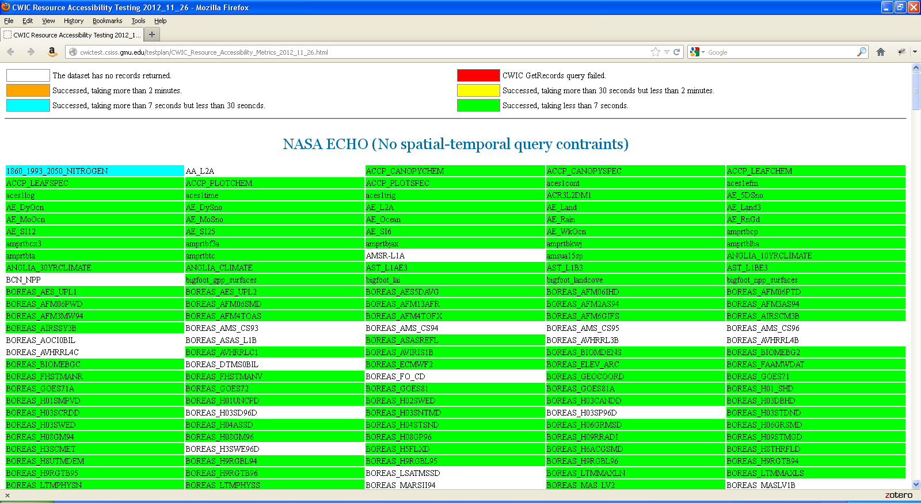
Fig. 5 Screenshot of CWIC resource accessibility test results
Please note that six different metrics status is used to evaluate the dataset accessibility, as shown in the following table:

Resource Accessibility Status | Color
The dataset has no records returned | 
CWIC GetRecords query failed | 
Succeed, taking more than 2 minutes | 
Succeed, taking more than 30 seconds but less than 2 minutes | 
Succeed, taking more than 7 seconds but less than 30 minutes | 
Succeed, taking less than 7 seconds | 
Table 1 Legend used in CWIC resource accessibility test
    - Test Frequency
Routine Dataset Connectivity Testing is a time-consuming testing. As of Nov. 2012, completion of testing for all CWIC datasets will take more than 3 hours. Hence the CWIC Test Team suggests on performing these tests on weekly basis to ensure the robustness and reliability of all CWIC datasets.
  - Update Driven Testing
    - Test Aims
The Update Driven Testing is designed to cope with updates made in CWIC service. CWIC, by adopting Mediator-Wrapper architecture, contains two modules: mediator and connector. If the updates were made in mediator level, all connectors are needed to be tested. If the updates made in connector level, only the related connector will be tested. CWIC test team will perform update driven testing to ensure all the updates are working as expected.
    - Test Inputs
Unlike routine dataset connectivity testing, the update driven testing will test both GetRecords and GetRecordById operation. All request types with different profile will also be tested.
For testing driven by update however, there is no need to include all datasets in the testing scripts. Instead, it’s reasonable to select one dataset from each data catalog, and build the GetRecords and GetRecordById query payloads for different query types and profiles. Following table lists the query payload types for the selected dataset.

 | ISO Profile | CSW Core Profile
Brief | payload-1 | payload-2
Summary | payload-3 | payload-4
Full | payload-5 | payload-6
Hits | payload-7
Table 2 CWIC functionality test payload types
So for each datasets, there will be one “hits” query and six GetRecords and GetRecordById queries.
    - Test Tools
Same as the routine dataset connectivity testing, Apache HTTPClient is used. Please refer to Section 5.1.2 for details.
    - Test Pass/Fail Criteria
All generated GetRecords and GetRecordById request payloads should get responses from the CWIC server. The response for a successful test must include the granule records other than exception, and also pass the XML schema validation.
    - Test Outputs
Outputs of CWIC Update Driven Testing include feedback (a Word document) to the CWIC Development Team. The feedback includes the information about when does the testing happen, which datasets involved, and the problem statement. This document will be prepared by CWIC Test Team manually.
    - Test Frequency
The update driven testing will be conducted when any updates are made in CWIC service.

  - CWIC Performance Test
    - Test Aims
CWIC performance test is intended to determine the responsiveness, throughput, reliability, and/or scalability of CWIC service under a given workload. This CWIC performance test focuses on the load test. Load tests are usually conducted to understand the behavior of a system under a specific load. Load can be specified as total number of concurrent users on the system performing a specific number of transactions within a given duration.
    - Test Inputs
The overall performance of the CWIC system depends on the performance of both CWIC server and remote catalogs. To test the overall performance, it only needs to select one dataset from each data catalog. Section 5.1.1 has provided detailed information on how to generate query payload XML as inputs to the test.
    - Test Tools
Apache JMeter (http://jmeter.apache.org) was utilized for performance test. JMeter can simulate a heavy load on the CWIC server to test its strength or different load types to analyze overall performance. The Apache User Interface or any XML editor can be used to create a jmeterTestPlan document. The following figure shows the basic interface of JMeter which enables the CWIC Test Team to modify Test Plan and GetRecords request payload.

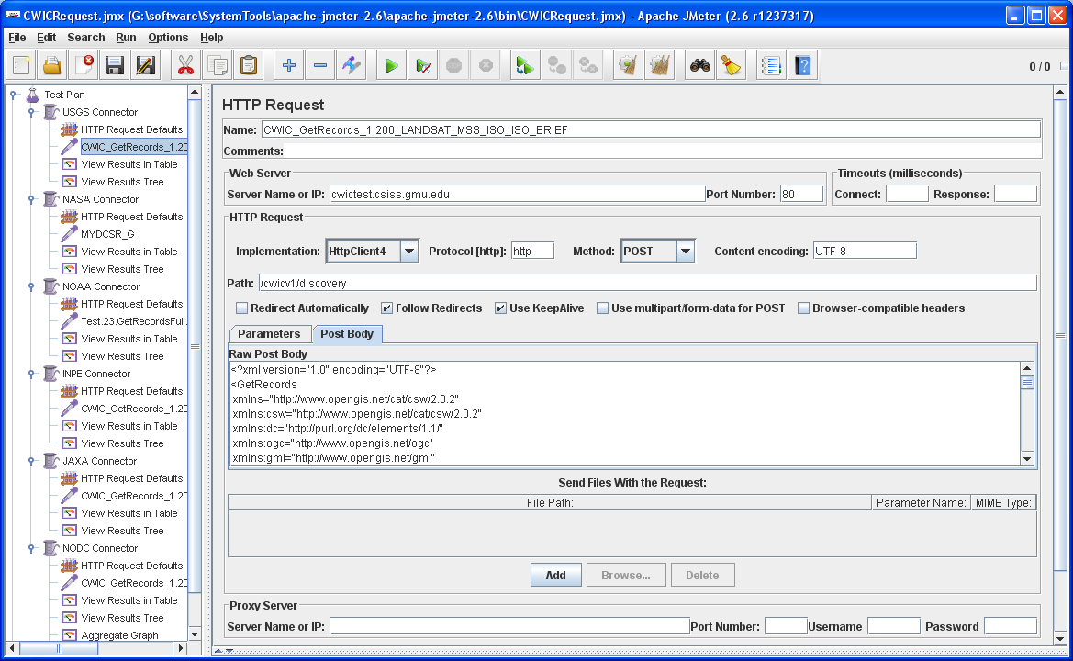
Fig. 6 Screenshot of CWIC performance test tool: Apache JMeter
    - Test Pass/Fail Criteria
For the load testing, the Number of Threads (concurrent users) is assigned to 200, and the Loop Count for each thread is specified as 2. The error rate should be 0%, which means the entire request sent from each thread is accepted and processed by the CWIC server.
By adding the listener [View Results in Table] in test plan, Apache JMeter will give the status for each test. The symbol means the query for a specific thread was failed, and means successful.
    - Test Outputs
The outcome of CWIC Performance Testing contains a performance report which will be sent to CWIC Development Team and CWIC clients. CWIC Test Team will prepare the document manually. The following information will be included in the performance report:
- Request payload XML
- Concurrent request number
- Average response time
- Error percentage
- Throughout
    - Test Frequency
The test will be performed when
- The hardware environment of CWIC server was changed, or
- The remote data catalogues made a major update.
- Testing for New Data Provider
New data providers are always welcome to CWIC, which makes CWIC more practicable and plentiful to discover multiple geospatial data. For every new data provider, CWIC Development Team will implement a connector to translate the query language and convert the metadata. Before implementing the CWIC connector, a series of testing are required to perform by CWIC Test Team to ensure the new data provider is qualified to be a data partner of CWIC. Basically, the testing applied to new data provider includes compatibility testing and performance testing.
  - Compatibility Testing for New Data Provider
    - Test Aims
The compatibility testing aims to ensure new data providers are qualified to be data partner of CWIC. The query interface and metadata model of new data provider will also be tested. Compatibility means that CWIC Queryables are supported by new data provider, and the mandatory elements are returned from the query response of new data provider.
    - Test Inputs
Test inputs are depend on native query interface of the new data provider. CWIC Test Team will prepare the test input manually. For example, if the new data provider is a catalog service built by GeoNetwork, a standard CSW query XML will be generated based on their Queryables. If the new data provider offers Web APIs for query, a list of query URL will be generated accordingly.
Inputs must be valid and recognized by the new data provider, with the spatial extent, temporal range and dataset identifier.
    - Test Tools
Test tools are depend on native query interface and metadata model of the new data provider.
As to the query interface, if the new data provider offers a standard CSW catalog service or Web APIs, Apache HttpComponents HTTPClient will be used as described in section 5.1.3. If the native query interface were encapsulated in the package, such as Java ARchive (JAR) or Dynamic Link Library (DLL), related testing environment will be setup to perform the query.
As to the metadata response, different tools are required to parse the response in different format. The response can be encoded in the XML document, Java object, or other formats.
    - Test Pass/Fail Criteria
To pass the compatibility testing, new data provider need to fulfill the requirement on both query interface and metadata response.
For the query interface, following query constraint items are designed where mandatory items must be supported by the new data provider.

Test Item | Description | Optionality
support-dataset-identifier | check the support of dataset identifier, which is a character string to identify the dataset of interest | Mandatory
support-spatial-extent | check the support of spatial extent, i.e., the bounding box of the spatial area of interest | Mandatory
support-temporal-range | check the support of temporal range, i.e., the begin date-time and end date-time of interest | Mandatory
support-get-record-by-indetifer | check the support of records query based on identifier | Mandatory
support-start-position | check the support of parameter indicating at which record position the catalogue should start generating output | Optional
support-max-records | check the support of parameter defining the maximum number of records that should be returned from the result set of a query | Optional
Table 3 Test items of query interface for new data provider

For the metadata response, following items are expected from the native response. All mandatory items must be provided by the new data provider.

Test Item | Description | Optionality
return-dataset-identifier | check the record identifier from native response, which can be used to build the GetRecordById request;  must be unique in the inventory system | Mandatory
return-spatial-extent | check the spatial bounding box of the returned records | Mandatory
return-temporal-range | check the temporal range of the returned records | Mandatory
return-data-access-url | check the data access URL of the returned records;  can be data download URL or ordering URL | Mandatory
return-image-browser | check the image browser image URL of the returned records | Optional
return-contact-information | check the point of contact information for corresponding dataset | Optional
Table 4 Test items of metadata response for new data provider

If all mandatory items listed in Table 5 and Table 6 is supported, the new data provider passes the compatibility testing.
    - Test Outputs
The outcome of compatibility testing contains a report about testing inputs, tools and results which will be sent to the new data provider. CWIC Test Team will prepare the document manually.
    - Test Frequency
Test will be performed when new data provider would like to be integrated into CWIC.
  - Performance Testing for New Data Provider
    - Test Aims
Depend on difference in hardware environment or inventory system magnitude, different data providers may vary in performance.
The performance test is intended to determine the responsiveness, throughput, reliability, and/or scalability of the new data provider under a given workload. The performance testing for new data provider focuses on the load test. A load test is usually conducted to understand the behavior of a system under a specific load. The load can be specified as total number of concurrent users on the system performing a specific number of transactions within a given duration.
    - Test Inputs
Refer 6.1.2
    - Test Tools
Regarding the performance testing for new data provider, the test tools depend on the native query interface (revise sentence, not clear). If the native query interface is a CSW interface or Web APIs interface, JMeter will be used as described in 5.3.3. If the native query interface were encapsulated in the package, a Java-based multiple thread program will be used to simulate the load test environment.
    - Test Pass/Fail Criteria
For the load testing, the Number of Threads (concurrent users) is assigned to 200, and the Loop Count for each thread is specified as 2.
If the error rate is 0%, the new data provider passes the performance testing. It means the request sent from each thread is accepted and processed by the new data provider and the response is returned correctly.
    - Test Outputs
The outcome of Performance Testing for new data provider contains a performance report which will be sent to the new data provider. CWIC Test Team will prepare the document manually. The following information will be included in the performance report:
- Test method and tools
- Test Pass/Fail Criteria
- Concurrent request number
- Average response time
- Error percentage
    - Test Frequency
Test will be performed when new data provider request to be integrated into CWIC.
- Personnel
CWIC Test Team includes the following member
Name | Role | Responsibility
Yuanzheng Shao
(GMU CWIC Team)
Lingjun Kang
(GMU CWIC Team)
Archie Warnock
(A/WWW Enterprises)

- Abbreviations and Glossary
Term | Meaning
CWIC | CEOS WGISS Integrated Catalog
OGC | Open Geospatial Consortium
CSW | OpenGIS Catalog Service for Web
CEOS | Committee on Earth Observation Satellites
WGISS | Working Group on Information Systems and Services
CWIC PROD | CWIC operational instance
CWIC TEST | CWIC public testing instance
CWIC DEV | CWIC development instance
GCMD | Global Change Master Directory
IDN | International Directory Network
NASA | National Aeronautics and Space Administration
ECHO | NASA EOS Metadata Clearinghouse
NOAA | National Oceanic and Atmospheric Administration
CLASS | Comprehensive Large Array-data Stewardship System
USGS | U.S. Geological Survey
INPE | Instituto Nacional de Pesquisas Espaciais (National Institute For Space Research, Brazil)
CCRS | Canada Centre for Remote Sensing
JAXA | Japan Aerospace Exploration Agency
NODC | National Oceanographic Data Center
GHRSST | Group for High Resolution Sea Surface Temperature
AOE | Academy of Optic-Electronic (AOE) of Chinese Academy of Science

