CWIC Capabilities Document Design
Yuanzheng Shao (yshao3@gmu.edu)
Nov. 28, 2012

1. Introduction
The mandatory GetCapabilities operation allows CSW clients to retrieve service metadata from a server [1]. It’s very important to design the response of GetCapabilities request to ensure the clients get the overall information.
This document will discuss the CWIC Capabilities document about how to encode the datasets list, resource URL, limitation and resource. Based on previous discussion, both implementing GetDomain operation and using <ExtendedCapabilities> element were proposed to enable CWIC provide more meaning information in an interoperable way, and comply with OGC CSW specification.

2. Existing solution
2.1 CWIC-Defined element
In order to give the list of CWIC datasets to CWIC clients, the development team put the datasets in the response of CWIC capabilities document. In the current operational version, the cwic-defined element <cwic:FederationMetadata> is applied in the capabilities document, which is NOT compliant to OGC CSW specification.
The following figure (Figure 1) illustrates the structure of current CWIC capabilities document.
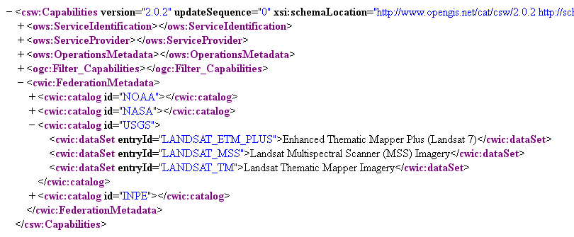
Figure 1. Current structure of CWIC capabilities document

2.2 Advantages & Disadvantages
Advantages:
(1) Describe the structure of datasets, and its associated catalog.
(2) Meet the basic requirement of CWIC clients by putting all servable datasets list
Disadvantage:
(1) Break CSW specification
(2) No limitation, valids and other cwic-related online resource

3. Proposed solutions
This part will discuss the two solutions about the capabilities document design.
3.1 GetDomain solution
“The optional GetDomain operation is used to obtain runtime information about the range of values of a metadata record element or request parameter. The runtime range of values for a property or request parameter is typically much smaller than the value space for that property or parameter based on its static type definition.”[1]
Based on the CSW specification v 2.0.2, the following table (Figure 2) list all KVP used to make a GetDomain operation.
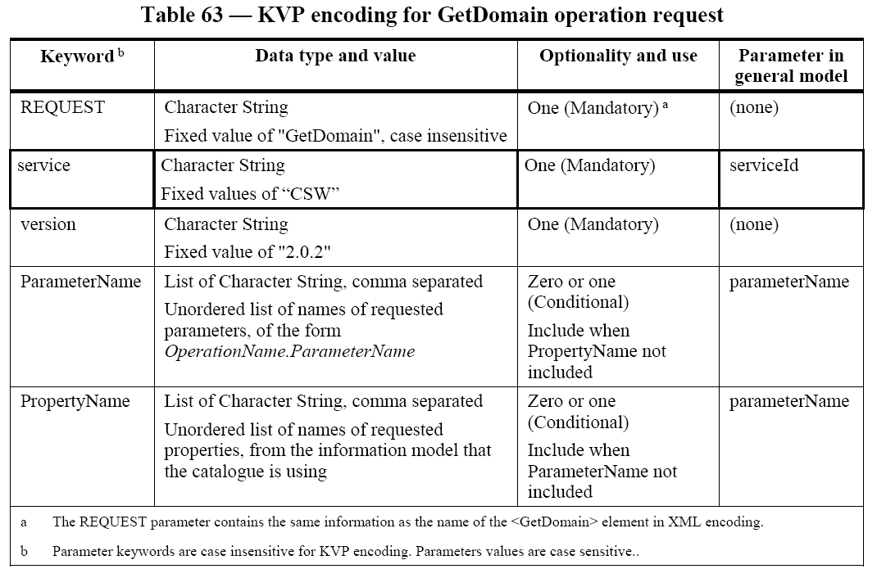
Figure 2. KVP encoding for GetDomain operation request

Please note that the request has to include one of the elements “ParameterName” or “PropertyName”.
3.1.1 GetDomain - ParameterName
OGC CSW defines the “ParameterName” as “The ParameterName parameter is used to specify the name of an interface parameter for which value domain information is desired.” The following is a sample request about CSW GetDomain request with ParameterName:
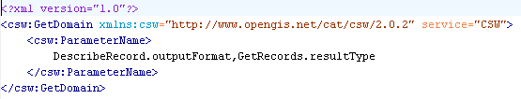
So “ParameterName” element can NOT be used to retrieve CWIC dataset information because the clients can not get any dataset-related parameter from <ows:OperationsMetadata> element.
3.1.2 GetDomain - PropertyName
OGC defines PropertyName as “The PropertyName parameter is used to specify the name of a property that is defined in the information model for which value domain information is desired.”
Based on this point, the Queryables defined in the capabilities document can be used as the PropertyName. We did not add the Queryables in CWIC operational instance, but the capabilities document of CWIC DEV has already added such Queryables, as following screenshots (Figure 3) shows:
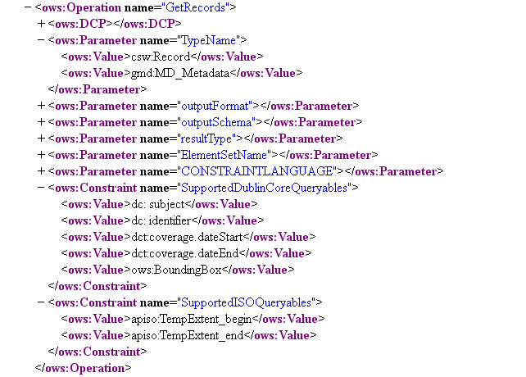
Figure 3. Queryables in CWIC DEV instance

The retrieve the dataset list, client needs to build the following query (Figure 4):
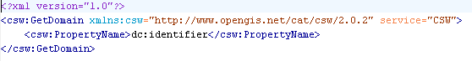
Figure 4. Sample GetDomain request with PropertyName (Not implemented)

The response should be like the following XML screenshot (Figure 5) shows:
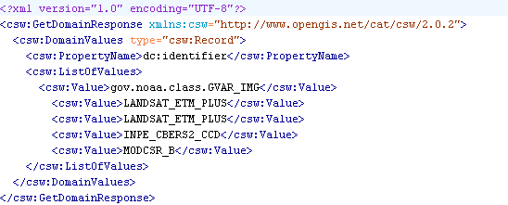
Figure 5. Sample GetDomain response with PropertyName (Not implemented)

The type of <csw:Value> is “xsd:anyType”, which means we can add some dataset related information, such as spatial extent and temporal range, as the following screenshot (Figure 6) shows. But semantically, the content of <csw:Value> element should be exactly what the request asked for. For example, “dc:identifier” property was used in the request, then the response should be the list of all CWIC datasets, each one encoded with a <csw:Value> element.

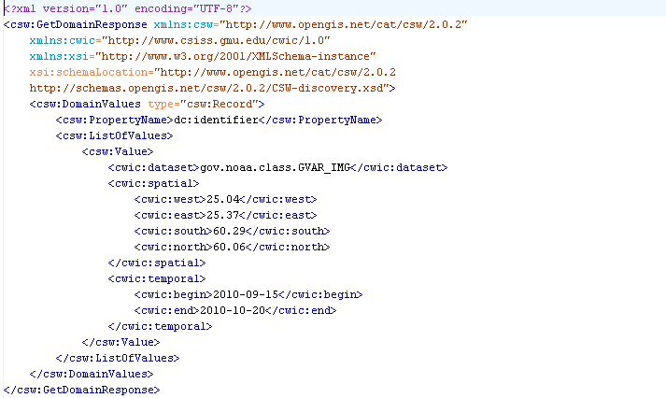
A sample of faked GetDomain response.

Include spatial and temporal, but can NOT match the semantically meaning of GetDomain – Property request
Figure 6. Extended GetDomain response with spatial-temporal info (Not implemented)

So from the definition and schema of GetDomain operation, it may NOT proper to be used to provide dataset list, related spatial-temporal footprint. More discussion is required here before we do the real implementation.

3.1.3 Advantages & Disadvantages
Advantages:
(1) Describe the structure of datasets, and its associated catalog;
(2) Meet the basic requirement of CWIC clients by putting all servable datasets list;
(3) By extending the response of GetDomain, spatial-temporal footprint can be added to the response;
(4) Comply with CSW specification.
Disadvantages:
(1) Extending response of GetDomain is kind of inconsistent with the semantically meaning of this operation
(2) Can not put the limitation information which apply to the catalog level
(3) Can not put the default query value which apply to the catalog level

3.2 <ows:ExtendedCapabilities> solution
3.2.1 <ows:ExtendedCapabilities> introduction
CSW specification does not give detailed introduction about the element <ows:ExtendedCapabilities>, but based on the schema [2], the <ows:ExtendedCapabilities> is defined as “Individual software vendors and servers can use this element to provide metadata about any additional server abilities.” (Figure 7)
Looks like it exactly match our requirements: adding datasets and related footprint, CWIC online resource URL, and limitation information.

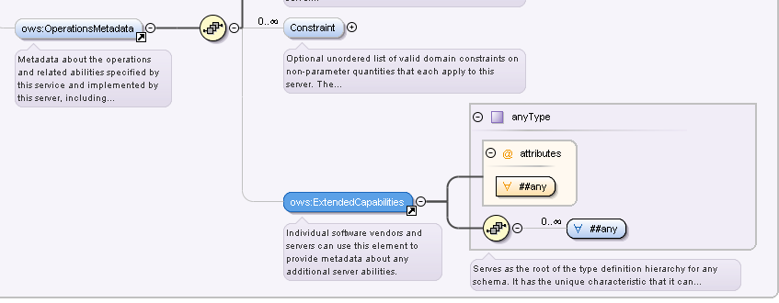
Figure 7. ExtendedCapabilities element is CSW schema

3.2.2 <ows:ExtendedCapabilities> implementation
Firstly, we need to make sure what kind of information will be included in the capabilities document.
1) Dataset Entry ID
2) Dataset GCMD title
3) Dataset spatial-temporal footprint
4) Default value (applicable to catalog level)
5) Limitation (e.g. no hits/pagination support, spatial/temporal limitation, etc)
To include those above information in the <ows :ExtendedCapabilities> element, we designed a sample XML as follows (Figure 8):
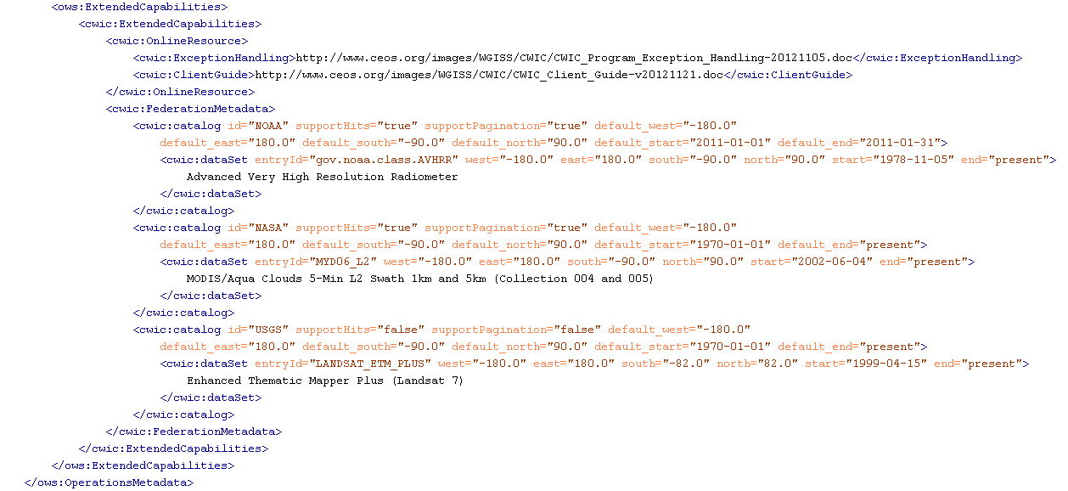
Figure 8. ExtendedCapabilities element is CSW schema (Not implemented)

Based on this design, we still keep the hierarchy level of catalog and its associated dataset. The spatial-temporal footprint can be retrieved from IDN CSW for each dataset. Moreover, we can also put CWIC online resource URL in the capabilities document.
The catalog contains the following attributes: id, supportHints, supportPagination, default_west, default_east, default_south, default_north, default_start, default_end.
The dataset contains the following attributes: entryId, west, east, south, north, start, end.
Through those attributes, CWIC clients can get the search hints (valid spatial-temporal footprint) for each datasets, and put the default value for the specific dataset, if user does not specify spatial or temporal, from the corresponding catalog attributes.
3.2.3 Advantages & Disadvantages
Advantages:
(1) Describe the structure of datasets, and its associated catalog;
(2) Meet the requirement of CWIC clients by putting all servable datasets list;
(3) Provide the limitation and default query constraint for each catalog;
(4) Provide spatial-temporal footprints for each datasets;
(5) Provide CWIC online resource URL;
(4) Comply with CSW specification.
Disadvantages:
(1) Make the capabilities document in bigger size;
(2) Existing clients have to update accordingly for such change.

Reference
[1] D. Nebert, A. Whiteside, and P. Vretanos, “OGC Catalogue Service Specification”, Open Geospatial Consortium Specification, 2007
[2] CSW-discovery schema: http://schemas.opengis.net/csw/2.0.2/CSW-discovery.xsd

