CWIC OpenSearch Best Practices

Abstract
The purpose of this document is to achieve the following with respect to any CWIC OpenSearch implementation,
- Define the expectations and requirements
- Remove ambiguity in implementation where possible
- Attempt best practices that allow a programmatic client to be produced from a CWIC Open Search Descriptor Document (OSDD)
- Facilitate a smooth integration process between the IDN and CWIC OpenSearch implementations.
Furthermore we wish to,
- Facilitate the aggregation of results between disparate earth data providers via OpenSearch common standards
- Maximize the possibility of interoperability with non-CWIC earth data discovery OpenSearch implementations (Federation of Earth Science Information Partners (ESIP) OpenSearch implementations for example)

Introduction

An Open Search Descriptor Document (OSDD) served by an OpenSearch implementation defines a discovery service in terms of,
- a HTTP GET query URL, defining simple keyword/value pair query parameters
- the result formats it supports (ATOM, RSS, HTML)
Given that document, a client can execute a query via a simple HTTP GET invocation.
The server will respond with a navigable result set containing references to pertinent inventory in terms of
- Spatial extent
- Temporal extent
- Metadata, data and documentation URLs
- Links to further searches (possibly represented by additional OSDDs)
The client can view these results in something as simple as a web browser or a complex as an aggregated portal implementation.

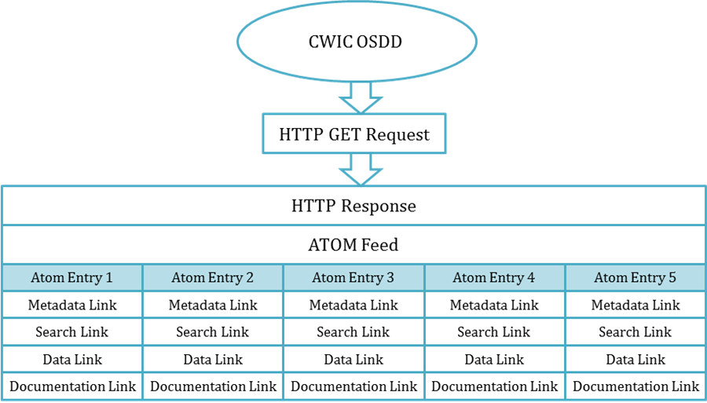

Specification and extension adherence

CWIC regards the following specifications and extensions as mandatory when implementing OpenSearch,
- ATOM Syndication format
- OpenSearch specification version 1.1 draft 5
- OpenSearch parameter extension version 1.0 draft 2
- OpenSearch geo extension version 1.0 draft 2
- OpenSearch time extension version 1.0 draft 1
- OpenSearch geo and time extension - OGC10-032r8

CWIC regards the following extension as optional but recommended when implementing OpenSearch,
- OpenSearch relevancy extension version 1.0 draft 1

CWIC has developed these Best Practices using aspects of the Federation for Earth Science Information Partners (ESIP) OpenSearch Best Practices RFC.

The Open Search Descriptor Document
The primary purpose of an Open Search Descriptor Document (OSDD) is to describe to a client (machine or human) how to search an inventory and what results to expect. Searching is defined in terms of protocol, endpoint and query parameters. Results are defined in terms of format.

Augmenting an OSDD with parameter elements as per Draft 2 of the parameter extension gives us the ability to
- Increase the specificity of our search parameters.
- Allow a client, in theory, to programmatically construct a user interface for an arbitrary OpenSearch implementation on the fly solely from an OSDD.

Both of these abilities are crucial to one of our CWIC goals, the ability to aggregate discovery across multiple, disparate providers.

Anatomy of a CWIC OSDD
They key element of an OSDD is URL. Taken as a whole, including any child parameter elements, the entirety of an OpenSearch implementation for a collection of resources can be described to a client.

For example,

<Url type="application/atom+xml" template="http://foo.gov/opensearch/datasets.atom?q={os:searchTerms?}”/>

Tells a client that an inventory of ‘dataset’ resources can be searched from the endpoint ‘foo.gov/opensearch’ using the http protocol and that the results can be filtered by the optional query parameter ‘q’.
Binding the parameter ‘q’ to the ‘os:searchTerms’ descriptor conveys meaning. In this case, the OpenSearch specification defines this meaning as ‘keyword or keywords desired by the search client’
The type attribute defines the format of results returned by any query against this resource collection. In this case, the results format is ATOM.

We recommend that a CWIC OpenSearch implementation supports the ATOM results format and that it may be requested via HTTP content negotiation or resource extension.

We can increase the specificity of a query parameter by leveraging the parameter extension. For example, an OpenSearch API that can only return a maximum of 2000 results can be described as follows,

<Parameter name="count" value="{os:count}" minimum="0" maxInclusive="2000"/>

We recommend that a CWIC OpenSearch implementation use ‘parameter’ elements as per the OpenSearch parameter extension to describe their search parameters.

A client may wish to generate a user interface at runtime by parsing the OSDD. Leveraging the parameter extension comes close to allowing us to achieve this.

For example, the following parameter definition may instruct a UI to provide a temporal widget by virtue of the value ‘{time:start}’ which describes an RFC-3339 date time. That widget would have a display name of ‘Temporal Start’ and will be deemed optional by virtue of the minimum value of zero.

<Parameter name="startTime"
uiDisplay= “Temporal Start”
value="{time:start}"
title="inventory which has a temporal extent containing this start time"
minimum="0"/>

We recommend that a CWIC OpenSearch implementation use name, value, title and uiDisplay1 attributes on all their parameter definitions.

Some of our common search parameters have characteristics that are difficult to capture using the parameter extension as it is in Draft 2.

Free text searching, for example, may support query syntax. Given that there is no widely adopted free text query syntax standard and that most implementations will provide this support through 3rd party products like Lucene or Elastic Search, we are proposing an augmentation to the parameter extension that will allow a parameter to exhibit a profile analogous to ‘my free text search query language behaves like Lucene’

For example,

<Parameter name="keyword"
value="{os:searchTerms}"
title="inventory containing all the specified keywords separated by space, case-insensitive, wildcards are supported"
minimum="0">
<link rel="profile" href="http://www.elasticsearch.org/guide/en/elasticsearch/reference/current/query-dsl-query-string-query.html"
title="This parameter follows the elastic search free text search implementations" />
</Parameter>

We recommend that any CWIC OpenSearch implementation with free text search capabilities define the properties of that capability via an atom link referring to a profile.

The geometry parameter as defined in the geo extension allows for the representation of a spatial constraint via Well Known Text (WKT). This WKT string may represent a number of different geometries such as point, line or polygon. It is likely that a CWIC OpenSearch implementation only supports a subset of these geometries. We are proposing an augmentation to the parameter extension that will allow a parameter to exhibit a number of profiles analogous to ‘my geometry search parameters supports point, line and polygon’

For example,

<params:Parameter name="geometry"
value="{geo:geometry}"
title="inventory which has a spatial extent overlapping this geometry"
minimum="0">
<atom:link rel="profile" href="http://www.opengis.net/wkt/LINESTRING"
title="This service accepts WKT LineStrings"/>
<atom:link rel="profile"
href="http://www.opengis.net/wkt/POINT"
title="This service accepts WKT Points"/>
<atom:link rel="profile" href="http://www.opengis.net/wkt/POLYGON"
title="This service accepts WKT Polygons"/>
</params:Parameter>

We recommend that any CWIC OpenSearch implementation with geometry search capabilities define an enumeration of supported geometry types via atom links referring to geometry type profiles.

Obtaining an OpenSearch Descriptor Document

We wish to track client usage through CWIC OpenSearch implementations for metrics purposes. We can do this by passing a client ID from implementation to implementation.

We recommend that a CWIC OpenSearch implementation expose its OSDD via the provision of a client-supplied identifier

In order to minimize the obtrusiveness on the client of we suggest the following,
- Expose your OSDD via an OpenSearch html landing page.
- Your OSDD is dynamically generated based on the submission of an html form on that page that has a single, mandatory ‘clientId’ parameter.
- Submitting the form will return an OSDD with that client ID embedded in the URL template attribute.
For example invoking,

HTTP GET foo.gov/datasets/openSearchDescriptorDocument.xml?clientId=foo

Would return an OSDD containing,

<Url type="application/atom+xml" template="http://foo.gov/opensearch/datasets.html?clientId=foo”/>

Full Example of a CWIC Open Search Descriptor Document

HTTP GET foo.gov/datasets/openSearchDescriptorDocument.xml?clientId=foo

<os:OpenSearchDescription
xmlns:os="http://a9.com/-/spec/opensearch/1.1/" xmlns:geo="http://a9.com/-/opensearch/extensions/geo/1.0/"
xmlns:time="http://a9.com/-/opensearch/extensions/time/1.0/"
xmlns:params="http://a9.com/spec/opensearch/extensions/parameters/1.0/"
xmlns:atom="http://www.w3.org/2005/Atom" >
<os:ShortName>CWIC Open Search</os:ShortName>
<os:Description>CWIC Best Practice OSDD</os:Description>
<os:Tags>CWIC</os:Tags>
<os:Contact>echodev@echo.nasa.gov</os:Contact>
<os:Url type="application/atom+xml" params:method="GET"
template="http://foo.gov/datasets.atom?keyword={os:searchTerms?}&amp;boundingBox={geo:box?}&amp;geometry={geo:geometry?}&amp;startTime={time:start?}&amp;endTime={time:end?}&amp;startPage={os:startPage?}&amp;numberOfResults={os:count?}&amp;clientId=foo">
<params:Parameter name="keyword" value="{os:searchTerms}" title="inventory containing all the specified keywords separated by space, case-insensitive, wildcards are supported" minimum="0">
<atom:link rel="profile" href="http://www.elasticsearch.org/guide/en/elasticsearch/reference/current/query-dsl-query-string-query.html" title="This parameter follows the elastic search free text search implementations" />
</params:Parameter>
<params:Parameter name="boundingBox" value="{geo:box}" title="inventory which has a spatial extent overlapping this bounding box" minimum="0"/>
<params:Parameter name="geometry" value="{geo:geometry}" title="inventory which has a spatial extent overlapping this geometry" minimum="0">
<atom:link rel="profile" href="http://www.opengis.net/wkt/LINESTRING" title="This service accepts WKT LineStrings"/>
<atom:link rel="profile" href="http://www.opengis.net/wkt/POINT" title="This service accepts WKT Points"/>
<atom:link rel="profile" href="http://www.opengis.net/wkt/POLYGON" title="This service accepts WKT Polygons"/>
</params:Parameter>
<params:Parameter name="startTime" value="{time:start}" title="inventory which has a temporal extent containing this start time" minimum="0"/>
<params:Parameter name="endTime" value="{time:end}" title="inventory which has a temporal extent containing this end time" minimum="0"/>
<params:Parameter name="startPage" value="{os:startPage}" minimum="0"/>
<params:Parameter name="numberOfResults" value="{os:count}" minimum="0" maxInclusive="2000"/>
<params:Parameter name="clientId" value="foo" minimum="1"/>
</os:Url>
<os:Query role="example"
geo:box="-180.0,-90.0,180.0,90.0"
time:start="2002-05-04T00:00:00-0400"
time:stop="2009-05-04T00:00:00-0400"/>
<os:Attribution>CWIC</os:Attribution>
<os:SyndicationRight>open</os:SyndicationRight>
</os:OpenSearchDescription>

The Search Request

An OpenSearch request is a HTTP request (normally ‘GET’ but this can be defined within your OSDD) directed to a specific collection of resources. Those resources normally describe datasets or granules in earth data discovery.

Anatomy of a CWIC Search Request

The set of resources returned can be constrained and traversed by attaching parameters to your request.
The requested format of your results can be defined in the request by content negotiation via the HTTP ‘accept’ header or using a resource extension.
Example of format request by resource extension,

https://foo.gov/opensearch/datasets.atom

Example of format request by HTTP ‘accept’ header,

Accept: application/xml+atom: https://foo.gov/opensearch/datasets

CWIC Query Parameters

CWIC recommends the use of keyword, spatial and temporal constraints for your search implementation. You may define other search parameters but the above 3 have been found to account for over 90% of user queries in a recent study conducted by NASA’s ECHO system.

It is expected that multiple query parameters will be AND’d together to form a result set.

Keyword constraints are key to discovering the appropriate data collections for a user.

We recommend that a CWIC OpenSearch implementation, if appropriate, should filter results by a free text keyword constraint as specified in the OpenSearch specification

Spatial and temporal constraints narrow down a result set to a user’s desired area and time of interest.

Bounding box is the simplest and most used type of spatial constraint. As per the geo extension we recommend you define a bounding box constraint as 4 longitude/latitude coordinates expressed as EPSG:4326 decimal degrees. The order of those coordinates should be west, south, east and north.

For example,

datasets.atom?box=-180.0,-90.0,180.0,90.0

The implied relation between a spatial constraint and any inventory returned is that the spatial extent of a resource overlaps the spatial constraint in the query.

We recommend that a CWIC OpenSearch implementation should filter results by a geo bounding box constraint as specified in the OpenSearch Geo extension

Temporal constraints can be expressed as intervals in time that may be open ended. A upper or lower temporal bound can be expressed as a date or date time constraint specified in the RFC-3339 format as per the OpenSearch Time extension.

Example – a fully specified range,

datasets.atom?startTime=2001-01-01T22:00:00Z&endTime=2001-01-01T22:00:00Z

Example – an open-ended range,

datasets.atom?startTime=2001-01-01T22:00:00Z

Example – an open-ended range with date only,

datasets.atom?startTime=2001-01-01

The implied relation between a temporal constraint and any inventory returned is that the temporal extent of a resource overlaps the temporal constraint in the query.

We recommend that a CWIC OpenSearch implementation should filter results by time start and time end as specified in the OpenSearch Time extension

CWIC result set navigation parameters

CWIC recommends using paging to navigate through results sets. Any defaults used by your implementation when not supplied by the client should be rendered in your result.

CWIC recommends that a startPage value of ‘1’ refer to the first page of a result set.
Example,

datasets.atom?startPage=1&count=10

Will return the results 1 through 10 of a result set.

datasets.atom?StartPage=2&count=10

Will return the results 11 through 20 of a result set.

We recommend that a CWIC OpenSearch implementation must allow a client to navigate a result set using the ‘startPage’ and ‘count’ parameters as specified in the OpenSearch specification

CWIC metrics parameters

In the OSDD section we talk about the need for the user to supply a client ID when obtaining an OSDD. The OSDD returned will embed that client ID in the URL template. In theory, all requests sent by that client will have that parameter present.

The purpose of this ID is to allow the tracking of metrics based on particular clients and users. This is a business need of our NASA sponsor.

To facilitate this need we recommend that your OpenSearch implementation use this ID reference when logging or generating your own metrics. Furthermore, we recommend that you propagate that client ID to other searches (see ‘Two step searching). The client ID is a mandatory parameter when obtaining an OSDD through your API but optional in any search request.

We recommend that a CWIC OpenSearch implementation must allow a client to specify a ‘clientId’ and that ID must be propagated to any secondary CWIC OpenSearch implementations

We understand that this is not an ideal means of providing user metrics but we feel this is the best way to provide ‘opt in’, non-obtrusive support.
The supplied client ID may be (a) non-unique and (b) not meaningful. This risk is balanced by the possible lack of interest in your OpenSearch API if a more thorough handshake (designated IDs for example) is required.

Example,

datasets.atom?clientId=foo

Full Example of a CWIC compliant Open Search Request

https://foo.gov/opensearch/datasets.atom?clientId=foo&searchTerms=air+temperature&box=10,10,10,10&startTime=startTime=2001-01-01T22:00:00Z&endTime=2001-01-01T22:00:00Z&pageNumber=1&count=10

The Search Response
An OpenSearch response is an ATOM feed with zero or more ATOM entries. Each entry represents a single resource pertaining to the query submitted within a set of results also defined by the query.

Anatomy of a response
An ATOM response is one ATOM feed element containing the following,
- Information about the search conducted in terms of title, author and ID.
- Information about the nature of the result set in terms of total number of results, number of results returned and how many the client asked for.
- Navigation information for traversing that result set including links to the previous, next, first and last results in the set.
- Zero or more entries pertaining to resources matching the client query

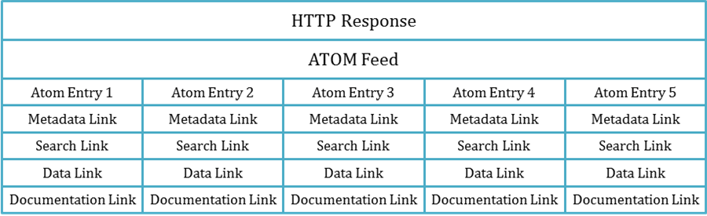

As described in the request section,

We recommend that a CWIC OpenSearch implementation must allow a client to navigate a result set using the ‘startPage’ and ‘count’ parameters as specified in the OpenSearch specification

This recommendation has an impact on how you describe your result set.
For example,

<feed>
…
<os:totalResults>3415</os:totalResults> <os:itemsPerPage>10</os:itemsPerPage> <os:startPage>1</os:startPage>
…
</feed>

Indicates that the client asked for the first page of results where there are 10 results per page and there are a total of 3415 results. The first 10 entries (1-10) would be represented in the feed. If the client asked for the second page (startPage=2) then the second 10 entries (11-20) would be represented in the feed.

In the case where zero results are returned the following would be contained in the feed,

<feed>
…
<os:totalResults>0</os:totalResults
…
</feed>

We recommend that a CWIC OpenSearch implementation does not include ‘itemsPerPage’ and ‘startPage’ in a feed result when zero entries are returned for a query.

In order to facilitate traversal of a result set we can leverage the REST concept of Hypermedia as the Engine of Application State (HATEOAS) and provide links to the current, previous, next, first and last pages in the result set as follows,

<feed>
…
<os:totalResults>50</os:totalResults> <os:itemsPerPage>10</os:itemsPerPage> <os:startPage>3</os:startPage>
<link href="foo.gov/opensearch/datasets.atom?count=1&numberOfResults=10" rel="first" type="application/atom+xml"/>
<link href="foo.gov/opensearch/datasets.atom?count=2&numberOfResults=10" rel="prev" type="application/atom+xml"/>
<link href="foo.gov/opensearch/datasets.atom?count=3&numberOfResults=10" rel="self" type="application/atom+xml"/>
<link href="foo.gov/opensearch/datasets.atom?count=4&numberOfResults=10" rel="next" type="application/atom+xml"/>
<link href="foo.gov/opensearch/datasets.atom?count=5&numberOfResults=10" rel="last" type="application/atom+xml"/>
…
</feed>

We recommend that a CWIC OpenSearch implementation provides navigation links for the first, previous, current, next and last pages of a result set.

Each resource in a result page will be represented by an ATOM entry element. That element will contain an ID, a link to the metadata from which this entry was derived, and, if applicable, a spatial extent and a temporal extent.

We recommend that a CWIC OpenSearch implementation provide a link of relation ‘alternate’ for each entry in a result set page. That link should point to the metadata from which this entry was derived.

When rendering a spatial extent for an entry we recommend that an implementation provide a minimum-bounding rectangle to represent more complex geometries such as polygon in addition to the accurate spatial extent. The rationale behind this is that bounding rectangle is the lowest common denominator of spatial constraint/extent supported by our providers and clients. You may also render your original extent in WKT as per the geo extension.

For example an MBR representing a point and it’s original representation,

<georss:box>39.1 -96.6 39.1 -96.6</georss:box>
<geo:geometry>39.1 -96.</geo:geometry>

We recommend that a CWIC OpenSearch implementation render spatial extents using a minimum-bounding rectangle in the ‘georss’ format.

When rendering a temporal extent an implementation should use a Dublin core date element, which will allow you to render date and date-time ranges, open-ended date and date-time ranges and single dated and date-times.

For example a date-time range,

<dc:date xmlns:dc="http://purl.org/dc/elements/1.1/">1984-12-25T00:00:00.000Z/1988-03-04T00:00:00.000Z</dc:date>

an open-ended date-time range,

<dc:date xmlns:dc="http://purl.org/dc/elements/1.1/">1984-12-25T00:00:00.000Z/</dc:date>

a single date-time,

<dc:date xmlns:dc="http://purl.org/dc/elements/1.1/">1984-12-25T00:00:00.000Z</dc:date>

a single date,

<dc:date xmlns:dc="http://purl.org/dc/elements/1.1/">1984-12-25</dc:date>

We recommend that a CWIC OpenSearch implementation render temporal extents using a Dublin Core date element.

Your entry should also render link elements pointing to various artifacts associated with the resource. Those may include data, additional metadata, browse imagery and documentation.

We recommend that a CWIC OpenSearch implementation use the following relation values when describing artifacts associated with a resource,

Artifact | Relation | Example
Metadata | via | <link href="foo.xml" rel="via"/>
Browse | icon | <link href="sample.gif" rel="icon"/>
Documentation | describedBy | <link href="foo.pdf" rel="describedBy"/>
Product | enclosure | <link href="foo.hdf" rel="enclosure"/>

Result ordering
Result ordering is optional as per OGC recommendations. We recommend that if you support search by free text that you employ relevancy ranking as per the Open Search Relevancy Extension and order your results by that ranking in descending order.

For example,
<feed xmlns:relevance="http://a9.com/-/opensearch/extensions/relevance/1.0/"
>
<entry>
…
<relevance:score>0.98</relevance:score>
..
</entry>
<entry>
…
<relevance:score>0.75</relevance:score>
..
</entry>
…
</feed>

Handling errors
In the event of an error the service implementation should respond with the appropriate HTTP error code and a response body that verbosely describes the error in a human-readable format.
These errors will generally fall into two categories,
- User input errors will be responded to with a BAD_REQUEST 400 response
- Processing errors will be responded to with an INTERNAL_SERVER_ERROR 500 response

Two-step Searching
The ESIP OpenSearch Best Practices document presents a very compelling case for the need for two-step/recursive searching for the earth data discovery use case. We repeat it here,

‘One serious hurdle to overcome in searching for data is the enormous number of data items to account for in responses, as well as the expected number of successful “hits” for a query. In ordinary web searches, the searcher is usually looking for a small number of web pages or documents. Relevance ranking typically does a good job of presenting these successful hits near the top of the returned list, followed by single point-and-click retrievals. However, when searching for earth science data covering large time periods or spatial areas, a user will often specify a set of constraints to find an appropriate data collection together with space-time criteria for files within that data collection. Often, the precision of the data collections returned for the search is low, with many spurious hits. However, the space-time precision of the files is often quite high: that is, the user truly wants to use all the data files of a desirable data collection set that fall within the space-time region of interest. Thus, searching for all data satisfying both dataset content and space-time region at the same time can produce a great many spurious hits, i.e., all the files for data collections that are not desired.’

The two-step solution breaks a search in to two distinct parts. A client will first identify datasets of interest (step 1) and then search for granules associated with those datasets (step 2).

To facilitate this, when an OpenSearch implementation representing dataset/collection resources returns results each entry in that result set should contain an atom link of relation type ‘search’ if applicable. That atom link should point to a URL of an OSDD pertaining to granules associated with that entry (i.e. Dataset/collection). A client can then parse that OSDD and formulate a search for granules belonging to that dataset.

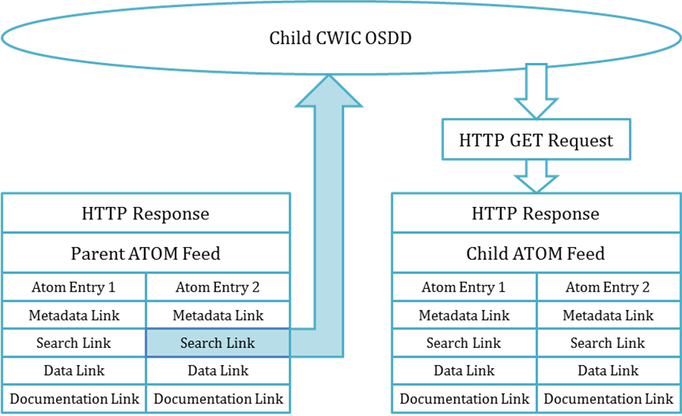

For example,

- Given an dataset OSDD, search for datasets of interest

GET http://foo.gov/opensearch/datasets?searchTerms=MODIS&clientId=d

- Parse search results

<feed … >
…
<entry … >
<id>http://foo.gov/opensearch/datasets/MODIS_dataset</id>
<link rel=‘search’ type=‘application/opensearchdescription+xml’>bar.gov/opensearch/granules/descriptorDocument?datasetId=MODIS_dataset&clientId=d</link>
…
</entry>
…
</feed>

- Parse granule OSDD

<os: OpenSearchDescription>
…
<os:Url type="application/atom+xml"
template="bar.gov/opensearch/granules.atom?datasetId= MODIS_dataset&clientId=d&box={georss:box?}">
…
</os:Url>
…
</os:OpenSearchDescription>

- Search for granules of interest

GET http://bar.gov/opensearch/granules.atom? datasetId= MODIS_dataset&clientId=d&box=1,2,3,4

We will petition OpenSearch to add the ‘uiDisplay’ attribute to the parameter element

