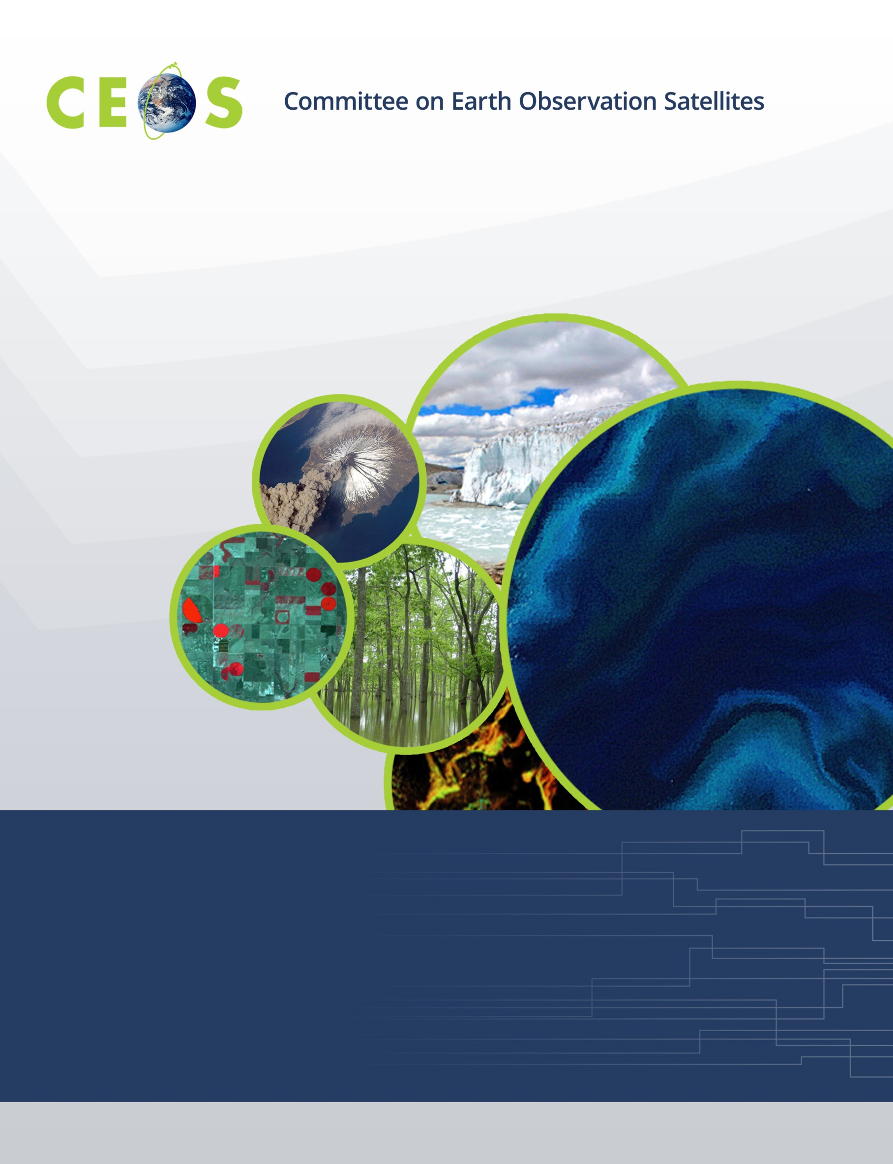

**Working Group on Calibration and Validation**

**CEOS WGCV #44, Darmstadt, Germany**

**Hosted by EUMETSAT**

**August 28-31, 2018**

**Agenda**

**Version Final, August 31, 2018**

|  |  |  |  |  |  |  |  |  |  |  |
| --- | --- | --- | --- | --- | --- | --- | --- | --- | --- | --- |
| **Monday, August 27, 2018** | | | | | | | | | | |
|  | |  | | | | | |  | | | |
| *WGCV Attendees Arrivals and Microwave Subgroup Meeting* | | | | | | | | | |
|  | **WGCV Business** | | |  | | |
|  | Chair available for splinters and pre-meetings | | | | |  | | | | | | |
|  | |  | | |  | | | |
|  | | |
|  | | |

|  |  |  |  |  |  |  |  |  |  |  |  |
| --- | --- | --- | --- | --- | --- | --- | --- | --- | --- | --- | --- |
| *13:00    Convene* | | | | | | | | | | | |
|  | | **Microwave Subgroup Meeting** | | |  | | | |
| 13:05 | | | Meeting Welcome | | | | | *X. Dong* | | | |
| TBD | | | Meeting adjourns | | |  | | | |
|  | | | | Contact Microwave Subgroup Chair to inquire about attendance  *All attendees to MWSG meeting must be registered for WGCV-44 or directly work with EUMETSAT to ensure access to meeting* | | |  | | | |

|  |  |  |  |  |  |  |  |  |  |
| --- | --- | --- | --- | --- | --- | --- | --- | --- | --- |
| **Tuesday, August 28, 2018** | | | | | | | | | |
|  |  | |  | | | | | | |
| 08:30   Registration *09:00   Convene* | | | | | | | | | |
|  | **WGCV Business and Meeting Introduction** | | |  | |
| 09:00 | Chair/Vice Chair welcome and opening | *K. Thome/C. Ong* | | | | | |
| 09:15 | Tour de table | *All* | | | | | |
| 09:30 | Logistics |  | | | | | |
| 09:45 | Overview of EUMETSAT | *B. Bojkov* | | | | | |
| 10:15 | Meeting overview, goals, and agenda approval | *K. Thome* | | | | | |
| *10:30   Break* | | | | | | | | |
| 10:45 | WGCV Chair’s Report | *K. Thome* | | | | |
| 11:15 | JAXA Agency Report and Vice Chair goals | *A. Kuze* | | | | |
| 11:45 | CEOS Executive Officer Report | *S. Hosford* | | | |
|  | CEOS 2019-2021 Work Plan |  | | | |
| *12:30   Lunch* | | | | | | | | |
| 13:30 | Addressing GHG validation in WGCV | *A. von Bargen* | | |
| 13:45 | Greenhouse gas reference standards for interoperability | *A. Kuze* | | |
| 14:15 | Cal/Val for greenhouse gas observation spectrometers | *A. Kuze* | | |
| 14:30 | RadCalNet status | *N. Fox* | | |
| 14:45 | Site classifications, definitions, and updates to Landnet | *K. Thome* | | |
| 15:00 | DEM Update and Discussion | *K. Thome* | | |
| *15:30   Break* | | | | | | | | |
| 15:50 | Communicating Terminology and definitions | *All* | | |
|  | **Subgroup reporting** |  | | |
| 16:10 | IVOS Subgroup Report | *N. Fox* | | |
| 16:30 | LPV Subgroup Report | *M. Roman* | | |
| 16:50 | MW Subgroup Report | *X. Dong* | | |
| 17:10 | SAR Subgroup Report | *B. Chapman* | | |
| *17:30   Adjourn*  *Icebreaker at EUMETSAT* | | | | | | | | |

|  |  |  |  |  |  |  |  |  |  |
| --- | --- | --- | --- | --- | --- | --- | --- | --- | --- |
|  | | |  | | | |  | | |
| **Wednesday, August 29, 2018** | | | | | | | | | |
|  | | |  | | | |  | |
| *9:00    Convene* | | | | | | | | | |
|  | | | **WGCV Business** |  | | | | | |
| 09:00 | | | Day 1 Summary | | *K. Thome* | | | |
|  | | | **GSICS/WGCV Interactions** | |  | | | |
| 09:15 | | | Overview of Cal/Val activities at EUMETSAT | | *J. Ackermann*  *D. Coppens*  *D. Just*  *T. Hewison* | | | |
| 10:00 | | | GSICS/WGCV linkages | | *K. Thome* | | | |
| 10:15 | | | L1 top-of-atmosphere interoperability | | *N. Fox* | | | |
| *10:30   Break* | | | | | | | | |
|  | | | **WGCV Interactions with other CEOS Virtual Constellations** | |  | | | |
| 10:45 | | | Recent activities of Atmospheric Composition VC | | *J-C Lambert* | | | |
| 11:05 | | | Recent activities of Ocean Colour Radiometry VC | | *E.Kwiatkovska* | | | |
| 11:20 | | | Recent activities of Ocean Surface Topography VC | | *R. Scharroo* | | | |
| 11:35 | | | Recent activities of Ocean Surface Vector Wind VC | | *S. Linow* | | | |
| 11:50 | | | Recent activities of Sea Surface Temperature VC | | *A. O'Carroll* | | | |
| 12:05 | | | Discussion of possible collaborative efforts with WGCV | | *All* | | | |
| *12:30   Lunch* | | | | | | | | |
|  | | | **WGCV Interactions with other CEOS Virtual Constellations** | |  | | | |
| 13:30 | | | Calibration/Validation of SAR and reflectance ARD products | | *M.Thankappan* | | | |
| 14:15 | | | WGCV/ LSI-VC ARD product assessment process | | *S. Hosford* | | | |
| 14:45 | | | Proposed WGCV CARD4L assessment process | | *K. Thome* | | | |
| *15:15   Break* | | | | | | | | |
|  | | **Agency Reports** | |  | | | |
| 17:15 | | BelSpo | | *J-C Lambert* | | | |
| 17:30 | | CNES | | *A. Meygret* | | | |
| 17:45 | | ESA | | *P. Goryl* | | | |
| *17:45   Adjourn*  *Dinner TBA Hosted by EUMETSAT* | | | | | | | | | |

|  |  |  |  |  |  |  |  |  |  |  |  |  |  |  |  |  |  |  |  |  |  |
| --- | --- | --- | --- | --- | --- | --- | --- | --- | --- | --- | --- | --- | --- | --- | --- | --- | --- | --- | --- | --- | --- |
|  | |  | | |  | | | | | | | | | | | | | | | | |
| **Thursday, August 30, 2018** | | | | | | | | | | | | | | | | | | | | | | | | |
|  | | | | |  |  | | | | | | | | | | | | |
| *9:00    Convene* | | | | | | | | | | | | | | | | | | | | | |
|  | | | **WGCV Business** | | | |  | | | | | | | | | | | |
| 08:50 | | | Day 2 Summary | | | | | | | *K. Thome* | | | |
|  | | | **WGCV Work Plan Status** | | | | | | |  | | | |
| 09:10 | | | WGCV Work Plan Actions | | | | | | | *K. Thome* | | | |
|  | | | -CARD4L-branded specification documents | | | | | | |  | | | |
|  | | | -Data product formats to facilitate interoperability | | | | | | |  | | | |
|  | | | -Long-term plans for Moderate-Resolution Interoperability | | | | | | |  | | | |
|  | | | **Agency Reports** | | | | | | |  | | | |
| 09:30 | | | CSIRO | | | | | | | *C. Ong* | | | |
| 09:45 | | | GA | | | | | | | *M.Thankappan* | | | |
| 10:00 | | | ISRO | | | | | | | *A. Misra* | | | |
| 10:15 | | | NASA | | | | | | | *X. Xiong* | | | |
|  | | | **WGCV Interactions with other CEOS Working Group** | | | | | | |  | | | |
| 10:30 | | | WGClimate summary of recent activities | | | | | | | *J. Schultz, .A. von Bargen* | | | |
| *10:45   Break* | | | | | | | | | | | | | | | | | | | |
| 11:00 | | | Summary of WGCV/WGISS interactions from WGCV-43 | | | | | | | *K. Thome* | | | | | | |
| 11:10 | | | Data Formats and Interoperability in the framework of FDA | | | | | | | *M. Thankappan* | | | | | | |
| 11:30 | | | Quality Indicators in Discovery Metadata | | | | | | | *N. Fox* | | | | | | |
| 11:50 | | | CEOS Data Cubes & Test Site Data Access | | | | | | | *G. Stensaas* | | | | | | |
| 12:10 | | | Standardization and Best Practices (e.g. ISO 19159-3) | | | | | | | *C.Ong* | | | | | | |
| *12:30   Lunch* | | | | | | | | | | | | | | | | | | | |
|  | | | **Calibration/Validation Updates** | | | | |  | | | | | | | |
| 13:15 | | | Overview of FY-3D commissioning test | | | | | | | *X. Hu* | | | | |
| 13:30 | | | Cal/Val for FY-3D Microwave sensors (MWTS/MWHS/MWRI) | | | | | | | *Q. Lu* | | | | |
| 13:45 | | | CMA FY-3D/HIRAS calibration and validation | | | | | | | *C. Qi* | | | | |
| 14:00 | | | FY-3D/MERSI-II commission test | | | | | | | *N. Xu* | | | | |
| 14:15 | | | Post-launch Calibration and Data Quality Assessment of Chinese High-Resolution Satellites | | | | | | | *L. Ma/S. Qiu* | | | | |
| 14:30 | | | Sentinel-5p MPC Operational Validation Facility | | | | | | | *J-C Lambert* | | | | |
|  | | | **WGCV Business** | | | | | | |  | | | | |
| 14:45 | | | Cal/Val Portal update | | | | | | | *P. Castracane* | | |
| *15:30   Break* | | | | | | | | | | | | | | | | | | | | |
| 16:45 | | | Collaborative Environments for Cal/Val | | | | | | *A.Della Vecchia* | | | | |
|  | **Agency Reports** | | | | | | |  | |
| 17:15 | | USGS | | | | | | | *G. Stensaas* |
| 17:30 | | AOE | | | | | | | *C. Li* |
| 17:45 | | NSSC | | | | | | | *X. Dong* |
| *18:00   Adjourn* | | | | | | | | | | | | | | | | | | |

|  |  |  |  |  |  |  |  |  |  |
| --- | --- | --- | --- | --- | --- | --- | --- | --- | --- |
|  | |  | | | | | |  | |
| **Friday, August 31, 2018** | | | | | | | | | |
|  | | | |  | | | |  | |
| *8:45    Convene* | | | | | | | | |
|  | | | **WGCV Business** | |  | | | | |
| 08:30 | | Day 3 Summary | | | *K. Thome* | | | | | | |
| 08:45 | | Carbon Actions related to Biomass | | | *K. Thome/M. Roman* | | | | | | |
| 09:15 | | Results from a National Remote Sensing Validation Workshop and DLR agency report | | | *A. von Bargen* | | | | | | |
| 09:45 | | Update on Pre-launch calibration workshop | | | *N. Fox/A. von Bargen* | | | | | | |
| 10:00 | | ACSG Subgroup Report including GHG discussion | | | *B. Bojkov* | | | | | | |
| 10:15 | | Vice Chair nomination and voting | | | *All* | | | | | | |
| *10:30   Break* | | | | | | | | | | | |
| 10:45 | | ACIX final report | | | *P. Goryl/A. von Bargen* | | | | | | |
| 11:00 | | Cloud Mask Task Group and CMIX | | | *P. Goryl* | | | | | | |
| 11:15 | | Continental scale surface reflectance validation | | | *M. Thankappan* | | | | | | |
| 11:45 | | Closure of WGCV actions (CV-01; CV-09; CV-13; CV-16) | | | *K. Thome* | | | | | | |
|  | | Action item summaries update | | | *K. Thome* | | | | | | |
| 12:00 | | Announcement of election results | | | *K. Thome* | | | | | | |
| 12:15 | | Meeting summary | | | *K. Thome* | | | | | | |
| 12:30 | | Future Directions and Meetings | | | *C. Ong* | | | | | | |
| 12:45 | | Chair hand-over | | | *K. Thome* | | | | | | |
| 12:45 *Adjourn* | | | | | | | | |