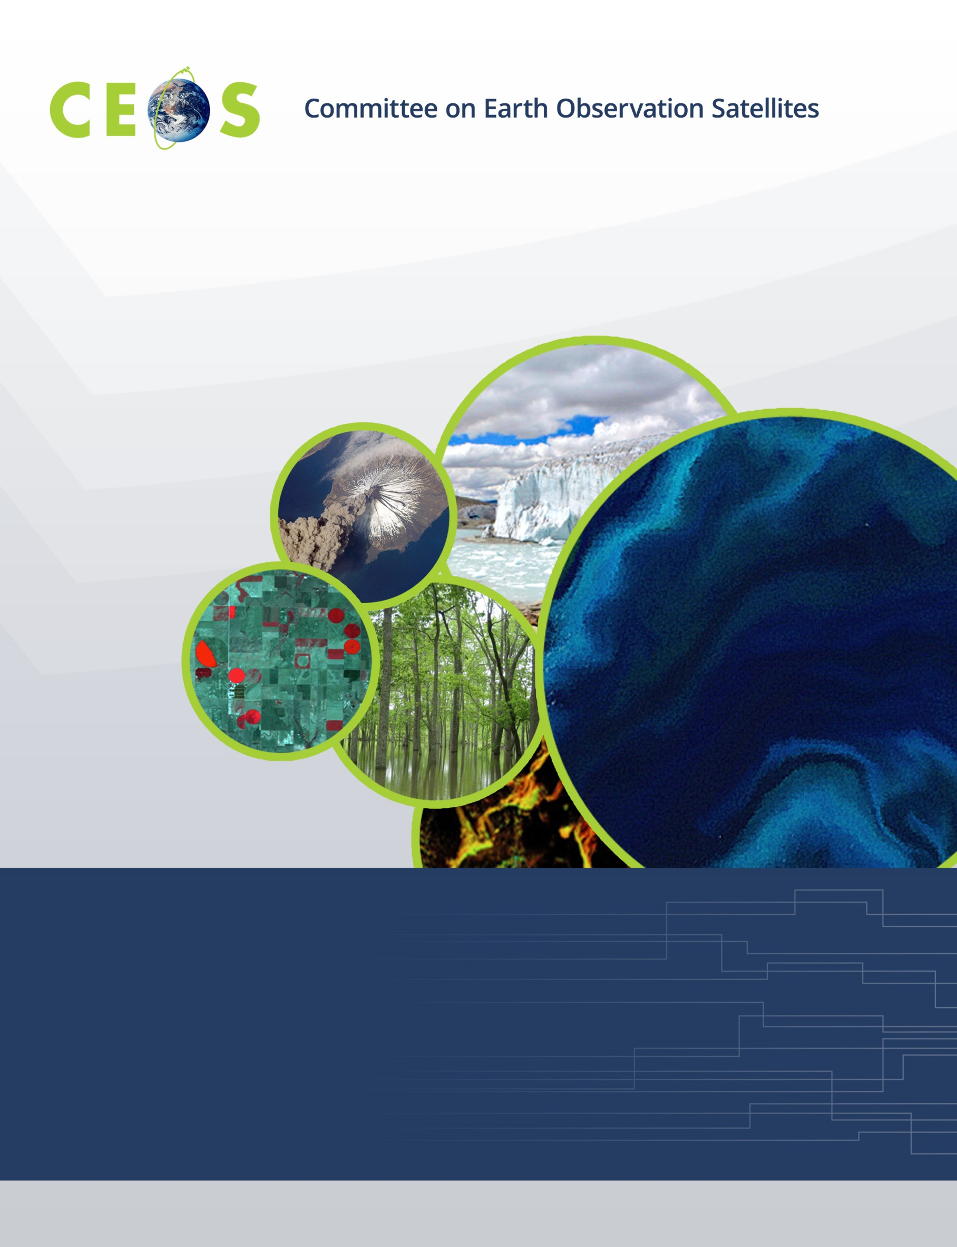

# 

# 

**Working Group on Calibration and Validation**

**CEOS WGCV Plenary #42, Sioux Falls, USA**

**Hosted by EROS Data Center, USGS**

**May 16-18, 2017**

**Agenda**

**Version 2.0 May 16, 2017**

Monday, May 15, 2017

## WGCV Attendees Arrive at Holiday Inn

#### WGCV Business

13:00 Chair available for splinters and pre-meetings

Tuesday, May 16, 2017 – EROS Data Center

Meet in Holiday Inn lobby for transit to EROS Data Center

7:30 Bus leaves for EROS Data Center

8:00 Security Paperwork and Registration

Coffee, light refreshments

## 09:00 Convene

#### WGCV Business and Meeting Introduction

09:00 Chair/Vice Chair welcome and opening *K. Thome/C. Ong*

09:15 Tour de table *All*

09:30 Logistics G. *Stensaas*

09:45 Welcome to EROS Data Center *Frank Kelly*

*Director, EROS Data Center*

*2016-2017 CEOS Chair*

10:15 Meeting overview, goals, and agenda approval *K. Thome*

## 10:30 Break

10:45 EROS Tour

11:30 WGCV Chair’s Report *K. Thome*

#### CEOS Chair Initiatives and Related Efforts

12:00 Land Surface Imaging Virtual ConstellationI (LSI-VC) *J. Lacey (LSI-VC co-chair)*

## 12:30 Lunch – WGCV-42 Photo

13:30 Moderate Resolution Interoperability *G. Fosnight (MRI co-lead)*

14:10 Future Data Architecture and Data Cubes *S. Labahn (FDA team co-lead)*

14:40 LC-MAP *J. Dwyer (WG-Climate)*

## 15:00 Break

15:20 LSI-VC collaboration/CEOS initiatives Discussion *All*

16:20 LPCS segment *K. Gallo (LPCS co-lead)*

16:30 USGS Calibration Center of Excellence *D. Helder*

16:45 New generation meteorological satellite *A. Kuze*

17:00 Round Table discussion of WGCV role in MRI, FDA, etc. *All*

## 17:30 Adjourn

17:30 Transit back to hotel

## 18:30 Gathering at Falls Overlook Café, Falls Park

Wednesday, May 17, 2017 – South Dakota State University

7:15 Meet in Holiday Inn lobby for transit to South Dakota State University

8:30 Arrive SDSU

## 09:00 Convene

#### WGCV Business

09:00 Day 1 summary *K. Thome*

09:15 SDSU welcome *D. Helder*

09:30 WGCV Action Item Status/CEOS Work Plan Status *K. Thome*

## 10:30 Break

#### Subgroup reporting

MW Sub-Group report on Thursday to accommodate travel

11:00 ACSG Sub-Group Report *J-C Lambert*

11:20 IVOS Sub-Group Report *N. Fox*

11:40 LPV Sub-Group Report *M. Roman*

12:00 ACIX Report *P. Goryl/K. Thome*

## 12:20 Lunch

#### Subgroup/Task Team reporting, cont’d.

13:20 SAR Sub-Group Report *B. Chapman (Remotely)*

#### Agency Reports

13:40 BelSpo *J-C Lambert*

13:55 JAXA *A. Kuze*

14:10 CSIRO *C. Ong*

14:25 GA *M. Thankappan*

## 15:00 Break

15;30 ISRO *A. MisraRay*

15:45 USGS *G. Stensaas*

16:00 NASA *K. Thome*

#### WGCV Business

16:15 RadCalNet Update *N. Fox/P. Goryl/K. Thome*

16:30 RadCalNet/LandNet process for adding new sites *N. Fox/C. Ong /K. Thome*

## 17:00 Adjourn -

## Reception Hobo Gallery, SDSU

19:00 Bus departs for hotel

Thursday, May 18, 2017– Sioux Falls Meeting Center

Enjoy added time to sleep (or work for those awake from jet lag)

## 09:00 Convene

#### WGCV Business

09:00 Day 2 Summary *K. Thome*

09:10 MW Sub-Group Report *X. Dong*

#### Agency Reports

09:30 NSSC *X. Dong*

09:45 DLR *A. von Bargen*

10:00 UKSA *N. Fox*

10:15 CNES *P. Henry*

## 10:30 Break

11:00 ESA *P. Goryl*

11:15 NOAA *T. Choi*

11:30 USGS report on LandsatSentinel intercomparison *R. Morfitt*

11:45 EUMETSAT *R. Munro*

#### WGCV Collaborations

12:00 GSICS from the Perspective of the UV Subgroup *R. Munro*

12:20 GSICS Solar Irradiance Spectrum *N. Fox*

## 12:40 Lunch

13:40 Pre-launch calibration workshop *K. Thome*

13:50 GCOS implementation plan and WG Climate Actions *A. von Bargen/K. Thome*

#### Task Group Reports

14:10 DEM Update and discussion *D. Gesch*

14:40 Cloud Mask Update and discussion *K. Thome*

## 15:00 Break

#### Carbon Actions

15:30 LPV and Biomass *M. Roman*

16:00 Cal & VAL for Greenhouse gases observation spectrometers *A. Kuze*

16:20Carbon actions for WGCV *K. Thome*

## 17:15 Adjourn

Friday, May 19, 2017

## 09:00 Convene

#### WGCV Business

09:00 Day 3 Summary *K. Thome*

09:30 WGCV Work Plan Update A. *von Bargen/K. Thome*

09:50 Proposal for regular WGCV telecons *K. Thome/C. Ong*

10:10 WGCV Newsletter and other outreach *K. Thome/J. Nickeson*

## 10:30 Break

11:00 Future Meetings; Vice Chair *K. Thome*

11:15 Action Item review *K. Thome*

11:45 Meeting wrap up *K. Thome*

## 12:00 Adjourn