Minutes v1.0
LSI-VC-9 Teleconference #3: CARD4L and the Product Family Specifications
Tuesday 12 May 2020

Participants
CONAE: Danilo Dadamia
ESA: Ferran Gascon
EC/JRC: Zoltan Szantoi
GA: Adam Lewis, Andreia Siqueira, Medhavy Thankappan, Fuqin Li
Labsphere: Chris Durell, Brandon Russell
JAXA: Takeo Tadono, Ake Rosenqvist
KARI: Chiho Kang, Daehoon Yoo
LAPAN: Kustiyo, Danang
LSI-VC Sec: Matt Steventon
NOAA: Kevin Gallo
SEO: Brian Killough
UK Catapult for UKSA: Electra Panagoulia
University of Zurich: David Small
USGS: Steve Labahn (Chair), Jenn Lacey, Tim Stryker, Chris Barnes
The presentation slides compiled for this meeting are attached in Appendix A.
Introduction
- Steve Labahn (USGS, LSI-VC Co-Lead, Chair) welcomed everyone to the third call of the LSI-VC-9 meeting. PFS updates, the status of CARD4L, and agency plans with regard to CARD4L are the focus for today’s call.
PFS Updates
- Andreia Siqueira (GA) presented background on the first update cycle for the original three PFS (slides 3-7).
- Feedback was received from various sources and a thorough update process was undertaken. Updates were shared via the LSI mailing lists last week, for review before virtual endorsement. The final documents are available here. Changelogs are available here (also summarised on slides 5-6).
- Andreia requested all feedback to be sent to her by May 22. Virtual endorsement via email is targeted for June 2020.
- Steve thanked Andreia for her great effort coordinating the annual updates of the PFS.
SAR Normalised Radar Backscatter (NRB) CARD4L
- Ake Rosenqvist (JAXA) presented developments in both SAR missions and the user base (slide 9). CARD4L for SAR is particularly helpful at lowering the barrier of entry for users with SAR data, even more so than for optical data.
- The NRB PFS has been updated and the Polarimetric Radar (POL) PFS is to be endorsed for the first time today. Other PFS are in the pipeline (Geocoded SLC, aiming for endorsement in 2021 and Interferometric Radar (InSAR) also targeting endorsement in 2021, perhaps at LSI-VC-11).
- The NRB document has been updated and v4.7 was shared with the LSI-VC mailing list on March 16. No comments were received. Ake proposes endorsement of v4.8 (minor modifications from v4.7 – all outlined in the changelog) today and its adoption as v5.0.
- Ake reviewed the changes to the NRB PFS in v4.8 (see slides 15-16). Overall the format was adjusted to tailor the PFS structure to better fit SAR (rather than the original optical basis). The SAR team has also worked to accommodate cases where multiple observations are used for a product, and in future are seeking to accommodate multi-source inputs.
- He reviewed some different metadata contributions. The SAR PFS team developed a metadata specification to accompany the NRB PFS. It is not mandatory (target requirement). Alignment with IEEE, STAC, OGC, or ISO standards will be considered (possibly by LSI-VC-11). The metadata specification is itself referenced in the PFS as a target requirement for metadata.
- Chris Durell (Labsphere) asked if there is any coordination between CEOS CARD4L and IEEE P4002 and SICD efforts. He noted that Leland Pierce is leading the IEEE P4002. Ake noted there is no coordination yet, but he is very interested in making sure at least the terminology in the PFS is consistent with their terminology. Ake has been contacted by Leland Pierce.
DECISION 01 | Normalised Radar Backscatter (NRB) Product Family Specification v4.8 was endorsed.
LSI-VC-9-04 | USGS to undertake an editorial check of NRB v4.8, before advancing the document to v5.0. Matt to post NRB PFS v5.0 on ceos.org/ard when ready. | ASAP
- Adam Lewis (GA, LSI-VC Co-Lead) commended the great effort of Ake and the whole SAR PFS team. He suggested that the importance of this work is perhaps not recognised as much as it should be in both CEOS and outside. There is great value in reducing the barriers associated with SAR data and the SAR community is doing a great service with this work. LSI-VC should look for further opportunities to flag this effort and communicate the benefits.
- The next big challenge is to encourage agency uptake of the SAR PFS. Ake noted there has been a great shift in acceptance of the ARD concept in the SAR community since this work started.
SAR Polarimetric Radar (POL) CARD4L
- Ake Rosenqvist (JAXA) also presented the initial POL PFS for endorsement.
- POL v2.8 was shared with the LSI-VC mailing list on March 16. No comments were received. Ake proposes endorsement of v2.9 (minor modifications from v2.8 – all outlined in the changelog) today and its adoption as v3.0.
- The POL PFS covers both polarimetric decomposition and polarimetric covariance matrix products. The structure is based on the NRB PFS and metadata specifications were also developed for this PFS. Ake reviewed both types of product (slide 26 and 28) and different types of metadata.
- Sample datasets have been produced but we still need some way to link these long-term on the CEOS ARD website.
- Ferran Gascon (ESA) noted the need to make it clear that these are sample products only. Non-sample products will only be advertised on the CEOS ARD website once they are fully assessed and operationally available.
- Ake added that the target audience for the sample products is the data providers themselves, rather than users. He suggested that agencies could host the data but have it linked on the CEOS ARD website.
LSI-VC-9-05 | Matt and Ake to revisit the action on hosting and linking sample datasets for SAR products on the CEOS ARD website. | ASAP
- Adam Lewis (GA, LSI-VC Co-Lead) asked if CEOS Agencies are looking to produce data to the specifications. Ake confirmed that JAXA are on the way towards this, however with many of the other agencies it is still up to us to persuade them. In many cases mission development has gone on in parallel (e.g., ALOS-4) and the various data processing systems are already set. If CARD4L is not considered from the outset and built into these processing chains, external approaches are necessary (could be software/tool-based solutions).
DECISION 02 | Polarimetric Radar (POL) Product Family Specification v2.9 was endorsed.
LSI-VC-9-06 | USGS to undertake an editorial check of POL v2.9, before advancing the document to v3.0. Matt to post POL PFS v3.0 on ceos.org/ard when ready. | ASAP
Aquatic Reflectance (AR) PFS
- Steve Labahn (USGS, LSI-VC Co-Lead) covered two topics: the AR PFS and Landsat’s provisional AR product (see slides 36-37).
- An initial draft of the AR PFS was completed in January 2020. Various reviews and expert inputs are ongoing and planned. A science expert review is planned by the end of June.
LSI-VC-9-07 | All to consider nominations for the Aquatic Reflectance PFS science expert review, which is planned by end-June. | End-May
- Steve hopes to provide a final draft of the AR PFS for LSI-VC review by the end of July, ahead of its planned endorsement at LSI-VC-10.
- Ferran Gascon (ESA) asked how the Landsat AR product compares to the standard surface reflectance over land. He noted that ESA is planning to have a single product for both land and coasts/inland waters. ESA plans to use the same units for each of these. Steve has also been pushing for an integrated product, but initially they will be handled separately. The products will however be in the same units (unitless).
- Steve noted the backup slides (80-83) on the measurement approach.
LSI-VC-9-08 | Steve to send Ferran some more information regarding how USGS is handling the Landsat Aquatic Reflectance provisional products and how the approach differs from land cover observations. | ASAP
- Ferran also asked whether there is any coordination with OCR-VC on the AR PFS. Steve would like to involve them in the science expert review and he is also closely coordinating with the CEOS-COAST project, which could be a key source of feedback.
- Ferran noted the ACIX-Aqua exercise which is comparing different approaches for Landsat and Sentinel-2 over aquatic environments.
Status of CARD4L Datasets
- Matt Steventon presented an overview of the status of CARD4L assessments, expected future assessments, efforts to produce CARD4L and ARD, and some issues (slides 38-45). He noted that data is often fragmented across the world with many different datasets, locations and access options. Commitment to global, top-down production is needed, otherwise users are left to create subsets of CARD4L themselves in an ad hoc manner. Data accessibility is also key, and cloud hosting of CARD4L is particularly efficient in this regard. He asked about the prospect of increasing cloud availability of agency-produced CARD4L.
- Matt suggested two actions for LSI-VC along these lines: to see if NASA could consider the possibility of assessing MODIS and VIIRS products against the CARD4L specifications – noting industry demand on informal consultation call, and for LSI-VC to encourage a Sentinel-1 CARD4L assessment by ESA.
- Brian Killough (NASA, SEO) reported on efforts he has undertaken to get an analysis-ready form of Sentinel-1 NRB. He originally contracted e-GEOS to pre-process the data, but this has fallen through. He is now working with Sinergise for Sentinel-1 processing. The intent is to establish an on-demand cloud processing flow for Sentinel-1 data to supply various Data Cube instances. Part of the contract will include looking at CARD4L compliance of the resulting products.
- Adam Lewis (GA, LSI-VC Co-Lead) reported that Element 84 are contracted by Digital Earth Africa to process Sentinel-2 into COG and STAC format, and to undertake a CARD4L assessment for this data.
- Ake Rosenqvist (JAXA) reported that the Geocoded SLC PFS (GSLC, in development) is based on the NISAR product documentation. He believes that CARD4L GSLC will be based on the NISAR products to a large extent, so we expect that to have CARD4L compliance.
- Medhavy Thankappan (GA) reported on the CARD4L compliance of Digital Earth Australia products. GA’s Landsat Collection 3 should meet all the requirements for the Threshold level of CARD4L. GA’s Sentinel products will inherit what comes from ESA.
LSI-VC-9-09 | LSI-VC Leads to coordinate a communication from LSI-VC to EC/Copernicus regarding the need for Sentinel-1 NRB CARD4L as a core product, citing examples of various ad hoc efforts ongoing to create Sentinel-1 NRB CARD4L – as evidence of demand for this type of product.  Zolti to confirm the best approach from the EC side (convincing Copernicus services of utility could be an approach). | ASAP
LSI-VC-9-10 | Brian and Adam to share their Sentinel-1 NRB CARD4L examples (e.g., Sinergise, DEAfrica, other use cases) to help inform the communication called for in action LSI-VC-9-08. | ASAP
LSI-VC-9-11 | Steve/USGS to follow up NASA LSI-VC contacts regarding the possibility of assessing MODIS and VIIRS products against the CARD4L specifications. | ASAP
WGCV CARD4L Peer Reviews
- Medhavy Thankappan (GA) reported an update on the WGCV CARD4L peer review process and the status of the Landsat and Sentinel-2 assessments (slides 47-54). He noted a summary of feedback from the CARD4L evaluations (slide 55) and suggested that the LSI-VC Leads and Andreia schedule a teleconference with WGCV representatives to review this feedback.
LSI-VC-9-12 | Andreia to set up a telecon between the LSI-VC Leads and WGCV contacts to review the points on slide 55 of the LSI-VC-9 Telecon #3 presentation (Summary of Feedback from CARD4L Evaluation). | ASAP
- Steve Labahn (USGS, LSI-VC Co-Lead) thanked Medhavy for his effort on the process and thanked WGCV for the support.
USGS CARD4L Update
- Steve Labahn (USGS, LSI-VC Co-Lead) presented an update on USGS Landsat Collection 2, the CARD4L self-assessments for Collection 2, and trials with Amazon Web Service hosting and processing of this data (slides 57-64).
- He confirmed that USGS will provide tools like EarthExplorer and a machine-to-machine gateway on AWS. If users take advantage of these systems, USGS will cover any egress costs. If users choose to use their own tools, there may be egress costs associated with using Collection 2 on AWS.
- Digital Earth Africa was used as a test for trial production of ARD. The first scaling test processed 183,077 Landsat 8 scenes from 2013-2019 over Africa to Level-2 for approximately $5700 USD.
JAXA CARD4L Update
- Takeo Tadono (JAXA) presented an update on JAXA’s EO mission portfolio, the ALOS series, and the global mosaics and forest/non-forest maps (slides 65-71). Takeo noted various re-processing efforts to reach CARD4L compliance with the mosaics, and also the planned release of CARD4L format conversion software for scene-based PALSAR and PALSAR-2 data.
- Steve Labahn (USGS, LSI-VC Co-Lead) commended the effort to release conversion software to help users produce CARD4L compliant data. He added that the re-processing effort is resource intensive but should pay off, noting USGS’ similar reprocessing efforts.
Digital Earth Africa Update
- Adam Lewis (GA, LSI-VC Co-Lead) presented on Digital Earth Africa (slides 72-77).
- Digital Earth Africa is based on the Open Data Cube model and depends on having a reliable supply of CEOS ARD. It uses continental-scale CEOS ARD, including the ALOS mosaics, provisional Collection 2, and self-processed Sentinel-2 CARD4L (through Element84, not officially assessed as CARD4L). They are also working on establishing a pipeline for Sentinel-1 CEOS ARD (not officially assessed).
- To have impact, Digital Earth Africa needs to be able to produce operational full-resolution products like fractional cover or median surface reflectance in order to generate unique continental-scale information like continental water summaries or continental assessments of coastal changes.
- Adam presented on the data supply chains necessary for Digital Earth Africa and what the project is doing to establish flows of Sentinel data:
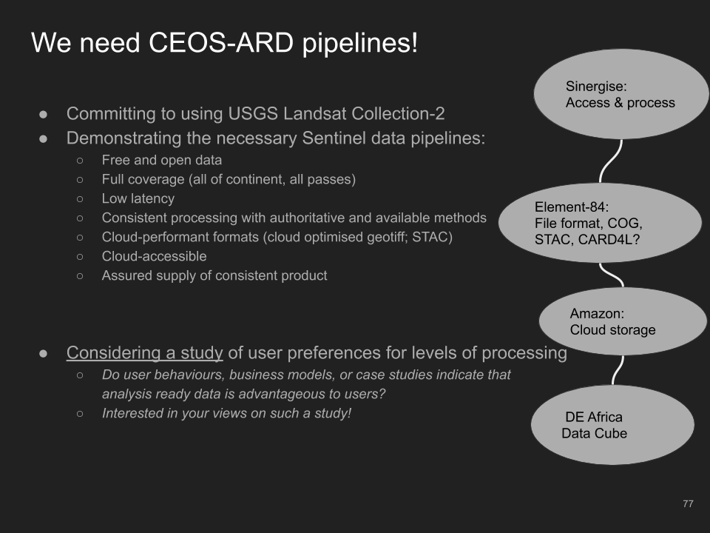
- He noted the importance of the action recorded earlier (LSI-VC-9-08) on putting together a case for data providers such as EC / ESA encouraging them to establish routine, global supplies of Analysis Ready Data. The proposed study of user preferences for levels of processing would be additional evidence for such requests.
- Ake Rosenqvist (JAXA) supported the idea of such a study, but noted that all we are trying to achieve with CARD4L is improving the radiometric and geometric quality of data – which should be welcomed by all users.
- Steve Labahn (USGS, LSI-VC Co-Lead) noted some statistics from the USGS ESPA system that shows Level-2 data is more in demand than Level-1. Adam said there is also evidence from the Copernicus Sentinel data access annual reports that is consistent with this statement.
- Users are relying on ESA, USGS, JAXA, etc. to produce these globally available data supplies.
- Ferran Gascon (ESA) noted that ESA is planning to meet the CARD4L threshold level with their Level-2A data in 2020. The next big step to reach an ideal level of support for projects like Digital Earth Africa would be back-processing of the entire archive to Level-2A, which is foreseen to start next year.
- Ferran added that ESA is reviewing COG internally, due to strong user demand. ESA is also reviewing the possibility of adding STAC for Sentinel-2. Further examples of user demand for both of these technologies would be helpful.
LSI-VC-9-13 | Steve to share USGS Collection 2 work done around COG and STAC (including the format study, slides from ARD19) to support other agencies interested in working in this direction (e.g., ESA/Ferran, EC/Zolti) – including any user feedback / examples of demand. Inputs from others are also welcome.  Context: Zolti noted the Copernicus User Requirements Reviews and the need for supporting evidence to initiate new work around topics like COG, STAC, etc. | COMPLETE
- Ferran reported that there is an ESA activity to investigate a Sentinel-1 ARD product, but there is nothing in the pipeline regarding systematic global production of such an ARD product. Adding a new standard product for Copernicus needs to be agreed by ESA and EC, and this is a lengthy process involving upper management, member states, users, etc. Copernicus is user-driven, and users are represented by the member states. Anything requested by the Copernicus Services are top priorities. Convincing Copernicus Services of the utility of Sentinel-1 CARD4L could be an approach. LSI-VC action on this topic is captured in action LSI-VC-9-08 above.
Closing
- Steve Labahn (USGS, LSI-VC Co-Lead) thanked everyone for their attendance and contributions to the discussions. He welcomed further updates on agency CARD4L plans via email. There may also be time during LSI-VC-9 teleconference #4.
- LSI-VC-9 Teleconference #4: LSI-GEOGLAM, LSI-Forests & Biomass, CEOS ARD Strategy, Loose Ends & Wrap-up will be held on May 13, 07:00 – 10:00 US East (other local times) [Presentation].
Appendix A: Meeting Presentation Slides
