17th Meeting of the CEOS Virtual Constellation for Land Surface Imaging (LSI-VC)
14-16 April 2025
Hosted by the Japan Aerospace Exploration Agency (JAXA)
JAXA Tsukuba Space Center, 2-1-1 Sengen, Tsukuba-shi, Ibaraki 305-8505 Japan
Meeting Room A, 2nd Floor in C-1. Headquarters Building

Meeting link: https://ceos.my.webex.com/meet/ceoswebex1

Meeting number: 2554 498 5768
Additional teleconference details can be found on the last page.

Meeting Objectives
Specific objectives of the LSI-VC-17 meeting include:
Advancing the CEOS-ARD Framework
- Review the initial implementation of the CEOS-ARD Product Family Specification (PFS) requirements in GitHub as modular ‘building blocks’ and discuss an appropriate governance framework and licensing arrangement. Confirm objectives and responsibilities for the next phase of development in the CEOS-ARD GitHub.
- In creating this set of unique ‘building blocks’ there has been an effort to consolidate similar requirements (including terminology, grammar) across the PFS for consistency and simplicity. We will review the initial round of consolidation suggestions and chart a timeline and actions to bring this consolidation to completion. There is also substantial feedback from the update of the Aquatic Reflectance PFS that needs to be taken into account in this consolidation and development of common building blocks.
- Agree to an update of the CEOS-ARD Framework to implement the new processing level matrix described here (page 32) and clarify our top-level categorisation of PFS (by sensor / wavelength / geophysical product / etc.). Describe in the updated CEOS-ARD Framework a processing Level based schema for new PFS and product types. The goal is to clearly define what we mean by levels in the context of CEOS-ARD and create a logical schema for PFS to fit into – clarifying the potential for CEOS-ARD PFS that go beyond the traditional ‘Level-2’, and how these higher level products relate to the lower level CEOS-ARD. Such a structure will allow us to start communicating and addressing the various calls for higher-level products from CEOS agencies, such as those in relation to EAVs, EBVs, etc. We will also consider the example of the NASA/JPL InSAR displacement product.
- Discuss the work of the WGISS Technology Exploration Interest Group (TEIG) to assess the AI/ML readiness of CEOS-ARD and decide whether any necessary changes or avenues of development are needed within CEOS-ARD.
- Discuss whether the optical PFS should adopt the approach of the SAR PFS in encouraging (as a Goal requirement) a single, consistent metadata file that addresses the requirements in a clear and concise manner, to ease the assessment process.
New CEOS-ARD Product Family Specifications
- Endorse Version 2.0 of the Aquatic Reflectance CEOS-ARD PFS, which has been updated by OCR-VC and IOCCG experts to include consideration of open oceans – expanding its scope beyond coastal and inland waters. Discuss feedback resulting from the update which encourages a reconsideration of requirements and structure that exists across the portfolio of optical PFS. This feedback on the fundamental structure / requirements of CEOS-ARD requires consideration in the context of all other PFS and is a timely input to the consolidation and ‘building block’ processes described above.
- Endorse an update of the Combined CEOS-ARD for Synthetic Aperture Radar PFS to include new requirements for Interferometric Radar (InSAR) products.
- Review and agree on the combined optical PFS requirement definitions. During the combined optical PFS exercise several requirement definitions with similar wording were consolidated into a universal requirement that applied across all three optical PFS. It would be a useful exercise to ensure this has not introduced any unintended deviations from the initial purpose of those requirements before a combined optical PFS is baselined.
CEOS-ARD and Data Quality
- Discuss the need for a future iteration of CEOS-ARD that introduces higher requirements for data ‘quality’, including for metadata (e.g., cloud mask issues discussed at LSI-VC-16), measurand uncertainties, and the introduction of tolerances and bounds for corrections, as well as a framework for ongoing monitoring of these qualities (i.e., not just for sample data submissions).
- Hold a joint session with WGCV experts to explore the utility of a greater connection between the Cal/Val Maturity Matrix (QA4EO heritage, used by the Joint Earth Observation Mission Quality Assessment Framework noted below) and CEOS-ARD for the purposes of describing data quality metrics, fitness for purpose, traceability, and uncertainties. Consider the Quality factor of the new WGISS Interoperability Handbook v2.0.
- Discuss the ‘Match-up Database’ activity under WGCV, its role in data quality assessments (including for CEOS-ARD) with a particular focus on serving the commercial sector, and the potential for integration of CEOS-ARD into the activity.
Increasing Commercial Sector Uptake of CEOS-ARD
- Hold a discussion on the Joint Earth Observation Mission Quality Assessment Framework – which is being used by NASA and ESA, specifically the NASA Commercial Satellite Data Acquisition (CSDA) and ESA Earthnet Data Assessment Pilot (EDAP) programmes as an objective framework with which to assess the data quality of commercial EO data sources – and the possibilities for CEOS-ARD in relation to this framework. Invite NASA CSDA and ESA EDAP representatives to share their work, experiences, and thoughts on CEOS-ARD and explore with them the possibility of greater connection between their work and CEOS-ARD. Discuss the role of CEOS-ARD as a tool for data procurement more generally, including as a common benchmark for data providers. Discuss the importance of formal standards to these programs and the commercial sector more broadly.
- Develop the proposal from LSI-VC-16 regarding LSI-VC providing a framework and interface for CEOS agencies that are interested in ‘buying out’ old commercial archives and then releasing the data under creative commons licensing (LSI-VC-16-03) and including CEOS-ARD as a key part of that procurement process. Discuss a mechanism for CEOS agencies to catalogue and identify archive buyout opportunities. This would be an ongoing job for LSI-VC to track and support.
- Resolve issues related to high resolution datasets and optical mosaics in CEOS-ARD, which inherently limits commercial sector participation. The former issue impacts both the RTC SAR products as well as optical products (specific sub-pixel accuracy requirement).
- Agree LSI-VC-18 location in Europe (tentatively EC/JRC in Ispra, Italy, from 3-5 September 2025) and discuss opportunities for engaging the European commercial sector at this occasion.
Increasing CEOS Agency Participation
- Brainstorm a list of high priority CEOS-ARD dataset candidates that should be encouraged from CEOS agencies. The aim is to both increase the CEOS-ARD portfolio but also bolster agency technical staff participation in LSI-VC and CEOS-ARD.
- Discuss a plan for CEOS-ARD dataset continuity timelines built upon the CEOS MIM Database and CEOS-ARD datasets table.
CEOS-ARD Community Consultation
- Reconnect with Japanese commercial sector contacts from LSI-VC-15 and others to gather feedback on the current state of CEOS-ARD, what they value in the current iteration of CEOS-ARD and what is needed in future evolutions. We will call on the community to help us understand the headline priorities for the future of CEOS-ARD and to lay the basis for a consultation paper that will kick-start a new phase in CEOS-ARD.
- Refine the plans for CEOS-ARD representation at various events throughout 2025 including ESA’s Living Planet Symposium (June, Vienna), IGARSS (August, Brisbane), and the International Astronautical Congress (IAC) 2025 (Sept/Oct, Sydney).
Thematic Topics
- CEOS AFOLU Roadmap actions: discuss the practicalities of their implementation and stewardship through the LSI-VC Forests and Biomass Subgroup. LSI-VC will reflect upon the discussions from the SIT-40 meeting and discuss the composition of the LSI-VC.
- Review outcomes of the Ramsar Convention on Wetlands EO consultation and EO Day and discuss impacts on LSI-VC.
- Revisit the quad-pol and multi-frequency data requests from the ESA POLINSAR Workshop 2023 and the CEOS response following the presentations to CEOS SIT-39 and SIT Technical Workshop 2024.

Meeting Location
LSI-VC-17 will be held at JAXA’s Tsukuba Space Center (TKSC), 2-1-1 Sengen, Tsukuba-shi, Ibaraki 305-8505 Japan
Meeting Room A, 2nd Floor in C-1. Headquarters Building
https://global.jaxa.jp/about/centers/tksc/index.html
Access: https://global.jaxa.jp/about/centers/tksc/files/traffic_e.pdf

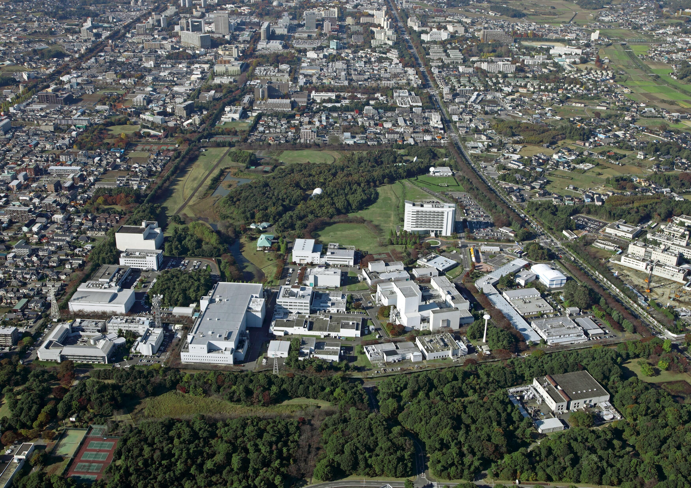

Some Accommodation Options
Hotel Grand Shinonome
https://www.hg-shinonome.co.jp/english/
This hotel has been tentatively reserved for the group. If you wish to stay, please make your own reservation by email. Email for booking: tomari@hg-shinonome.co.jp Please indicate “JAXA Meeting Participant” in your booking email.
West Tower Single: 8,800 JPY/night (no breakfast), 10,340 JPY/night (with breakfast)
Other types of room can be arranged if requested.
Access: https://www.hg-shinonome.co.jp/english/access.html
If there are many guests in the hotel, daily bus service to TKSC will be arranged.
Hotel Nikko Tsukuba
https://www.nikko-tsukuba.com/eng/
Daiwa Roynet Hotel Tsukuba
https://www.daiwaroynet.jp/en/tsukuba/

Transportation
Tsukuba is accessible by train from central Tokyo (Akihabara/Asakusa) and takes about 60 minutes on the 'Tsukuba Express': Please take the Tsukuba Express “Rapid” or “Sub Rapid” train bound for Tsukuba Station.

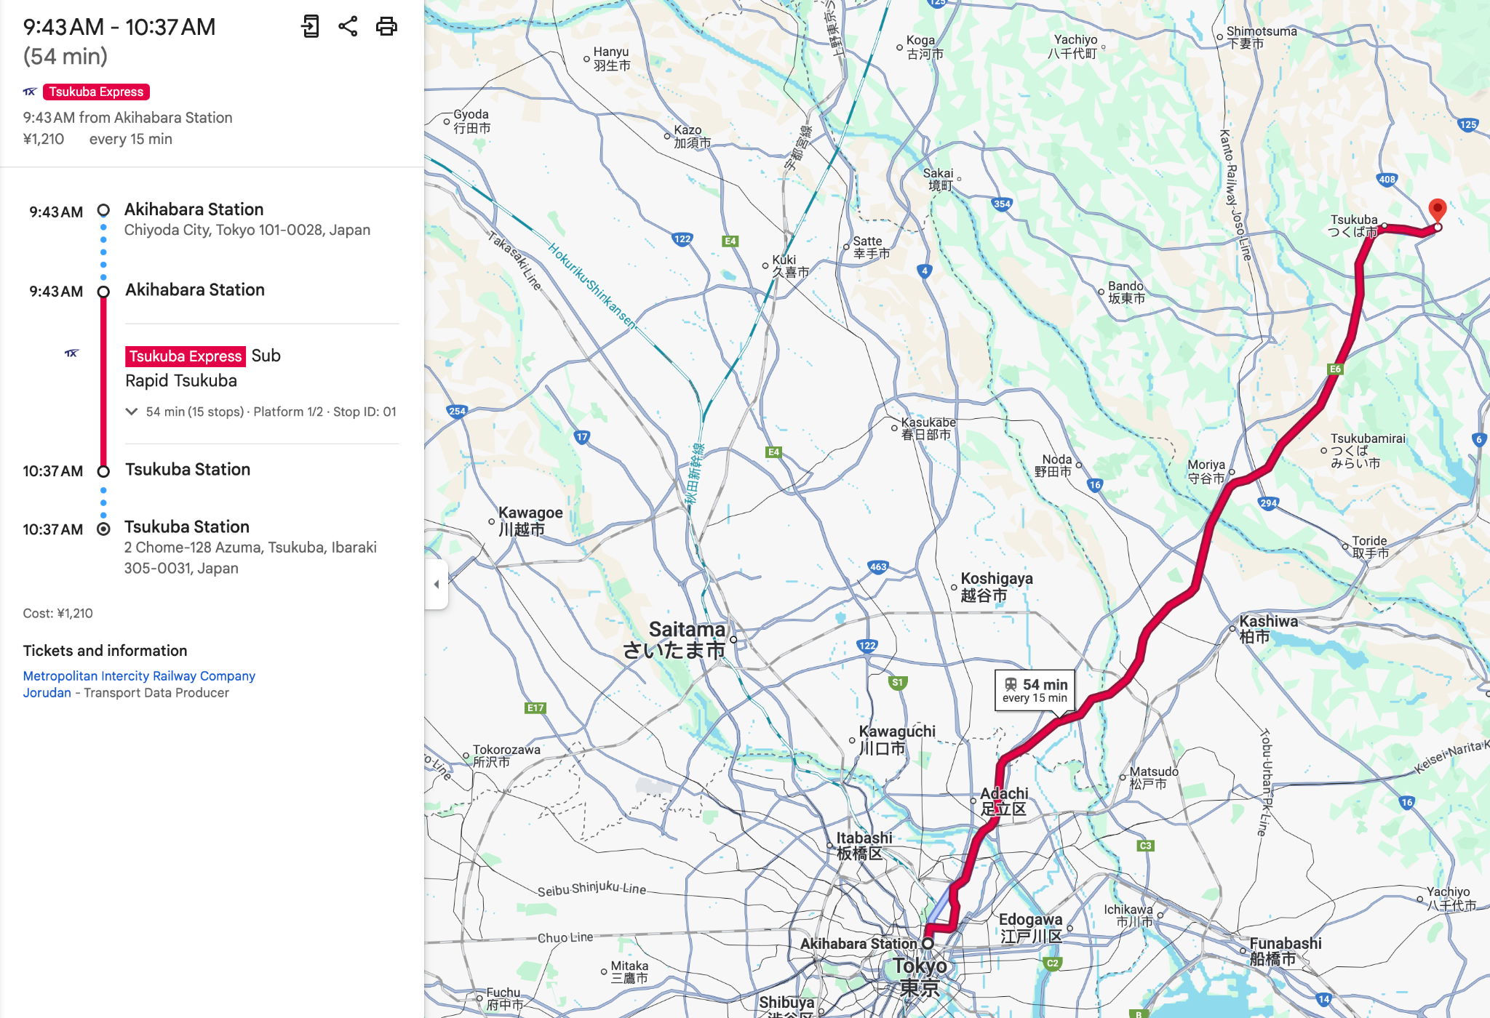

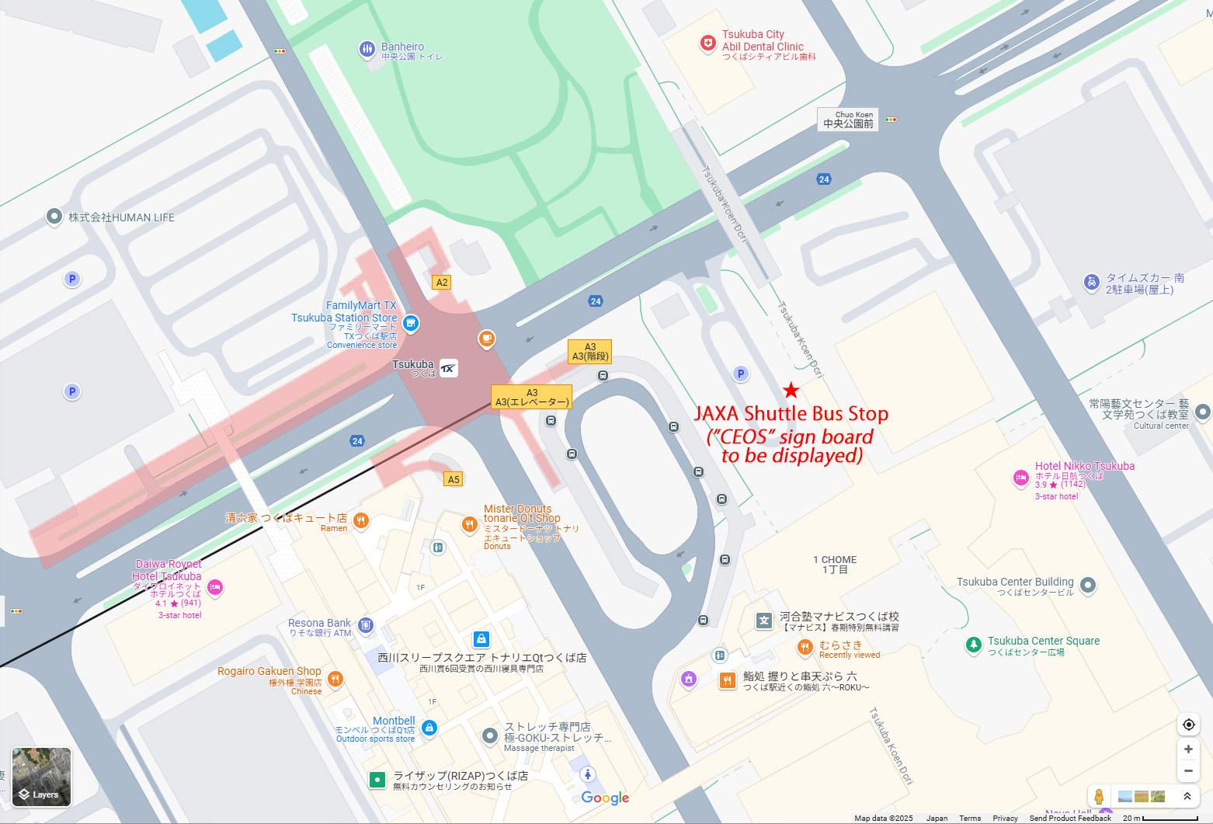
Enlarged map of the Tsukuba Station area. The JAXA shuttle bus for LSI-VC participants to the Space Center (TKSC) will depart from the area near red-★ on the map (in the parking lot on the ground level). The bus departs at 9:30 every morning, so please do not be late.
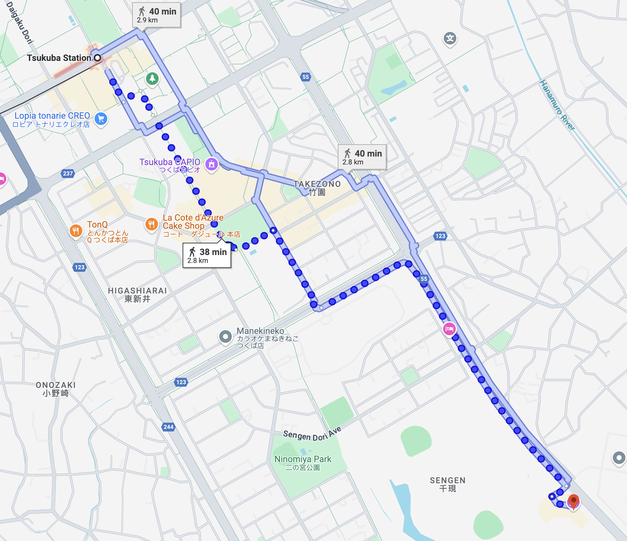
If you miss the JAXA shuttle bus, it is then a (pleasant!) 40-minute walk from the Tsukuba station to the JAXA Space Center. We recommend taking a bus or taxi from Tsukuba Station of the Tsukuba Express.

Agenda

Monday April 14
Location: Meeting room A (HQ bldg. 2F)
Meeting link: https://ceos.my.webex.com/meet/ceoswebex1
Meeting number: 2554 498 5768
Arrival / Teleconference Open  Meeting teleconference connection will be open for testing.  The shuttle bus to the Space Center (TKSC) departs from Tsukuba Station at 9:30 |  | 09:55 | 5 min
Session 1: Welcome and Introductions
1.1 | Welcome from Hironori Maejima (JAXA, CEOS SIT Chair) | 10:00 | 15 min
1.2 | Welcome [slides]  Takeo Tadono (JAXA), Matt Steventon (LSI-VC Secretariat) and LSI-VC Co-Leads  - Opening remarks  - Roundtable of introductions  - Meeting overview | 10:15 | 15 min
Session 2: CEOS Analysis Ready Data (CEOS-ARD)
2.1 | Addition of Interferometric Radar (InSAR) products to the combined CEOS-ARD PFS for Synthetic Aperture Radar (For Endorsement) [slides]  Ake Rosenqvist (JAXA)  2.1 CEOS-ARD_PFS_Synthetic_Aperture_Radar_v1.2_annotated.pdf2.1 CEOS-ARD_Metadata-spec_Synthetic_Aperture_Radar_v1.2.xlsx | 11:00 | 30 min
2.2 | Version 2.0 of the Aquatic Reflectance CEOS-ARD PFS (For Endorsement) [slides]  Arnold Dekker (CSIRO)  CEOS-ARD Aquatic Reflectance PFS v2.0 Candidate DRAFT (14 March 2025) | 10:30 | 30 min
2.3 | CEOS-ARD Datasets and Continuity (For Discussion)  Matt Steventon (LSI-VC Secretariat)  2.3 Potential CEOS-ARD datasets  - Brainstorming a list of high priority CEOS-ARD dataset candidates that should be encouraged from CEOS agencies and other data providers  - Ideas for LSI and CEOS-ARD dataset continuity timelines built upon the CEOS MIM Database  - Improved regular reporting to CEOS leadership regarding gaps and requirements  - Action for a roadmap of CEOS-ARD dataset targets | 11:30 | 15 min
 | Buffer time | 11:45 | 15 min
Lunch |  | 12:00 | 60 min
Session 3: CEOS-ARD Framework Considerations
3.1 | Proposal for a CEOS-ARD Framework update [slides]  Peter Strobl (EC/JRC) and Matt Steventon (LSI-VC Secretariat)  Reference Presentation: Semantics and Architecture in ARD (Strobl)  - Examples of NASA/JPL InSAR displacement product (+ higher level products in pipeline) (Ake)  - Action an update of the CEOS-ARD Framework doc | 13:00 | 60 min
3.2 | WGISS Analysis of AI/ML readiness of CEOS-ARD and Suggestions for the CEOS-ARD PFS and Framework [slides]  Yousuke Ikehata (JAXA) | 14:00 | 45 min
Break |  | 14:45 | 15 min
Session 4: CEOS-ARD and Data Quality
4.1 | Data quality findings and issues from the CEOS-ARD assessment process [slides]  Peter Harrison (Geoscience Australia) | 15:00 | 30 min
4.2 | European perspectives (ESA EDAP, TPM, CCM) [slides]  Leonardo De Laurentiis (ESA)  - Joint Earth Observation Mission Quality Assessment Framework  - Role for CEOS-ARD as a benchmark / pre-qualification step  - Assessing dataset quality | 15:30 | 40 min
4.3 | WGCV Capabilities for Data Quality and Connection to CEOS-ARD Framework [slides]  Nigel Fox (WGCV IVOS Chair, NPL UK)  - Cal/Val Maturity Matrix and use in the ESA-NASA Joint Earth Observation Mission Quality Assessment Framework  - Potential role for Cal/Val Maturity Matrix in CEOS-ARD quality metrics  - Match-up Database and potential use for CEOS-ARD quality assessment  - Expressing fitness for purpose | 16:10 | 40 min
4.4 | Proposal and Discussion: Future of CEOS-ARD and Data Quality Considerations [slides]  Jonathon Ross (Geoscience Australia) | 16:50 | 70 min
Adjourn |  | 18:00
Reception hosted by JAXA @ Cafeteria  Shuttle bus to Tsukuba Station departs at the entrance |  | 18:30 - 20:00  20:15

Tuesday April 15
Location: Meeting room A (HQ bldg. 2F)
Meeting link: https://ceos.my.webex.com/meet/ceoswebex1
Meeting number: 2554 498 5768
Arrival / Teleconference Open  Meeting teleconference connection will be open for testing.  The shuttle bus to the Space Center (TKSC) departs from Tsukuba Station at 9:30 |  | 09:55 | 5 min
Session 5: CEOS-ARD for Procurement
5.1 | NASA Commercial Satellite Data Acquisition (CSDA) Program perspective [slides]  Melissa Martin and Dana Ostrenga (NASA CSDA)  - Joint Earth Observation Mission Quality Assessment Framework  - Role for CEOS-ARD as a benchmark / pre-qualification step  - Assessing dataset quality and the role of the Cal/Val Maturity Matrix  - Discussion | 10:00 | 60 min
Session 6: CEOS-ARD PFS Requirements
6.1 | Consistency of Optical CEOS-ARD PFS Requirements [slides]  Chris Barnes (USGS/KBR; remote from USA)  - Objective: Review and agree on the combined optical PFS requirement definitions before formally initiating the building block approach and Github transition  - Review fundamental feedback generated through the Aquatic Reflectance PFS update  - Metadata discussion: Consider optical metadata specification as done on the SAR side | 11:00 | 60 min
Lunch |  | 12:00 | 60 min
Session 7: Commercial Sector Uptake of CEOS-ARD
7.1 | New Space Intelligence [slides]  Masahiko Nagai and Muhammad Daniel | 13:00 | 30 min
7.2 | Discussion session regarding commercial sector uptake of CEOS-ARD [slides]  Moderator: Matt Steventon (LSI-VC Secretariat)  - Objectives and motivations  - Existing engagements and prioritisation  - What are the issues with the current CEOS-ARD PFS and Framework that limit applicability and uptake by the commercial sector  - Decisions: Plans to resolve known issues hindering commercial sector uptake (high resolution data; optical mosaic products)  - Building the business case for CEOS-ARD  - Coordinated, coherent engagement strategy and team of advocates / allies | 13:30 | 75 min
Session 8: JAXA Tsukuba Space Center Site Tour and Exhibition
8.1 | JAXA Tsukuba Space Center Site Tour and Exhibition  - Group photo | 14:45 | 120 min
Adjourn  Shuttle bus to Tsukuba Station departs at the entrance |  | 17:00  17:30
No-host dinner near Tsukuba station / hotels

Wednesday April 16
Location: Meeting room A (HQ bldg. 2F)
Meeting link: https://ceos.my.webex.com/meet/ceoswebex1
Meeting number: 2554 498 5768
Arrival / Teleconference Open  Meeting teleconference connection will be open for testing.  The shuttle bus to the Space Center (TKSC) departs from Tsukuba Station at 9:30 |  | 09:55 | 5 min
Session 9: CEOS-ARD PFS Building Blocks and GitHub Implementation
9.1 | CEOS-ARD Building Blocks Progress [slides]  Matthias Mohr (SEO; remote)  - Progress overview  - Review the technical development roadmap / next steps | 10:00 | 135 min
Lunch |  | 12:15 | 50 min
9.2 | CEOS-ARD Governance and GitHub Implementation [slides: 1, 2]  Christopher Barnes (USGS/KBR; remote from USA) and Matthias Mohr (SEO; remote)  - Clarifying a roadmap and any phases, schedule and milestones towards full implementation  - Governance framework  - Decision/action: CEOS-ARD licensing [slides: 1, 2] | 13:05 | 30 min
Session 10: Agency Reports
10.1 | ESA efforts to improve mission interoperability [slides]  Ferran Gascon (ESA) | 13:40 | 60 min
10.2 | USGS Landsat Collection 3 Status [slides]  Christopher Barnes (USGS/KBR; remote from USA) | 14:40 | 20 min
Session 11: Land Surface Imaging Data Continuity and Availability
11.1 | Discussion: CEOS-GEO interface and LSI-VC role [slides]  LSI-VC Secretariat and Co-Leads | 15:00 | 20 min
11.2 | Develop a proposal regarding LSI-VC providing a framework and interface for CEOS agencies that are interested in ‘buying out’ old commercial archives and then releasing the data under creative commons licensing (LSI-VC-16-03) [slides]  Maggie Arnold (GA)  - Mechanism for CEOS agencies to catalogue and identify archive buyout opportunities. Ongoing job for LSI-VC to track and support.  - Action to start fleshing out a framework | 15:20 | 30 min
Session 12: Agency Reports, SAR, AFOLU
12.1 | Latest activities related to SAR CEOS-ARD products from ISRO [slides]  P.V. Jayasri (ISRO) | 15:50 | 20 min
12.2 | Synthetic Aperture Radar (SAR) Topics [slides]  Ake Rosenqvist (JAXA)  - Revisit the quad-pol and multi-frequency data requests from the ESA POLINSAR Workshop 2023 and the CEOS response following the presentations to CEOS SIT-39 and SIT Technical Workshop 2024  - ICGS-SAR potential transition to SAR-VC. Impact on LSI-VC? | 16:10 | 15 min
12.3 | EO for Wetlands [slides]  Ake Rosenqvist (JAXA)  12.3 Ramsar-SC64_inf2_earth_observation_consultation_e.pdf  - Review outcomes of the Ramsar Convention on Wetlands EO consultation and EO Day and discuss impacts on LSI-VC | 16:25 | 20 min
12.4 | CEOS AFOLU Roadmap actions and implementation and stewardship under LSI-VC [slides]  Matt Steventon (LSI-VC Secretariat)  - Naming of the F&B subgroup?  - New Terms of Reference?  - Overall management of the AFOLU work | 16:45 | 10 min
12.5 | JAXA ALOS-4 update [slides]  Takeo Tadono (JAXA)  12.5_Tadono_JAXA.pptx | 16:55 | 15 min
Session 13: Closing
13.1 | Wrap up  LSI-VC Secretariat and Co-Leads  - Discussion and decision: LSI-VC-18 plans and European commercial sector engagement opportunities  - Closing remarks | 17:10 | 10 min
Adjourn  Shuttle bus to Tsukuba Station departs at the entrance |  | 17:20  17:30

Webex Connection Details
Meeting link: https://ceos.my.webex.com/meet/ceoswebex1
Meeting number: 2554 498 5768
Join from a video conferencing system or application
Dial: ceoswebex1.ceos.my@webex.com
You can also dial 173.243.2.68 and enter your meeting number.
Join by phone
+1-650-479-3208 United States Toll
Access code: 2554 498 5768
Global call-in numbers
https://ceos.my.webex.com/ceos.my/globalcallin.php?MTID=mf31cbd892c421d70ad0a66143bc89fb4

