Minutes v1.0
15th Meeting of the CEOS Virtual Constellation for Land Surface Imaging (LSI-VC)
3-5 April 2024
Hosted by RESTEC / JAXA
Minato-ku, Tokyo

Participants
CONAE: Danilo Dadamia*, Laura Frulla*
CSIRO: Zheng-Shu Zhou*
EC-JRC: Peter Strobl*
Ecosystem Extent Task Team: Gary Geller*, Shaun Levick*
ESA: Ferran Gascon, Francesco Sarti*, Magdalena Fitzyk*
GA: Andreia Siqueira*, Medhavy Thankappan*, Peter Harrison*
GEOGLAM: Alyssa Whitcraft, Sven Gilliams
IEEE: Siri Jodha Khalsa (Univ. of Colorado, Boulder)*
ISRO: Hari Priya Sakethapuram*, Jayashree, Keerthi V*, Mamavalan Ramanujam*, Radhika*, Srikanth, V. , Raghav Mehra*, Usha Sundari*
JAXA: Ake Rosenqvist, Osamu Ochiai, Takeo Tadono
JAXA/RESTEC: Pegah Hashemvand, Mariko Dehara*, Momoko Sumida*, Satoshi Uenuma, Teppei Sato, Toshi Kamei
LSI-VC Sec: Matt Steventon, Stephen Ward, Libby Rose
NASA: Eric Vermote
NASA-JPL: Bruce Chapman*
New Space Intelligence: Dorj Ichikawa, Gaku Saito, Yumiko Nagai
NRCan: Francois Charbonneau
Radiant Earth: Matthias Mohr*
SEO: Dave Borges
USGS: Steve Labahn, Tim Stryker, Chris Barnes, Kelly Bruno, Steve Covington
University of Leicester: Darren Ghent
WGClimate: Wenying Su*
WGISS: Nitant Dube*
Yamaguchi University: Rosalie Reyes, Vaibhav Katiyar

* indicates online

Wednesday, April 3
Session 1: Welcome and Introductions
Welcome [Slides]
Steve Labahn (USGS, LSI-VC Co-Lead) welcomed participants to the meeting, noting that fellow co-leads Andreia Siqueira (GA, LSI-VC Co-Lead) and Peter Strobl (EC-JRC, LSI-VC Co-Lead) will join online. Steve thanked RESTEC and JAXA for hosting the meeting in Tokyo.
Steve invited everyone to introduce themselves. The full list of participants can be found on page 1.
Matt Steventon (LSI-VC Secretariat) reviewed the objectives for LSI-VC-15. LSI-VC-15 will feature a commercial engagement workshop on 5 April 2024, with about six companies joining for discussions related to CEOS-ARD and LSI in general. This is our follow up to the New Space Task Team actions and our own ambition to engage the commercial sector in CEOS-ARD.
Action Review [Doc]
Matt Steventon (LSI-VC Sec) reviewed selected actions from LSI-VC-14 and the team teleconferences since then.
- LSI-VC-14-01: Libby and Matt to prepare an edition of the CEOS-ARD Newsletter on multi-modal applications of CEOS-ARD, starting with the USGS RCMAP and CSIRO NovaSAR examples.
  - CEOS-ARD newsletter has been drafted including case studies from NovaSAR-1. The newsletter will also include the ISRO EOS-4 (RISAT-1A) assessment news.
  - Steve Labahn (USGS, LSI-VC Co-Lead) offered to share some materials on RCMap.
LSI-VC-15-01 | Steve to share an update on RCMAP / multi-modal analyses for the next CEOS-ARD newsletter. | May 2024
- LSI-VC-14-02: Ensure that the discussion on whether georeferenced products might be considered ARD, or is a map projection strictly required, features in the context of the OGC ARD SWG.
  - This has been addressed in the CEOS-ARD specifications but the elevation to OGC specifications remains pending. It was suggested to keep the action open and continue seeking an opportunity to raise the issue in the OGC discussions.
- LSI-VC-14-04: USGS team to follow up with Tom Sohre following the WGISS-56 meeting regarding the discussions there about consistent front-end APIs across CEOS for data search and discovery as an important enabling technology for cross-cloud data access. Also reflect on the SEO’s inputs to WGISS-56 on this topic.
  - This action can be closed. Cross-cloud access for CEOS-ARD will be covered in the frame of the CEOS Interoperability Framework.
  - Steve Labahn (USGS, LSI-VC Co-Lead) noted some notional protocols, perhaps not as specific as needed, have been developed by USGS and ESA.
- LSI-VC-14-08: LSI-VC Leads to summarise options for addressing the issue related to high resolution datasets and the 0.5 pixel rRMSE sub-pixel accuracy requirement of the SR PFS, for debate and decision at LSI-VC-15.
  - Discussions about high-resolution data sets for CEOS-ARD and the sub-pixel accuracy are ongoing. The discussion during the LSI-VC-15 meeting will hopefully address this topic. The action can be closed.
- LSI-VC-14-10: Sarah Cheesbrough (UK Satellite Applications Catapult) to share with USGS and the LSI-VC team: details of the methodology used to assess user needs in the context of the UK EO Data Hub.
  - The action remains open as no updates have been received from Sarah on the UK EO Data Hub.
- LSI-VC-14-11: LSI-VC Leads to reflect on the slides provided by Yves Crevier (CSA) and organise a follow up call to discuss next steps on actions.
  - Slides from Yves Crevier include the RADARSAT R&D challenge. It was suggested that it would fit well under section 5 of the CEOS-ARD strategy. It would be worth following up with Yves Crevier. Matt has added the RADARSAT R&D challenge to the CEOS-ARD Strategy (section 5).
- LSI-VC-14-13: Hari Priya and Zheng-Shu Zhou to connect regarding the NovaSAR CEOS-ARD, seeing if the work done by CSIRO might be transferable to the planned ISRO CEOS-ARD product, for efficiency (give the ISRO team a head start) and to potentially maximise interoperability of resulting products.
  - Remains open. CSIRO has completed their CEOS-ARD assessment. The goal is to work together and avoid duplications. Matt has re-connected ISRO with CSIRO regarding this matter.
- LSI-VC-14-18: Andreia and Dave to ensure the timeline for the update of the CEOS-ARD Industry Engagement Strategy reflects similar engagement activities that will take place in the context of the OGC ARD SWG.
  - It has been agreed that the industry engagement strategy will be a chapter within the CEOS-ARD Strategy. It is not clear how to address this yet and there is no specific timeline.
  - Dave Borges (SEO) suggested communicating the updated CEOS-ARD strategy with the OGC ARD SWG Chairs as well as with Mattias Mohr and others working on community engagement.
- LSI-VC-14-28: Ake to share KMLs for the ALOS-4 PALSAR-3 QP Bi-monthly QP national coverages over SE-Asia (Thailand, Vietnam, Nepal, Laos, Cambodia) and the monthly QP time-series observations over R&D sites with the ESA POLINSAR team.
- LSI-VC-14-29: Ake to collate information about sites where QP or compact pol data are being acquired, for communication with the ESA POLINSAR team.
  - The above two actions can be closed. Ake Rosenqvist (JAXA) will present the results of this discussion this week.
- LSI-VC-14-31: Dave Borges (CEOS SEO) to share information on the CEOS Analytics Lab (CAL) with the ESA POLINSAR team.
  - This is an open opportunity and needs more collaboration. Ake Rosenqvist (JAXA) and Dave Borges (SEO) will have a follow up discussion to ensure the POLINSAR team are aware of CAL and the possibilities for it to support their work.
- LSI-VC-14-33: Alyssa Whitcraft (GEOGLAM) will write a short paper on the GEOGLAM observation requirements, the potential use of the RCA EORES system and MIM Database, and clarify possible next steps and specific requests for CEOS agencies.
  - Papers were submitted for LSI-VC-15 and SIT-39. There is a significant session on April 4 to discuss this topic, ahead of further discussion at SIT-39. This action can be closed.
Session 2: CEOS Analysis Ready Data (CEOS-ARD)
CEOS-ARD Updates and Self-Assessment Reports
CONAE (SAOCOM) [Slides]
Danilo Dadamia reported:
- SAOCOM ARD Software has been implemented on CONAE’s systems. Updated XML metadata files and Sigma0 and Gamma0 products have been processed consistent with CEOS-ARD for Synthetic Aperture Radar specifications.
- Need to implement the reprocessing option in SAOCOM catalogue to complete the process.
- New version of SAOCOM ARD software was developed to incorporate SAOCOM L-Band TopSAR Narrow band and Wide band.
- Examples of Sigma0, Gamma0 and output of auxiliary data were presented.
- All SAOCOM images, independent of the mode, can be produced to CEOS-ARD specification.
Discussion
- Ake Rosenqvist (JAXA) expressed interest in implementing the scripts developed by CONAE on the CEOS Analytics Lab. This would serve as an example of how to produce CEOS-ARD compliant products from lower level data.
- Danilo Dadamia (CONAE) noted that the software is developed in Python using SNAP and can be run on different servers.
- The access options for SAOCOM data are detailed in these slides and below. Availability varies geographically and there are a few different avenues for data access depending on the situation.
LSI-VC-15-02 | Dave and Ake to work with Danilo and the CONAE team to explore implementation of the processes used for SAOCOM CEOS-ARD in the CEOS Analytics Lab as an example. | June 2024
LSI-VC-15-03 | Matt to add SAOCOM to the CEOS-ARD website ’under development’ table, along with NISAR and Sentinel-1 (OPERA products; both RTC and GSLC) and Radarsat Constellation Mission (RCM) products. | May 2024
CONAE Agency Update [Slides]
Laura Frulla (CONAE) reported:
- SAOCOM-1A and 1B are both operational. SAOCOM-1A has exceeded its design lifetime. The repeat cycle is 16 days for each satellite, reduced to 8 days for the constellation.
- Access to SAOCOM data can be done by three methods:
  - Announcement of Opportunity (AO), through the ESA Earthnet Third Party Missions Programme
  - Catalogue - for already existing data. Data inside the ASI exclusivity area can be accessed through ASI, while outside it can be accessed via CONAE.
  - One click possibility:
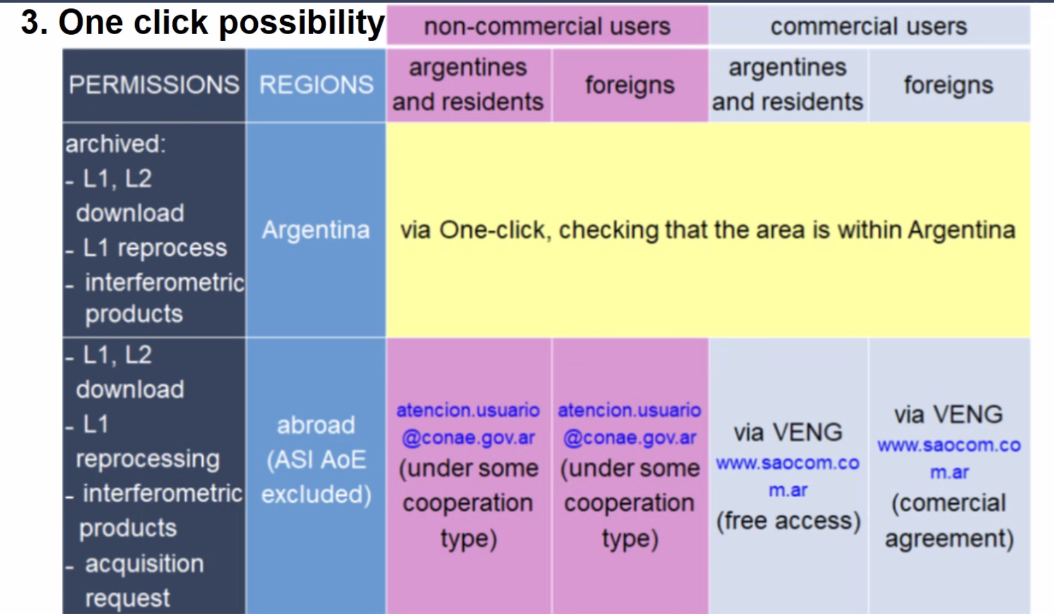
- The baseline mission includes fixed acquisitions for soil moisture and SAR calibration.
- The foreground mission is for variable acquisitions on user request. The ongoing background mission created a useful database, including for biomass, polar zones, and regions of interest for WGDisasters.
- Planned missions for CONAE include SABIA-MAR for ocean observations (launch planned for 2025), and SAOCOM-2 (launch planned for 2029). SAOCOM-2 will have better geometric resolution, operative TOPSAR interferometric products, wide swath modes, better duty cycle, improved Antarctic capacity, among various other improvements.
- A companion is planned for SAOCOM-2 in 2030, for single pass interferometry acquisitions with SAOCOM-2. SAOCOM-3 is planned for 2034 and will include digital beam forming capability.
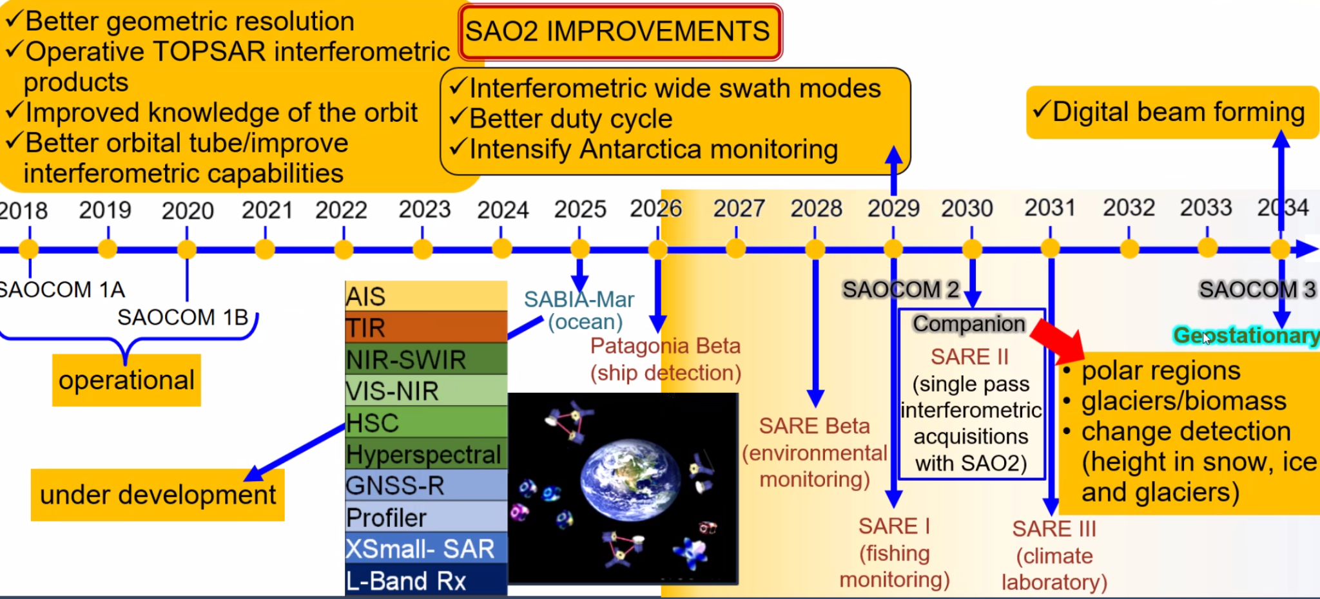
Discussion
- Ake Rosenqvist (JAXA) asked whether the companion smallsat would be capable of full polarimetric reception, particularly for PolInSAR applications.
- Laura Frulla (CONAE) noted that the idea would be for dual polarisation but this has not been decided yet. Currently, CONAE is focusing on preparing specifications for SAOCOM-2, and will later consider the specifications for the companion.
- Matt Steventon (LSI-VC Sec) asked if SAOCOM-2 will have the same cooperation with ASI. Laura said yes and noted that CONAE is advocating for free and open access to data, which is a condition from their side.
- Eric Vermote (NASA) noted the challenges associated with geostationary SAR due to the distance of the orbit.
NASA/JPL (OPERA & NISAR) [Slides]
Bruce Chapman (NASA/JPL) reported:
- The OPERA project, managed by JPL and funded through the Satellite Needs Working Group, aims to produce products required by US government agencies. It is already producing a HLS-based surface water product and Sentinel-1 RTC product.
- A self-assessment of the Sentinel-1 RTC product revealed two issues that made the product non-compliant with CEOS-ARD. These issues are currently being addressed.
- One of the issues pertained to the omission of the "Azimuth Spacing in metres" attribute in the original OPERA RTC metadata hdf5 file. This attribute has now been added to future iterations of the product to meet CEOS-ARD requirements. The omission occurred because the algorithm team recorded the "azimuth time interval" (PRI) and ground velocity from the source SLC but did not record the varying azimuth spacing in metres.
- This value is a threshold requirement of the CEOS-ARD specifications. It is intended to allow users to estimate the number of looks in the RTC multi-look product. The OPERA RTC product has an image layer providing the exact number of looks per pixel.
- NASA has proposed a minor change to the specification, suggesting that the Threshold requirement be either the azimuth spacing (in metres) or the PRI (in seconds) of the source data product, along with other attributes. A Goal requirement has been proposed, surpassing the baseline requirement, which includes a pixel-for-pixel image layer providing the number of looks.
- The second issue is related to section 2.4 “local incidence angle image”. Initially, this image layer was not provided at full resolution, which did not meet the threshold requirement. To address this, OPERA (and NISAR) now plans to provide separate full-resolution static image layers for each image frame. This approach of storing static files separately in the archive from the RTC product has been discussed with the CEOS-ARD team and was provisionally agreed.
- When finding the desired product at ASF, the static layers can also be downloaded, or a link might be provided in the metadata.
- It is now believed that the OPERA RTC product is compliant with the CEOS-ARD specifications.
- The software and metadata of NISAR “GCOV” product is being developed by the same team that produced the OPERA RTC product, and it is therefore expected to be compliant as well.
- OPERA is also producing CSLC products from Sentinel-1 data – a GSLC product. A self-assessment is yet to commence.
- The OPERA S1 RTC product has the VV and VH in a Geotiff cloud-optimised format, with metadata in HDF5 and XML formats, and a separate static layer for the incidence angle and layover/shadow masks in Geotiff format.
- The OPERA S1 CLSC product is in HDF5 format, as with all NISAR products, as HDF5 is standard for NASA archiving.
- While software support for HDF5 exists to some extent in most software (such as gdal), it is not as user-friendly as Geotiff.
- While the data format is not specified for CEOS-ARD, it can be an important factor in whether a data product is ‘analysis ready’ for non expert users. The suitability for cloud use is now a key factor in whether a product is ‘analysis ready’.
- As part of CEOS-ARD activities, it may be worthwhile for LSI-VC to discuss ensuring widely used remote sensing formats and features continue to be supported by the various useful software packages.
- CEOS-ARD built around the concept of making data easier to use and ensuring data is visualisable is a part of this objective. Discussions on data format may warrant consideration as a Goal requirement in future revisions.
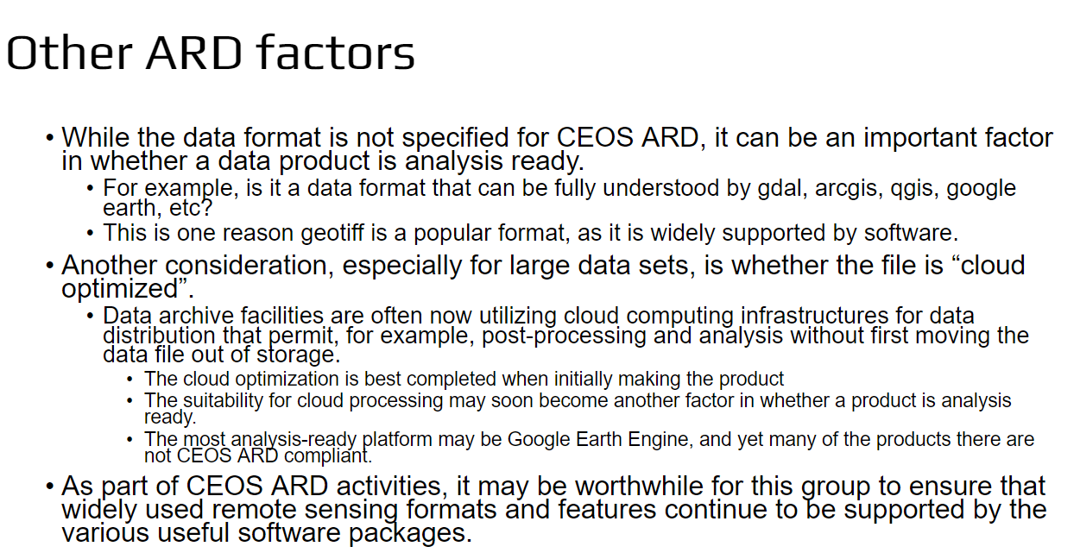
Discussion
- Ake Rosenqvist (JAXA) noted that adjustments to PFS as requested by Bruce, will be discussed at the next call of the SAR group. Ake believes that these adjustments can be accommodated without breaking compatibility.
LSI-VC-15-04 | Ake to report back to the LSI-VC Secretariat regarding minor updates to the combined SAR PFS to address azimuth spacing requirements.  Context: NASA have proposed a minor change to the specification, adjusting the threshold requirement to be the azimuth spacing (in metres) or the PRI (in seconds) of the source data product (as well as the other attributes). A target requirement that supersedes the baseline requirement would be a pixel-for-pixel image layer providing the number of looks. | May 2024
- The CEOS-ARD combined SAR self-assessment specification is available online and can be used by the OPERA project team for their self-assessments. Bruce Chapman (NASA/JPL) will let the team know.
- Regarding format discussion, there have been several discussions on whether recommending data formats at the Goal level should be considered.
- Bruce noted that NASA archives in HDF5. There are pros and cons to all choices. At least providing guidance on widely used formats would be helpful.
- Eric Vermote (NASA) noted that transitioning from hdf4 to hdf5 was a lengthy process for NASA. Any future changes are tricky and decisions are not taken lightly.
- Steve Labahn (USGS, LSI-VC Co-Lead) noted that Landsat data are archived in hdf5, but are distributed in geotiff for cloud optimisation.
- Advisory notes about formats were considered, but the focus shifted to the CEOS Interoperability Framework, which should guide data formats. It would be beneficial to include recommended data formats within the CEOS-ARD PFS, considering user needs and multiple available options.
- The Interoperability Framework is more comprehensive in listing factors (beyond formats) and underlines that only if all of them play together, interoperability is achievable. Interoperability is a major if not the main ingredient of 'analysis readiness'. The Interoperability handbook WGISS has started is the right place to have this discussion. For ARD we will then have to decide which factors we plan to cover and which (if any) to leave to other standards (always keeping an eye of where OGC/ISO are moving).
- Ake Rosenqvist (JAXA) noted that ALOS-2 PALSAR data in GEE are compliant, although access to all metadata layers may vary.
- Ferran Gascon (ESA) expressed concerns about GEE's incomplete inclusion of metadata, similar to those of USGS regarding traceability.
- Tim Stryker (USGS) expressed concerns about Google’s lack of concern regarding traceability, emphasising the idea of authoritative data.
- Dorj Ichikawa (New Space Intelligence) highlighted the importance of having data in a format that facilitates use by the end user, versus archive optimised formats.
- Ferran acknowledged the difficulty in being too directive, suggesting that several options would work. Steve proposed to work towards being more prescriptive.
- CEOS-ARD objective was to help grow the user community and lower the barrier to entry.
- In the case of SAR, metadata specifications have been followed by most data providers, with guidance provided as necessary.
- Putting format requirements as a Goal could be a good way to recommend without limiting the ability to reach CEOS-ARD Threshold.
LSI-VC-15-05 | LSi-VC Leads to reflect on the recommendations from Bruce Chapman (his last slide) regarding changes to the CEOS-ARD Specifications, including around being more prescriptive on formats and ensure this is reflected via either: revision of the Goal requirements, through Technical Advisory Notes, or via the CEOS Interoperability Framework with WGISS, as appropriate. | June 2024
NRCan (RCM) [Slides]
Francois Charbonneau (NRCan) reported:
- Since April 2023, RCM data has become accessible to the public for selected products. Hence, there has been increased motivation to develop a CEOS-ARD compliant product for the ScanSAR 30 m compact polarimetric product - the RCM National Land Standard Product.
- The systematic processing of RCM-LSC to CEOS-ARD is ongoing finalisation of the production chain and product validation, with peer review submission expected in late spring 2024, followed by systematic production commencement in summer 2024.
- Data access will be through AWS, with STAC metadata included.
- In the mid-term, the full archive of RCM 30m Complex Pol data over Canada will be processed to CEOS-ARD.
- In the longer term, NRCan aims to reprocess RADARSAT-1 and -2 data, though RADARSAT-1 has ARD performance limitations due to geolocation inaccuracy, and RADARSAT-2 is subject to commercial restrictions.
- The optimal goal is to produce 28 years of RADARSAT CEOS-ARD, from 1996 to the present.
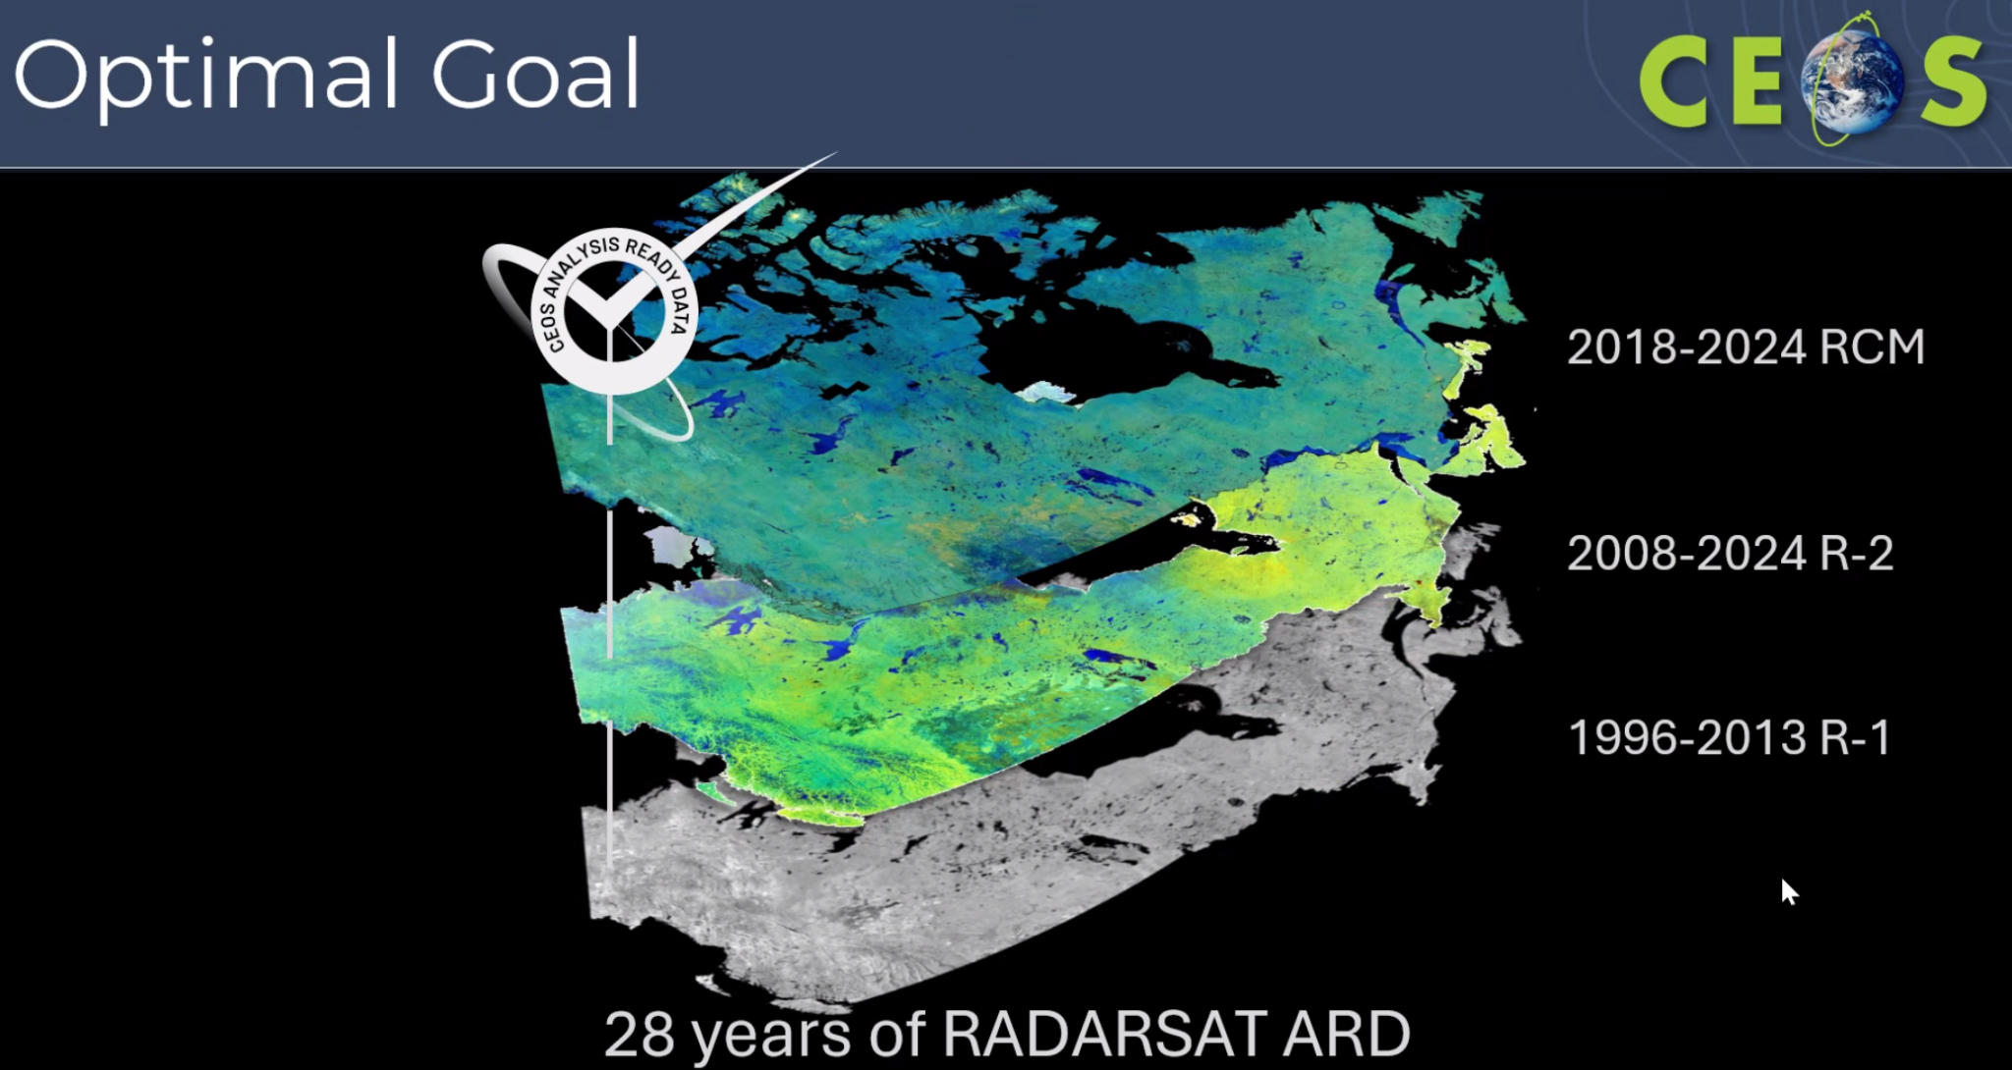
Discussion
- Ake Rosenqvist (JAXA) noted that Francois Charbonneau (NRCan) is the driver of the XML metadata specification.
- Steve Labahn asked about the challenge related to geolocation inaccuracy. Fine beam mode is 7 m, and standard is 20-25 m resolution. In terms of geolocation accuracy, it could be off by 500 m, making it unsuitable for ARD.
- Francois Charbonneau (NRCan) suggested adding a flag for imprecise data, as users often overlook this aspect and consequently end up with bad results.
ISRO (RISAT-1A / EOS-04) [Slides]
Hari Priya (ISRO) reported:
- RISAT-1A (EOS-04) CEOS-ARD NRB product was designed for the ScanSAR Imaging mode.
- Ten datasets with various polarisation combinations have been assessed as CEOS-ARD compliant. The products include Medium Resolution ScanSAR (MRS) of 18 m and Coarse Resolution ScanSAR (CRS) of 36 m.
- Data can be downloaded through Bhoonidhi.
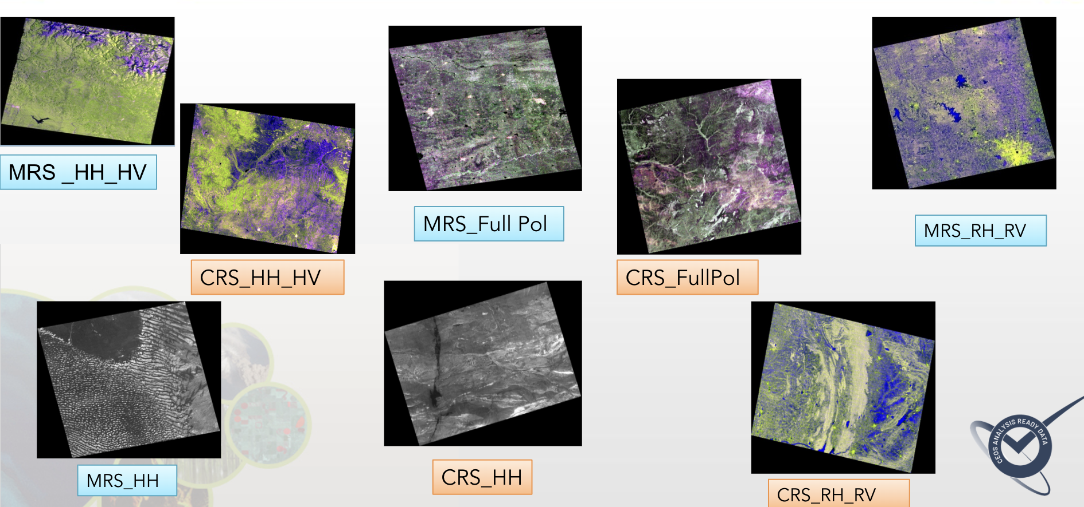
- ISRO is working on a number of other products for EOS-04 (RISAT-1A), EOS-09 (RISAT-1B) and NISAR, including Polarimetric Radar, GSLC and interferometric products.
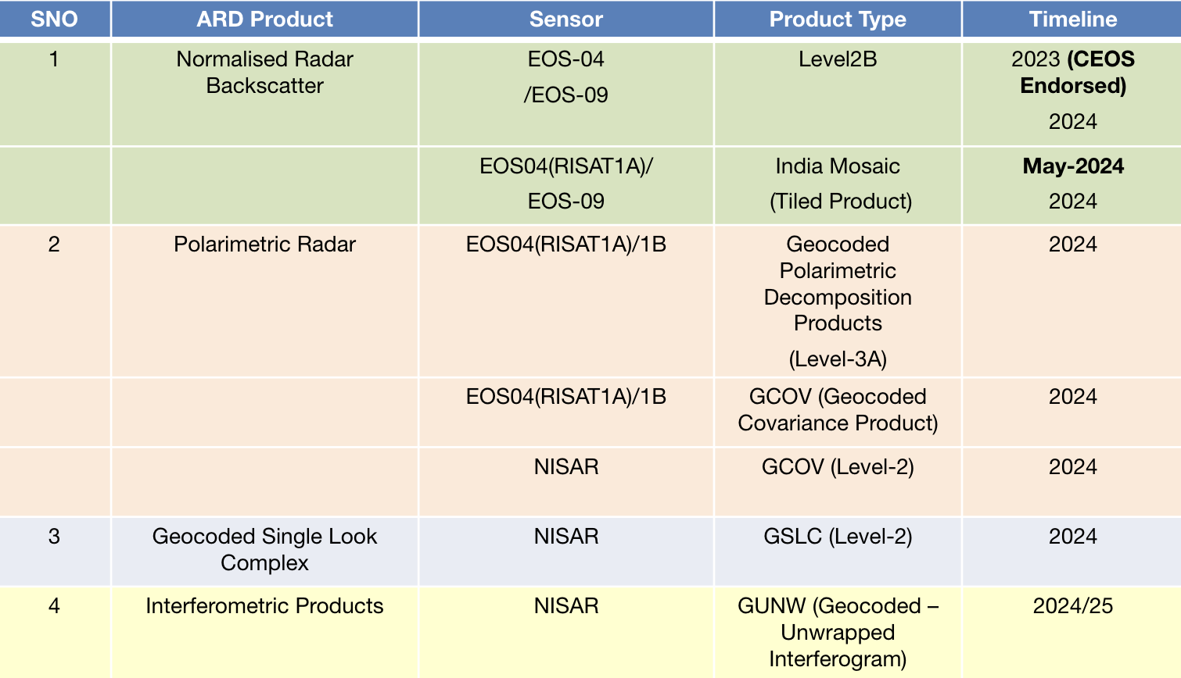
- The India mosaic products will be submitted for CEOS-ARD compliance soon.
Discussion
- Ake Rosenqvist (JAXA) asked about the accessibility of EOS-04 data and whether the archive is open access.
- Hari Priya (ISRO) noted, referencing the India Space Policy 2023, data with resolution of 5 m and coarser are available for access through Bhoonidhi, allowing for direct download.
- EOS-04 data is acquired globally, with systematic coverage of the Indian subcontinent.
- Steve Labahn (USGS, LSI-VC Co-Lead) noted receiving communications on the optical side from Radhika and Manju Sharma about ResourceSat-2.
- Hari Priya noted that Radhika is in the process of getting the data ready and will soon provide the optical self-assessment to the team.
- Matt Steventon (LSI-VC Sec) expressed interest in hearing ISRO’s perspectives on dataset accessibility during the commercial session.
LSI-VC-15-06 | Matt to ensure that the ISRO CEOS-ARD roadmap is completely reflected on ceos.org/ard | May 2024
CEOS-ARD Strategy 2024 and Scene Setting [Slides]
Matt Steventon (LSI-VC Secretariat) reported:
- The CEOS-ARD Strategy for 2024 is an update of the strategies produced in 2019 and 2021. It reflects progress to date, takes stock of future directions and needs and confirms our strategy for the next few years.
- A broad portfolio of CEOS-ARD that is easily discovered, accessed and utilised is the ultimate goal.
- The strategy includes six chapters:
  - CEOS-ARD Availability, Product Diversity, and Representation: This chapter aims to address gaps in representation, and calls on CEOS Agencies to task the Virtual Constellations and provide support for the CEOS-ARD Oversight Group.
  - Framework and Specification Advancement: This chapter outlines development priorities for CEOS-ARD, including high resolution issues, replica datasets, scope of data/metadata and format requirements. Version control is also a key issue to be addressed, and how to ensure products don’t become non-compliant when a new version of a specification is issued.
  - Discovery, Access, Utilisation, and Interoperability: This chapter outlines tasks to ensure that data can be found easily, embracing cloud native and machine-to-machine concepts. This also includes branding for CEOS-ARD datasets, to ensure a coherent offering of datasets. Leveraging the CEOS Interoperability Framework is key.
  - Community Engagement: CEOS is encouraged to commit to continue providing the co-chair of the OGC ARD SWG, currently through NASA, Patrick Quinn. The strategy also calls for engagement with thematic groups within CEOS, including WGClimate, GEOGLAM, etc. The CEOS-ARD GitHub is another key component to increasing community involvement.
  - Research, Test Cases, and Pilot Activities: This chapter includes support and use of the CEOS Analytics Lab, the Ecosystem Extent Demonstrators, Surface Reflectance Quality, Equivalency and Consistency Project, and the CSA Radarsat-2 Tropical Forest R&D Project. There is opportunity for other pilot activities to be added to this section.
  - Commercial Engagement: This is an evolution of the previous CEOS-ARD Industry Engagement Strategy.
- Chapter 1 includes a table of high priority candidate datasets for CEOS-ARD assessment and LSI-VC members are encouraged to help fill this out.
- It was suggested there needs to be a thread in the Strategy about capturing the benefits of CEOS-ARD.
- There is an open question about whether this should be raised for endorsement at CEOS Plenary to bring visibility.
Discussion
- Eric Vermote (NASA) noted that the next re-processing of MODIS will be in a year, indicating that It is too late to influence any change to include CEOS-ARD considerations at this point.
- Tim Stryker (USGS) noted that table 1 includes mostly land products and asked whether there are any suggestions from the oceans community regarding their contributions to CEOS-ARD. He also asked if there anything we can do within the agencies to support CEOS-ARD beyond land.
- Dave Borges (SEO) noted COAST-VC is likely to be established at the SIT-39 meeting. LSI-VC Leads have had calls with COAST, and they are aware and interested in being represented on the CEOS-ARD Oversight Group.
LSI-VC-15-07 | Matt to add COAST to the test cases / pilots chapter (5) of the CEOS-ARD Strategy 2024 and seek to ensure that teams ongoing awareness of CEOS-ARD and representation in the CEOS-ARD Oversight Group. | May 2024
LSI-VC-15-08 | Matt to consider how to add a thread in the CEOS-ARD Strategy 2024 about capturing the benefits of CEOS-ARD. | July 2024
- AC-VC was not receptive to the idea of CEOS-ARD for atmospheric applications. A presentation at the ESIP meeting on NASA atmospheric ARD demonstrated that possibilities exist. There is a desire to bridge the gap by connecting with NASA GES DISC people working on atmospheric ARD and aligning their efforts with CEOS.
LSI-VC-15-09 | Matt to share the CEOS-ARD Strategy 2024 draft with the NASA team working atmospheric ARD and seek to make a connection to CEOS-ARD and the activity of the CEOS-ARD Oversight Group and AC-VC. Copy Dave Borges for AC-VC follow up. | May 2024
- OCR-VC and P-VC are advancing their own CEOS-ARD discussions, although it is proving to be a challenge to justify. The work of P-VC is expected to serve as a good demonstration for the other VCs.
- Steve noted the need to keep track of WG and VC chair rotations and ensure active representation to the CEOS-ARD Oversight Group.
- Ferran Gascon (ESA) suggested adding data formats to chapter 2, alongside metadata specifications.
LSI-VC-15-10 | Matt to reflect on the membership of the CEOS-ARD Oversight Group and ensure the latest rotations of WG and VC Chairs haven’t left gaps in representation. | May 2024
LSI-VC-15-11 | Matt to add the data formats discussion to section 2 of the CEOS-ARD Strategy 2024. | May 2024
- Version control was discussed. It was noted that the process is not robust and reassessing against new versions of the specifications should be avoided. A mechanism is needed for incremental updates of specifications and assessments. This is captured in the Strategy as a development priority.
- Eric Vermote (NASA) noted the importance of version control, which can be lacking on the commercial side in his experience. The communication of PFS updates and the format for indicating updates are also important. The principles should be clear. GitHub should help make this more visible.
- Eric also emphasised the necessity of ensuring that any updates do not break existing compliant products.
- Steve Labahn (USGS) mentioned the ongoing discussion about adding a custom tag on AWS for CEOS-ARD datasets.
LSI-VC-15-12 | LSI-VC Secretariat and USGS team to discuss getting a CEOS-ARD tag onto their AWS datasets as a first implementation example for others to follow. Capture the specifics in the section of the CEOS-ARD Strategy related to cloud discoverability/visibility. Also follow up with other CEOS-ARD hosts (JAXA EORC website, CDSE, Tellus, etc.) | May 2024
- Dave Borges (SEO) noted that the SEO is considering an organisational GitHub account for all of CEOS.
- Libby Rose (LSI-VC Sec) is looking at getting the PFS into markdown format, which will allow GitHub users to make pull requests, etc. The existing CEOS-ARD GitHub repository is open for anyone to create issues and make pull requests. The CEOS-ARD issue tracker is already very active.
LSI-VC-15-13 | Consider the potential of using the CEOS-ARD Github to serve as a repository for sample CEOS-ARD datasets. | LSI-VC-16
- Steve Labahn noted that it feels like LSI-VC have been pausing development in favour of redirecting issues to the OGC ARD SWG. While this seems logical, in practice the SWG is without strong direction and is not progressing as expected. Steve emphasised the need for continued progress on the CEOS-ARD side, to avoid basing future development on an uncertain foundation.
- Ake Rosenqvist (JAXA) concurred, highlighting there are many unresolved issues, and a lack of direction and clarity. There is a state of uncertainty on the OGC side, which is causing a wait and see approach.
- Peter Strobl (EC-JRC, LSI-VC Co-Lead) expressed reservations about how the OGC standard is being developed and the intended final structure. He is waiting to see how this will be resolved before becoming too invested.
- Siri Jodha Khalsa (Univ. of Colorado, Boulder) noted that both he and Peter attended the SWG meeting in Delft last week. Due to time constraints and a heavy focus on presentations, there was little room for discussion. He noted that this impeded progress on the critical issues facing the OGC ARD SWG. The first document only serves as a framework. Given the current situation, he anticipates delay in achieving any substantial progress.
- Ferran Gascon (ESA) noted he is in favour of continuing to advance the CEOS-ARD work independently of the OGC efforts, given the realities of the situation on the OGC side.
- Dave Borges (SEO) asked what the long term mitigation strategy will be considering the potential for differences to arise between the OGC and CEOS-ARD approaches.
- Ake Rosenqvist (JAXA) noted that we will stay closely involved with the OGC ARD SWG, to ensure alignment with CEOS-ARD, but that we should avoid deferring / delaying future developments while waiting for traction on the OGC side.
- There was a question about whether an OGC Community Standard process would be a better approach, whereby CEOS-ARD could eventually be adopted as-is, like was the process for STAC. Siri Jodha explained that community standards follow a shorter process and are based on existing agreements within the community. On the other hand, joint ISO/OGC efforts involve a more extensive review process by ISO national standards bodies.
- Matt Steventon noted that the CEOS-ARD Strategy is written to emphasise the need to keep progressing CEOS-ARD for satellite EO, keep this vibrant community active, while also keeping an eye on the ISO/OGC work.
- The OGC ARD SWG hasn’t delivered on its promise of providing a means to broaden engagement, with participants largely being from CEOS member agencies.
- Steve Labahn emphasised the importance of continuing commercial engagement workshops through LSI-VC to get their perspectives on CEOS-ARD.
- Dave Borges mentioned his attempts to involve companies by requesting a small allocation of staff time to join the SWG but he hasn’t been able to get anyone engaged so far.
- Tim Stryker encouraged presenting the new CEOS-ARD Strategy for endorsement at CEOS Plenary 2024.
- Steve Labahn acknowledged the strong support for CEOS-ARD work within the radar community. He also suggested mapping the Strategy to CEOS Work Plan items (existing or new). Perhaps this could be done via a single task with sub-bullets if there are too many.
Decision 01 | LSI-VC encourages working towards a presentation of the CEOS-ARD Strategy 2024 at the SIT Technical Workshop, towards endorsement at CEOS Plenary 2024.
Product Family Specification (PFS) Feedback and Updates – Discussion and Decisions [Slides]
Surface Reflectance PFS Comments from the CHIME Team
Ferran Gascon (ESA) reported:
- CHIME is a future hyperspectral mission, part of the Copernicus programme.
- When specifying the mission, ESA specified the data should be CEOS-ARD compliant with the Surface Reflectance PFS.
- The CHIME team questioned if the bottom-of-atmosphere reflectance products on sensor geometry that have been appended a per-pixel latitude, longitude, altitude and refined geometry information are CEOS-ARD compliant.
- Item 1.6 “Map Projection” indicates that non-projected products are still compliant.
- However, in the Threshold requirement for item 4.1 (Geometric Correction) the description is considered unclear in particular regarding what can be considered as “consistent”.
- The text for 1.6 reads: “Sub-pixel accuracy is achieved in relative geolocation, that is, the pixels from the same instrument and platform are consistently located, and thus comparable, through time.” However, in sensor geometry a near coincident ground location will appear on a different image location within the products and the actual pixel footprint will be slightly different.
- The text for 4.1 reads: “A consistent gridding/sampling frame is used, including common cell size, origin, and nominal sample point location within the cell (centre, ll, ur).” In sensor-geometry each image element corresponds to a given focal-plane element, but this does not translate to a fixed ground sampling distance (it will depend on the local DEM). Does this qualify as consistent sampling?
- The CHIME team asked what constitutes a consistent gridding. Can a consistent gridding be achieved without a map projection?
- Page 19 states: “These products would be resampled onto a common geometric grid (for a given product) and would provide baseline data for further interoperability both through time and with other datasets.” This would not be satisfied by CHIME sensor geometry products.
Discussion
- Ake Resenqvist (JAXA) asked whether another processing level could be introduced where the product is registered to a ground grid, allowing for time series consistency. He suggested that a projection or geographical coordinates might be necessary for CEOS-ARD compliance.
- At the last meeting, it was agreed to relax the requirements for 1.6 to allow for sensor geometry products, following a request from the Sentinel-3 team. However, the hyperspectral community prefers to avoid resampling data.
- Siri Jodha Khalsa (Univ. of Colorado, Boulder) recalled Peter Strobl's proposal for new ‘Level’ definitions to separate geometric and radiometric aspects. This approach would enable better handling of these types of cases. He suggested revisiting the discussion after Peter’s presentation later in the meeting.
- Steve Labahn expressed concern that changing the requirement of 1.6 may have violated a fundamental rule of CEOS-ARD by removing the ability to directly stack the data.
- We cannot revert the relaxation of 1.6 requirements, as it would mean Sentinel-3 would no longer be compliant. Changing the requirement for only hyperspectral missions could accommodate that community without affecting multispectral missions.
- Ferran Gascon (ESA) suggested a possible solution: allowing the relaxation of this requirement only for hyperspectral missions and updating the text accordingly. Data providers need to provide data in a way that allows users to orthorectify in whatever way necessary. This caveat approach might also provide a means for addressing the issues with very high-resolution sensors.
- It was proposed to make some editorial changes to address the concerns raised by the CHIME team. The LSI-VC team should discuss how we fit very high-resolution, multispectral and hyperspectral requirements most efficiently into one specification – including consideration of Peter’s proposed approach to defining Levels.
- The key priorities should remain true to the objectives of CEOS-ARD, including stacking through time, interoperability, and ease of use of data.
LSI-VC-15-14 | LSI-VC Leads to connect, via Ferran Gascon, with the CHIME team to agree potential changes to the Surface Reflectance PFS that would add specific caveats for hyperspectral missions. | May 2024
LSI-VC-15-15 | LSI-VC Leads to consider a similar caveat approach (ref: LSI-VC-15-14) for high resolution missions, as a means for addressing the issues raised by KARI around sub-pixel accuracy. | May 2024
Review of GitHub Issue Tracker Open Threads
A number of issues have been identified in the effort to update the CEOS-ARD STAC Extensions. Some of these open issues were raised for discussion and decision.
2.13 in SR / NLSR – Requirement "to be determined"
- Matt Steventon (LSI-VC Sec) proposed to change the 2.13 Goal requirement to ‘As Threshold’ for the SR and NLSR PFS.
Decision 02 | Change the 2.13 Goal requirement to ‘As Threshold’ for the SR and NLSR PFS.

LSI-VC-15-16 | Matt to initiate the process to change the 2.13 Goal requirement to ‘As Threshold’ for the SR and NLSR PFS. And to check the AR PFS handling of this parameter.  Note: This is not an urgent change, so consideration will need to be given to the cycle in which the change is made. | May 2024
'No Data' Definition
- The empty pixels terminology is problematic.
- Matthias' proposal is to replace “(‘empty pixels’)” with “(e.g., ‘empty pixels/invalid observation/below noise floor’)” in the SR/ST/NLSR PFS.
- This should also be harmonised with the SAR PFS.
- Peter suggested differentiating four cases at the Threshold level:
  - Sensor-dependent:
    - 'NoData': No sensor reading available (e.g., outside FOV).
    - 'Invalid': Sensor acquired observation, but no valid result obtained (e.g., below noise floor).
  - Measurand-dependent (may change over the value chain):
    - 'Falsified': Valid observation acquired, but not representing desired measurand (e.g., cloud/snow).
    - 'Valid': Verifiable observations of the measurand (e.g., ToR, LST).
- Essentially this is about flagging whether a sample can be used for analysis.
Discussion
- Ake Rosenqvist (JAXA) highlighted a requirement in the SAR PFS for a data mask of ‘invalid’, ‘valid’ or ‘no data’ at the Threshold level. At the Goal level, individual pixel level is requested.
- Perhaps this mask requirement should be reflected on the optical PFS. The definitions of valid and invalid data should be clear.
- Siri Jodha Khalsa (Univ. of Colorado, Boulder) agreed, suggesting that within the pixel array itself, there should be a simple invalid/valid bit. At the Goal level, the mask should include explanations for why data is considered as ‘no data’, e.g., cloud cover.
- There should be another mask depending on the sensor type or domain of observation which would declare the reason for ruling out the pixel.
- Ferran Gascon (ESA) suggested having separate requirements for the measurand and sensor.
- The group considered adopting the approach of the AR PFS for the SR / ST / NLSR PFS. It was also suggested that the definitions could be included in the table at the top of the PFS.
- Regarding the specific requirement for the mask, it was questioned if there was a strong reason from the AR PFS team to include more details. Up to now the approach has been binary – data or no data. While SAR has three levels, valid, invalid and no data, a suggestion was made to try and harmonise with the SAR PFS also.
- When the mask layer contains invalid data, what is written to the data array is determined by the data provider, and this should be clearly stated in the metadata file.
- The invalid data could have a note to refer to other masks to understand the reason behind the invalidity.
- There was a discussion about whether the term ‘Falsified’ is necessary. Peter Strobl (EC-JRC, LSI-VC Co-Lead) suggested that it should be able to identify where the data is masked, and where it never existed, even though the result may be the same.
- Ferran Gascon (ESA) expressed uncertainty about whether this mask needs to contain information about why data is invalid. While cloud masks are included separately, there was a consideration about including separate masks instead of using ‘falsified’. It was agreed that this mask should be simple, and complemented by other masks. This can be addressed in the expected effort to create a combined PFS for optical data.
Decision 03 | Agreed that we need to ensure consistency between the ‘No Data’ fields of the PFS (incl. SAR) and that some stratification is necessary to describe the different cases (sensor dependent, measurand dependent). This will be dealt with in the process to develop a combined optical PFS. Definitions will need to be agreed for the cases of ‘NoData’, 'Invalid', 'Falsified' (TBC), and 'Valid'. This could be handled in the same way as on the SAR side, with a mask layer to indicate each case at the Threshold level. Goal level requiring a per-pixel approach. LSI-VC will consider different masks and ways to capture the specifics of why a pixel is registered as ‘No Data’.
Spectral Bands & Full Width at Half Maximum (FWHM)
- Spectral bands (1.10) require only central wavelength for SR/ST/NLSR PFS. For AR it additionally requires FWHM. There is an open question as to whether this can be aligned.
- To promote interoperability between different datasets, we need more information than just the central wavelength of spectral bands.
- The proposal for LSI-VC-15 decision is to adjust the SR, ST, NLSR PFS to include at a minimum FWHM at Threshold, and Full Spectral Response Function at the Goal level.
- This was agreed in principle, and further consideration will be given to it in the context of the combined optical PFS.
Decision 04 | Agreed to adjust the SR, ST, NLSR PFS to include at a minimum FWHM information at Threshold, and a full spectral response function at the Goal level. This will be addressed in the process of developing a combined optical PFS.
Map Projection (1.6) in the ST PFS
- Map projection is required at Threshold in all PFS except for ST. The question is whether this can be aligned and whether there is a specific reason this is a Goal requirement for ST, rather than Threshold?
- It was noted that the v5.0.1 update of the SR PFS has also created another inconsistency with the ST PFS. However, noting the discussion from earlier, we may have unintended consequences from the update of requirement 1.6 in the SR PFS, so we shouldn’t be too quick to make the ST match it.
- LSTM will be an orthorectified product, which will be like Sentinel-2. So, there shouldn’t be any issues related to requirement 1.6.
- To enable machine-usability the Threshold level should specify the datum used.
- One of the conclusions of the vocabulary exercise is that a new platform is needed to move forward on interoperable vocabulary.
Decision 05 | Agreed to make 1.6 of the ST PFS consistent with that of the SR PFS v5.0.1. It was agreed that the changes to 1.6 in the SR PFS which have raised issues related to hyperspectral sensors will not adversely affect the ST side. This will be dealt with in the process to combine the optical PFSs. The caveats for hyperspectral sensors on the SR side will not be applicable to the ST side.
0.5 Pixel rRMSE Accuracy [Slides]
- This is a long standing issue, first raised by KARI in 2019.
- KARI had to downsample their product eight times in order to meet the SR PFS. This issue will become more frequent as resolutions improve and we look to engage more with the commercial sector.
- On the SAR side, it was decided to not have a per-pixel requirement. Geometric accuracy is for the data provider to specify – then it is up to the user to decide whether the accuracy is good enough for their application (scientific rigour versus inclusivity discussion). However, this defeats the fundamental purpose of being CEOS-ARD (i.e., stackable data through time),
- We have to be careful with absolute accuracy, especially for <10m resolution data as there are no suitable open global references.
- Peter Strobl (EC-JRC, LSI-VC Lead) noted the need to first define ‘high resolution’, and shared the following definitions from Copernicus:
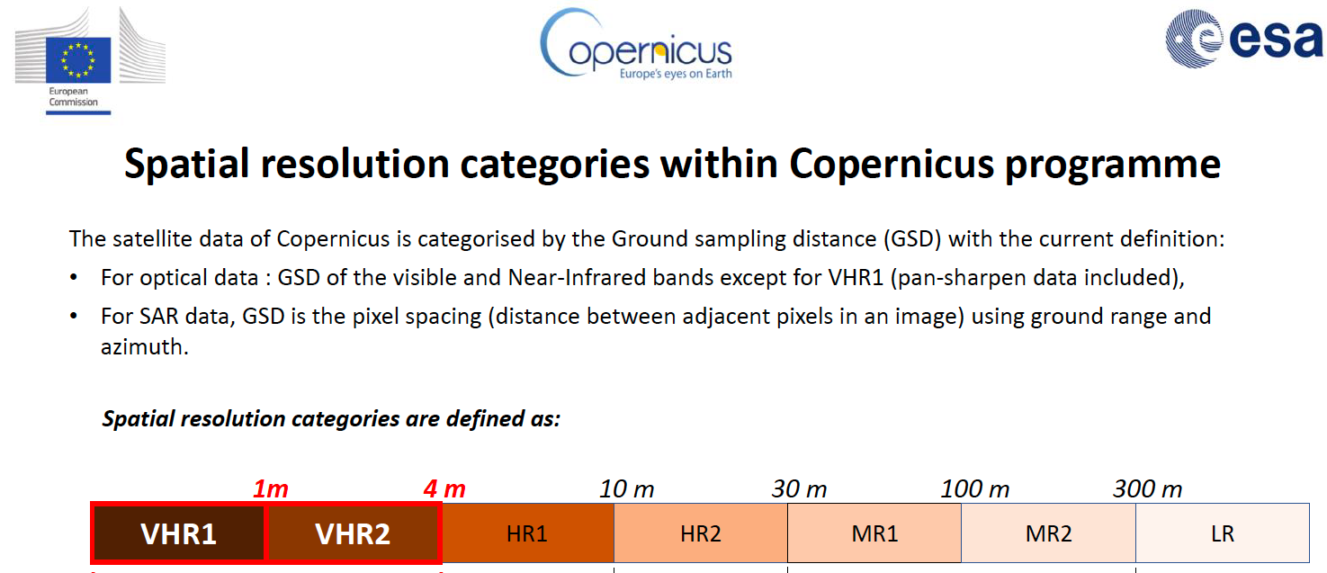
- Furthermore, we need to distinguish geolocation uncertainty (absolute) from geometric co-registration. As a benchmark, 'pixel' should be replaced by 'GSD' (ground sampling distance - usually at sea level), which is a sensor characteristic.
- In the range of HR2 and coarser, it is reasonable to expect less than 0.5 GSD (absolute) geolocation uncertainty (CE95) and the same or better in co-registration terms.
- For HR1 or finer, Peter recommended fixing the requirement at 5m absolute and 0.5-1.0 GSD relative, as a threshold for intraband and intrapath.
- Steve Labahn (USGS, LSI-VC Co-Lead) noted that USGS is considering this approach for Landsat Collection 3.
- Peter Strobl (EC-JRC) emphasised the importance of providing uncertainty information or accuracy as a probability density function for each sample. Need to know where the sample is. Need to put those in requirements.
- It was suggested to first focus on Threshold requirements, not mandating a value, but ensuring information is provided for users to decide whether it is fit for purpose.
- Agree on using a fitness for purpose approach as done on the SAR PFS.
Decision 06 | Agreed in principle to try a ‘fitness for purpose’ approach to accuracy requirements for the combined optical PFS. This is the approach used on the SAR side, that is, not mandating a value, but ensuring information is provided for users to decide whether it is fit for their use case. This will resolve the issue with the 0.5 sub-pixel rRMSE accuracy requirement for high resolution datasets and the principle will be broadly applicable to other quality / accuracy aspects of the PFS. This principle will be adopted in the definition of the combined optical PFS.
Combined Optical PFS Discussion [Slides]
- A combined PFS for optical sensors (comparable to the Combined SAR PFS) is suggested, to help address some of the inconsistency issues discussed.
- This could include a matching metadata specification as done for the Combined SAR PFS.
- We should also consider common elements between the optical and SAR PFS with a view to further harmonisation.
- The Combined SAR PFS has the benefit of ensuring consistent parameter names and specifications across all SAR PFSs, simplifying PFS revisions and change tracking, and simplifying interfacing with ongoing external standardisation frameworks (OGC/ISO, STAC).
- The SAR PFS is accompanied by a single metadata specification, with a consistent mapping of parameter names between the PFS and suggested metadata. The metadata specification is only a requirement at the Target level, but so far all data providers have chosen to adopt it.
- Ake has completed a mapping of the various optical CEOS-ARD PFS, which shows significant consistency. This analysis looks only at the high-level requirements and more effort would be needed to iron out inconsistencies in the definitions themselves.
- This would also aid the CEOS-ARD STAC extension work. Matthias Mohr has suggested switching to a grouping of similar requirements (“profiles”) as e.g., in STAC with their extensions, and then combining them in the actual PFS. This means it only needs to be maintained once and it would be consistent.
- However, we could run into issues with the desire for sensor agnostic PFS, noting the original goal to look less at the sensor and more at the geophysical parameters.
- The SAR PFS accommodates the possibility that the CEOS-ARD product may not be generated from a single data source (e.g., mosaic products). This is indicated by source data attributes (1.6) and CEOS-ARD product attributes (1.7) being separated. This could be carried across to the optical side as well.
- Steve Labhan (USGS, LSI-VC Co-Lead) asked about the situation where one requirement needs two different definitions for different PFS.
- Ake Rosenqvist (JAXA) suggested separating the requirements for each PFS if it cannot be made consistent. However, he advised against using the same parameter name.
- There was a consensus that CEOS should not halt or defer its work while waiting for the ISO/OGC ARD standards to progress. However, it was acknowledged that CEOS should keep watch and maintain alignment.
Decision 07 | Agreed in principle to attempt a combined PFS (including joint optical and SAR in time). We will start by looking at the common parameters of the optical PFS and seeing where the requirements match exactly. Discussion will then focus on those parameters where the requirements differ. It was agreed that it could make sense to seek to combine the SAR and optical PFS from the outset, rather than doing the harmonisation in two steps.

Agency Updates
USGS [Slides]
Steve Labahn (USGS) reported:
- Each Landsat satellite provides 16-day global coverage; it is reduced to 8 for a combination of Landsat 8 and 9.
- Landsat 7 was lowered out of operational orbit in 2022, and imaging was suspended in January to retain health and safety of the batteries. NASA had announced the refuelling demonstration mission was cancelled, but Congress has instructed it to keep developing at least until the end of the fiscal year.
- Landsat Next is designed to provide more frequent and finer-resolution science-quality data of the changing surface of the Earth, in concert with commercial and international datasets. The mission will include three smaller satellites, with a combined 6-day revisit time supporting more frequent coverage.
- Landsat Next will image in 15 new bands, and offer improved spatial resolution (10-30 m) with the launch readiness targeted for 2030.
- If only two of the three satellites are operational, then the revisit will be nine days, which will still meet the needs of users. Combined with Sentinel-2 next generation, we could see daily revisit for most areas on the globe.
- The Landsat 2030 International Partnership Initiative was announced in December 2023 at the U.S. National Space Council Meeting. It is open to interested governments willing to commit to global, open use of Landsat observations and supporting the use of Landsat data for public decision support, commercial value-added services, and scientific and global change research.
- There are a number of objectives outlined for Landsat Collection 3, which is planned in the 2028/29 timeframe:
  - Define and implement collection governance
  - Include Landsat Next data stream
  - Accommodate intermediate Collection releases
  - Standardise processing levels and product naming convention terminology
  - Provide radiometric and geometric continuity across the historical Landsat archive
  - Improve Landsat Next, L8/L9, and historical archive compatibility
  - Optimise to meet user needs while minimising costs
  - Support optical sensor-agnostic exploitation (i.e., meet CEOS-ARD Goal/Threshold-Level requirements)
  - Utilise a robust geometric and radiometric validation process
  - Enable/enhance in-cloud exploitation and reduce data egress; enable AI/ML
  - Coordinated/common auxiliary data and algorithms across major moderate-resolution data providers (i.e., maximise interoperability)
  - Provide open-source algorithms/software
- Four USGS products have been assessed as CEOS-ARD compliant. The US ARD product uses a different map projection to the global product.
- USGS is attempting to meet Target CEOS-ARD level compliance for Collection 3.
Discussion
- Landsat Next is currently in the formulation phase, where product requirements have been defined. NASA develops the spacecraft and USGS develops the ground system. Timeline is aligned to NASA requirements. Instrument suite RFP is out, which will be followed by spacecraft RFP. The spectral bands and resolutions are mostly finalised at this stage. NASA is expected to make some decisions on the instrument suite design later this year.
- The International Partnership initiative is to leverage capacities. Landsat Next will produce 13 times more data.
CSIRO Update [Slides]
Zheng-Shu Zhou (CSIRO) reported:
- NovaSAR-1 is a low-cost SAR technology demonstrator satellite produced by SSTL and Airbus DS, funded by UKSA. CSIRO acquired a 10% share in the acquisition and tasking capacity.
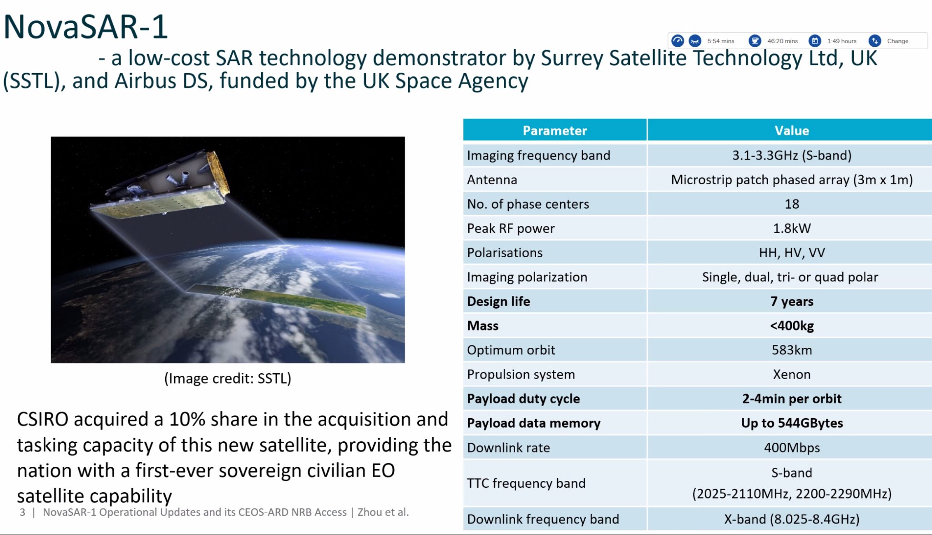
- Imaging tasking requests can be made through CSIRO. Daily allocation is split over disaster acquisitions, merit based science projects, CSIRO activities and background mapping.
- Cal/Val sites include the Queensland Corner Reflector Array (QCRA) and WA Geodetic Station. There is potential for future sites in Antarctica.
- The NovaSAR-1 National Facility data hub includes over 4800 level 1 products, and 2680 CEOS-ARD NRB products over Australia. Almost 600 users are registered across 49 countries.
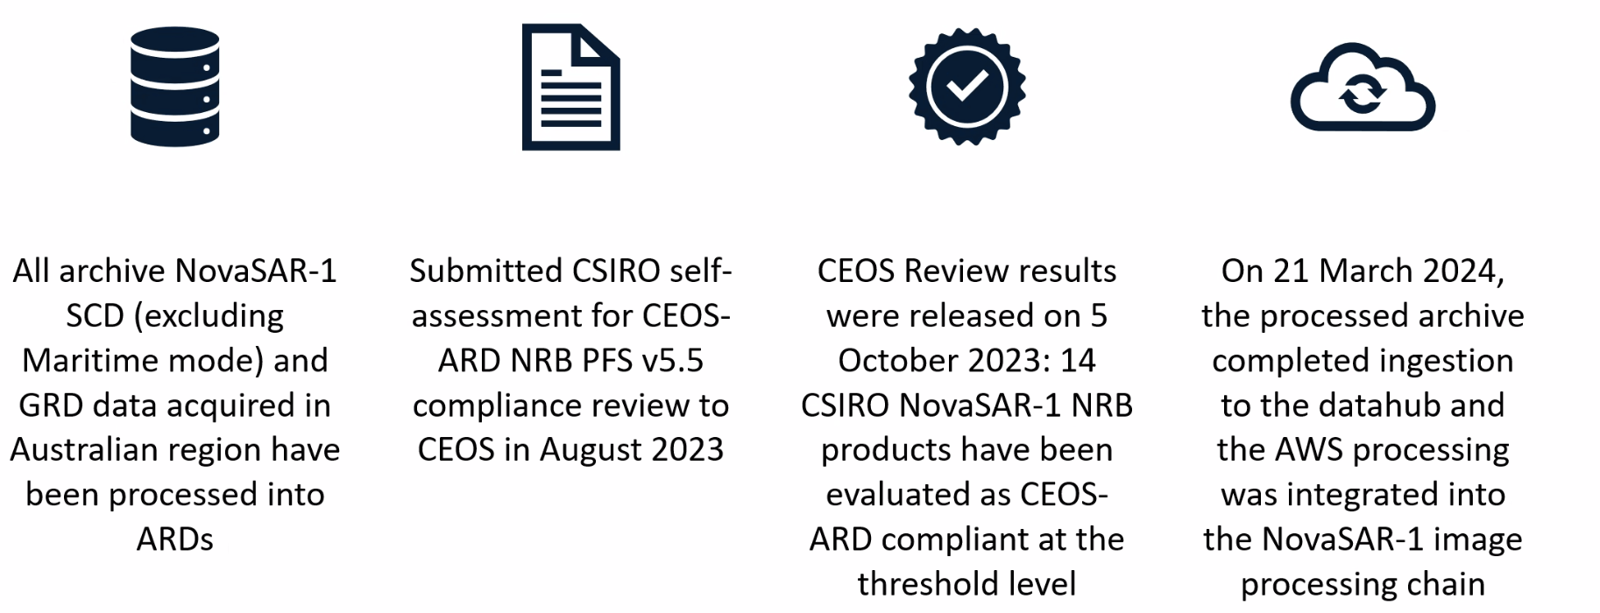
- In January 2024, ESA shared a NovaSAR-1 announcement of opportunity to use Airbus’ share of NovaSAR through the ESA Third Party Mission programme.
- Next steps include expanding the availability of CEOS-ARD products outside of Australia, and including the CSIRO NovaSAR share in the ESA TPM offering. CSIRO would also like to continue working on impact reports for CEOS-ARD products.
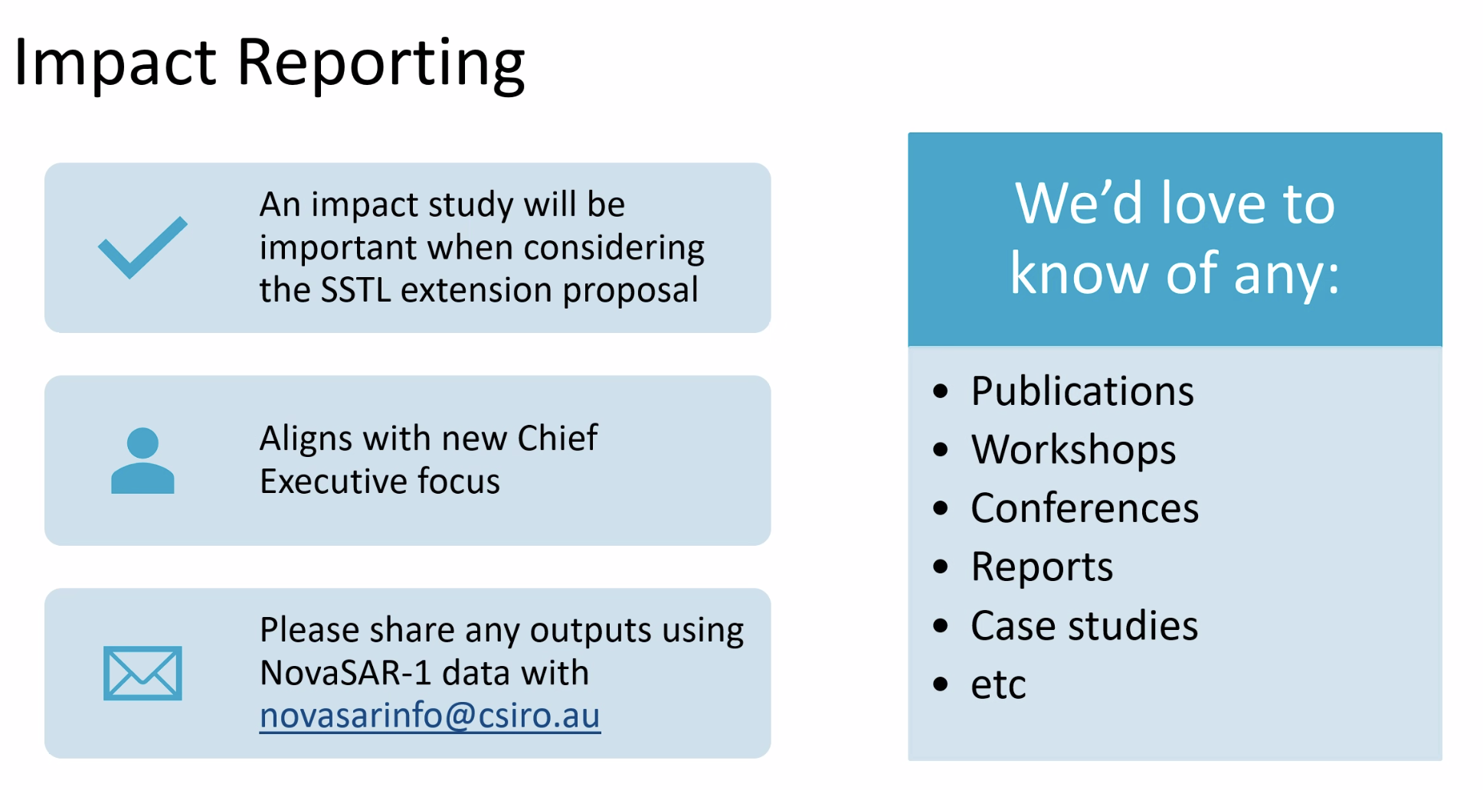
Discussion
- Ake Rosenqvist (JAXA) noted the open discussion about collaboration between ISRO, CSIRO, and USKA on aligning their individual NovaSAR-1 data products (and with CEOS-ARD).
- Hari Priya (ISRO) noted that they are currently internally testing NovaSAR Ground Terrain Corrected (GTC) and Radiometric Terrain Corrected (RTC) products. ISRO is interested in comparing data from CSIRO.
LSI-VC-15-17 | Hari Priya (ISRO) to connect with Zheng-Shu Zhou (CSIRO) to coordinate the two agencies’ NovaSAR-1 CEOS-ARD products. | May 2024

JAXA [Slides]
Takeo Tadono (JAXA) reported:
- JAXA has three CEOS-ARD compliant products. They have since been updated for compliance with the new Combined SAR PFS. The new self assessments were submitted on 2 April, 2024. Revisions were only required to the XML metadata.
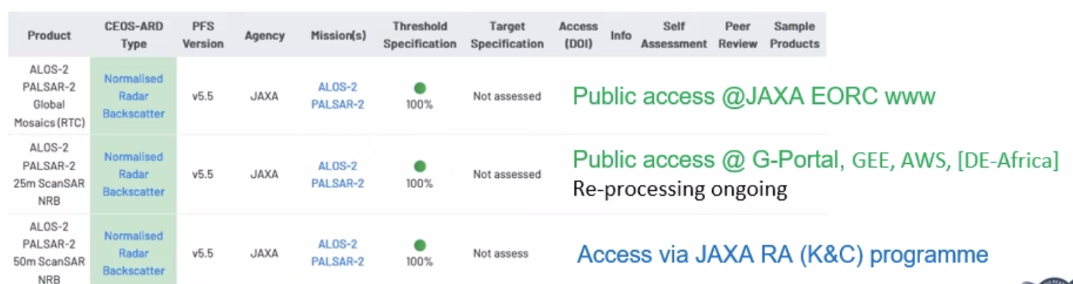
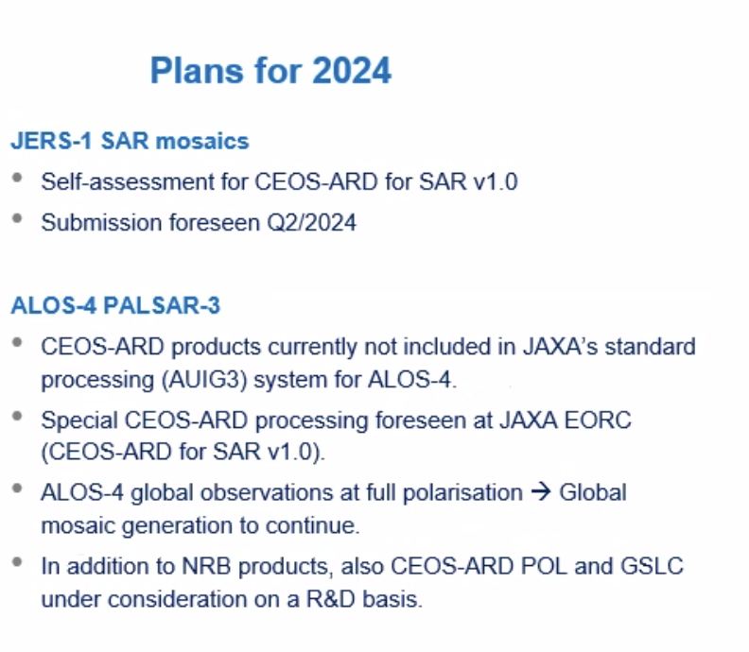
- Plans for 2024 include submitting a self-assessment for JERS-1 SAR mosaics in Q2 2024, and considering special processing for upcoming ALOS-4 PALSAR-3 data.
- JAXA currently has six missions operating:
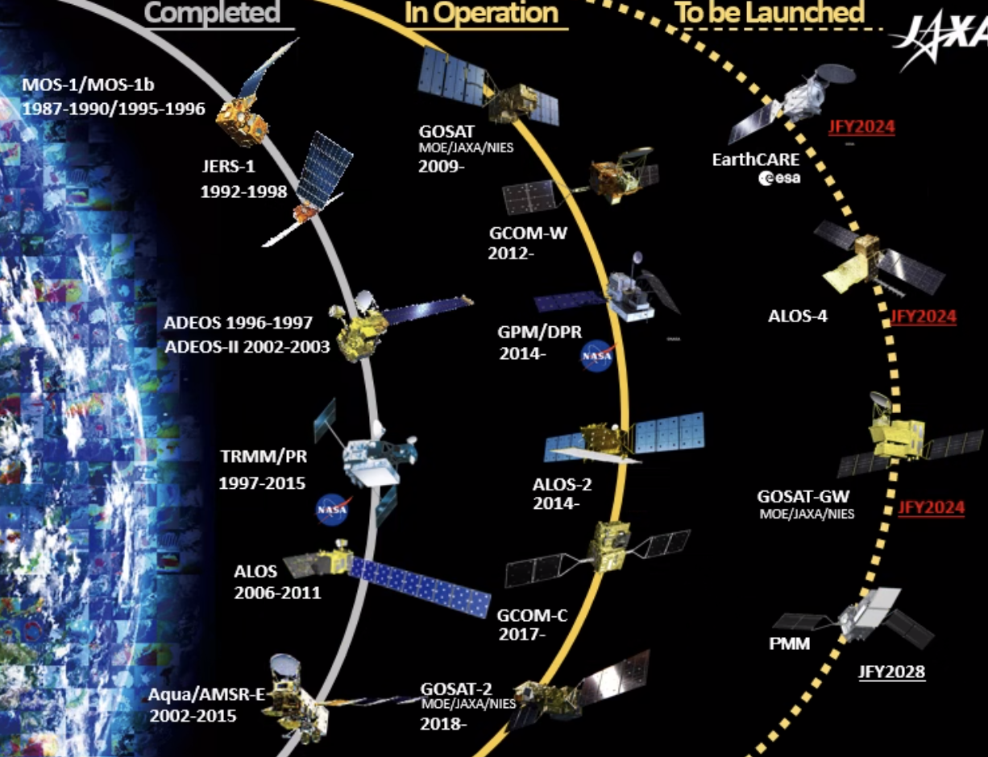
- ALOS-3 was lost due to the failure of the H3 test launch in March 2023. However, the second test flight of the H3 rocket was successful on 17 February 2024, paving the way for the launch of ALOS-4. ALOS-4 is expected to launch in 2024 using the H3 rocket.
- ALOS-2 remains in good health, with onboard calibration completed every 3 months.
- ALOS-2 and ALOS-4 will be 103 degrees out of phase, resulting in short latency for emergency observations.
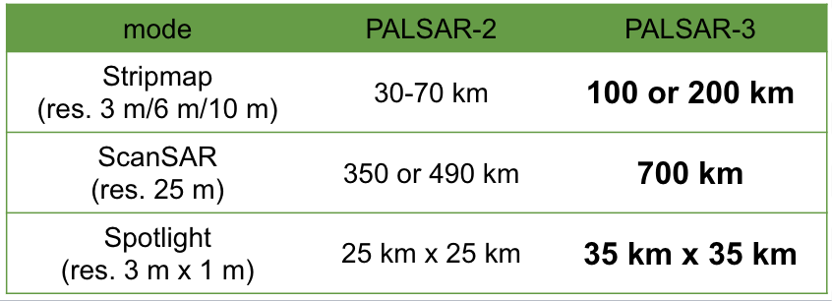
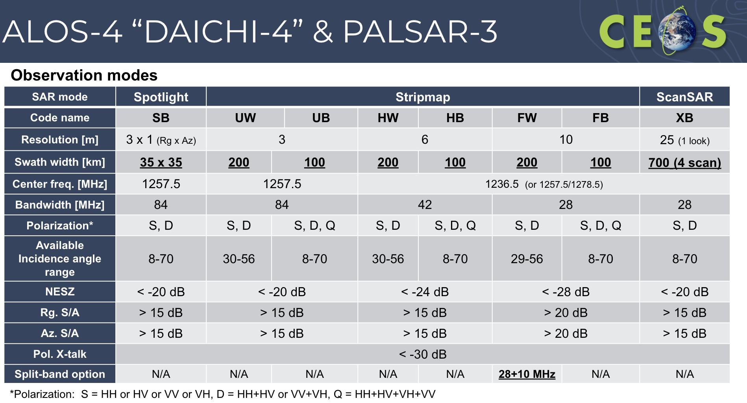
- The main observation beam for PALSAR-3 is the right-looking observation with 30-44 deg. incidence angle. Left observation and other incident angle beams are used for emergency observations and pre-disaster basemaps. For each beam, the near-range scene boundary is aligned with the ALOS-2 scene boundary.
- System pre-flight tests have been completed and confirmed clearance for flight of ALOS-4. The satellite has been transferred to Tanegashima Space Center and final assembly is underway.
- JAXA is developing the AUIG4 system for data ordering – a user interface to be used for tasking PALSAR-2 and -3.
- ALOS-4 Standard products will be compatible with ALOS-2. Product documentation and sample products are in preparation, and the data policy is under discussion.
- Higher level products include global mosaics (NRB), global forest/non-forest maps (FNF), disaster response maps and information, and time-series InSAR over the entirety of Japan.
- Regular operations are scheduled to commence from seven months after launch.
Discussion
- Zheng-Shu Zhou (CSIRO) noted that CSIRO has downloaded the ALOS global mosaic for Australia from 2015 to 2022. He asked about the continuity plan for this dataset from 2023 onwards, particularly regarding whether the same processing flow will be maintained.
- It was clarified that there will be no change to the product, and the processing flow will remain consistent. However, the product from 2023 onwards will be compliant with the Combined SAR PFS v1.0, as opposed to NRB PFS v5.5. The only anticipated changes will be minor adjustments in the metadata.
Session 3: Data Discovery, Access, Utilisation, Interoperability
CEOS-ARD Surface Reflectance Products: Quality, Consistency and Equivalence [Slides][Paper]
Medhavy Thankappan (GA) reported:
- The CEOS-ARD initiative has been effective in promoting the need to standardise surface reflectance products but it does not prescribe SR measurement equivalence as a requirement for interoperability.
- There exists ambiguity in definition of the Surface Reflectance measurand as highlighted by Schaepman-Strub et. al. (2006).
- Many approaches to "surface reflectance" production are observed, including inputs, model selection and model parameters:
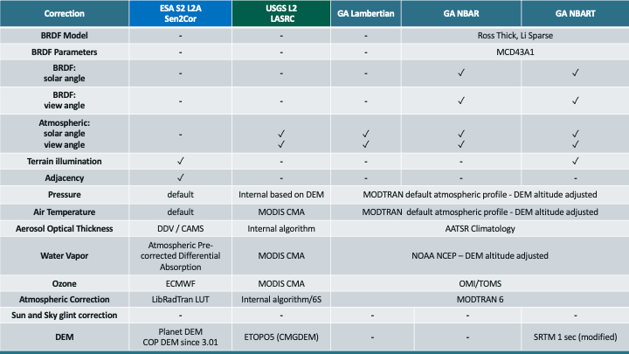
- GA proposes to build on CEOS-ARD achievements and take next steps to deliver on CEOS-ARD multi-sensor interoperability objectives.
- This concept was presented at ARD23 Workshop, WGCV-52 in June 2023 and LSI-VC-14 in October 2023.
- This proposal seeks to establish a set of inputs, corrections, associated parameters and tolerances for achieving SR equivalence in the context of interoperability between CEOS-ARD SR products and facilitate effective multi-sensor analyses.
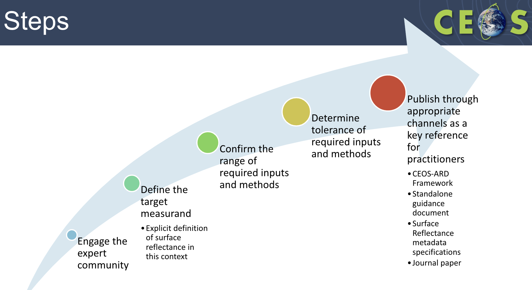
- The goal is to reduce the duplication of effort, and allow for global applicability of algorithms and consistent time-series across sensors and providers.
- The outcomes from WGCV-53 included some ideas for first steps on this project:
  - Defining Surface Reflectance and its purpose, to address uncertainties associated with SR products for specific applications and clarifying what users can expect from the product.
  - Reporting what is done in the process for SR products is important, metadata should include information indicating what is being produced to avoid confusion and ensure consistency.
  - Clarifying the meaning of ‘interoperability’.
- The WGCV and WGISS joint meeting in October 2024 will be a key opportunity to discuss further.
Discussion
- Medhavy Thankappan (GA) noted that while CEOS-ARD work has taken us to a certain point along the interoperability spectrum, this initiative would be taking us to the next stage. SR is a broad term, and should be used in context for what is being applied. There is no common definition of what SR means. This concept is more about establishing an understanding of the steps and tolerances in SR production.
- Documenting the steps, processes, and necessary tolerances to promote interoperability is a more realistic approach than agreeing the use of a common methodology for SR production. Even simple elements like common ancillaries could significantly align products so that they are more suited to multi-sensor analyses.
- Approaches like HLS and Sen2Like are not scalable to other missions and sensors. It’s not feasible to do this for all instruments.
- Medhavy suggested running a small pilot to understand the issues. He proposed conducting this pilot with the CEOS Interoperability Framework in mind.
- Medhavy also highlighted the importance of establishing an agreed definition of SR, at least within the context of CEOS-ARD.
- There is an action from the WGCV-53 meeting to look into the different CEOS-ARD SR products and comparing their approaches, with the intention to reflect this information on ceos.org/ard.
- Medhavy plans to socialise this information further at the ARD24 workshop in San Francisco.
- The core work would be conducted by WGCV, but LSI's involvement was noted.
- Peter Strobl (EC-JRC, LSI-VC Co-Lead) will attend LSI-VC-16, the joint WGCV/WGISS meeting in Sioux Falls, and the CEOS Plenary meetings.
- It was suggested that LSI-VC participation at the joint WGCV/WGISS meeting would be beneficial. The ultimate objective would likely involve incorporating this information into a technical advisory note, with WGISS potentially providing guidance, including the information in metadata.
LSI-VC-15-18 | To support the Surface Reflectance Quality, Consistency and Equivalence activity, LSI-VC to discuss a definition of a homogenised Surface Reflectance product in the context of CEOS-ARD. Ensure this is input to the Interoperability Framework activities in WGISS. | LSI-VC-16
LSI-VC-15-19 | LSI-VC Secretariat to capture more information about exactly what is included in each of the CEOS-ARD SR datasets (i.e., whether they include BRDF, terrain illumination, etc.) on the ceos.org/ard tables of CEOS-ARD products.  Note: For that we need disambiguation. Revising processing levels along the lines that Peter proposed would be helpful in doing so in a transparent way. The alternative will be many more 'L2xy' levels, which to harmonise would be a challenge of its own. | July 2024
CEOS-ARD STAC Extension Update [Slides]
Matthias Mohr reported:
- The focus has been on mapping the CEOS-ARD requirements to STAC properties and extensions.
- The previous STAC CARD4L Extension was complex, and covered only the SR, ST, NRB and POL PFS. There were many CARD4L fields that should live in separate STAC extensions, and the naming was also outdated.
- Working with CEOS on clarifications, a single optical template, and “profiles”.
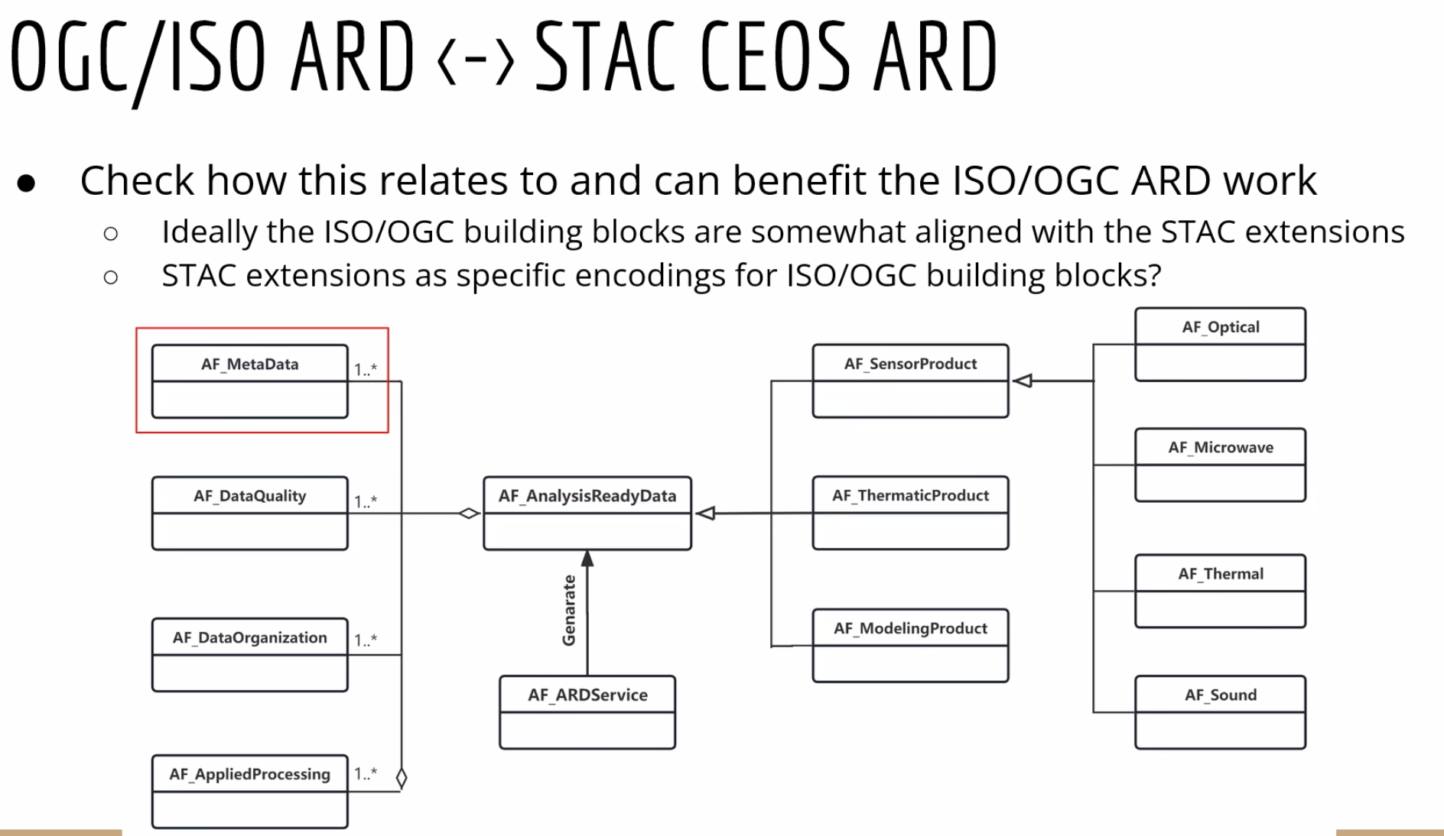
- The CEOS-ARD STAC Extension has been simplified by not including all optional requirements.
- “Profiles” have been created for optical and microwave.
- The Extension will be extended to cater for the new PFS as well.
- Draft for optical is available in the repository, pending some clarifications.
- Updates may be necessary if the Optical PFS is merged.
- A review by CEOS is sought, and efforts will be made to create some example datasets.
- Matthias has started working on an example for Sentinel-2.
- Radar is planned for 2024. The process requires a lot of discussions for new STAC extensions in approximately 30 fields. Support is needed from SAR experts to help accomplish this.
- The draft extension for optical can be found at github.com/stac-extension/ceos-ard.
Discussion
- Matt Steventon (LSI-VC Sec) noted that it was agreed in principle earlier today to do the passive optical (spectroradiometers) combination. The next step involves examining areas where parameters have different requirements and definitions.
- Steve Labahn (USGS, LSI-VC Co-Lead) commended the progress achieved so far and thanked Matthias for his efforts. Steve sought clarification on the optional comments, particularly regarding the Goal requirements. There are many things that could be done to meet the Goal requirement, so it is not a trivial mapping to STAC. STAC allows you to link to existing metadata. If e.g. S2L2A is directly peer reviewed to be CEOS-ARD compliant, then the metadata is available already, linked via STAC. This would not be in the STAC file directly as STAC primary use case is search and discovery.
- Is this covered in the STAC best practices activity in WGISS? Matthias has heard about it, and looked at it a few times but it has not been discussed within the STAC community. The work that Matthias is doing is aligned with what he has seen of the CEOS STAC Best Practices.
- Ake Rosenqvist (JAXA) asked a question about field names, noting the use of ‘ceos_ard’. Is there any reason why a dash isn’t used? A decision was made to use CEOS-ARD specifically for search engine optimisation. A dash is allowed in STAC in principle but best practice is to use underscore. It would be better to remove the dash, and leave no space. Depends which is preferred, ceos_ard or ceosard. Only the fields which have underscore, everything else uses dash.
- CEOS will have the opportunity to review before it is published.
- It was emphasised that the combined optical PFS should be finalised before the STAC extension is published.
- Peter Strobl (EC-JRC, LSI-VC Co-Lead) raised a concern regarding the categorisation of 'Optical' versus 'Radar' at the same level. He suggested that if the criteria is wavelength range it would be 'Optical' vs. 'Microwave' and if it is sensor class it would be 'Spectroradiometer' vs. 'Radar'.
LSI-VC-15-20 | Matthias to change field names from ‘ceos_ard’ to ‘ceosard’ in the CEOS-ARD STAC Extension. | COMPLETE

Decision 08 | Will wait until progress is made on the Combined Optical PFS before publishing the new CEOS-ARD STAC Extension.
CEOS Interoperability Framework [Slides]
Nitant Dube (ISRO, WGISS Vice Chair) reported:
- WGISS is developing a second version of the CEOS Interoperability Handbook, originally from 2008. This is following on from the work in recent years to develop the CEOS Interoperability Framework.
- The objective is to provide guidance for development of interoperable data and services and assist measurement of their maturity level.
- WGISS will also develop an Interoperability Maturity Matrix, to help agencies assess their level of interoperability.
- The draft handbook will be presented during WGISS-58 in October 2024, with the final version planned for endorsement at CEOS Plenary 2025.
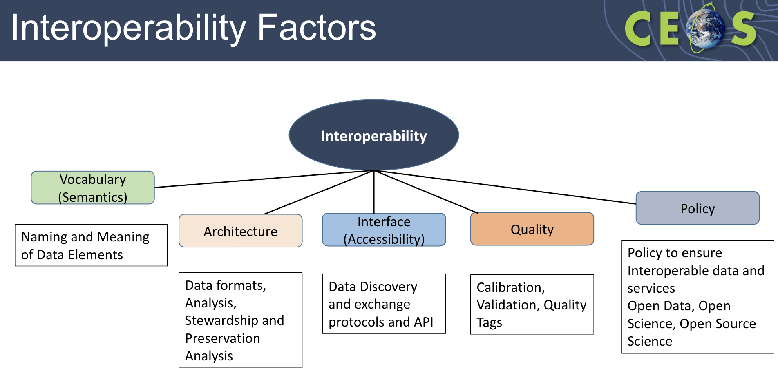
- The idea is to link existing and completed CEOS activities to the various factors. WGISS is working on adding to the list of activities.
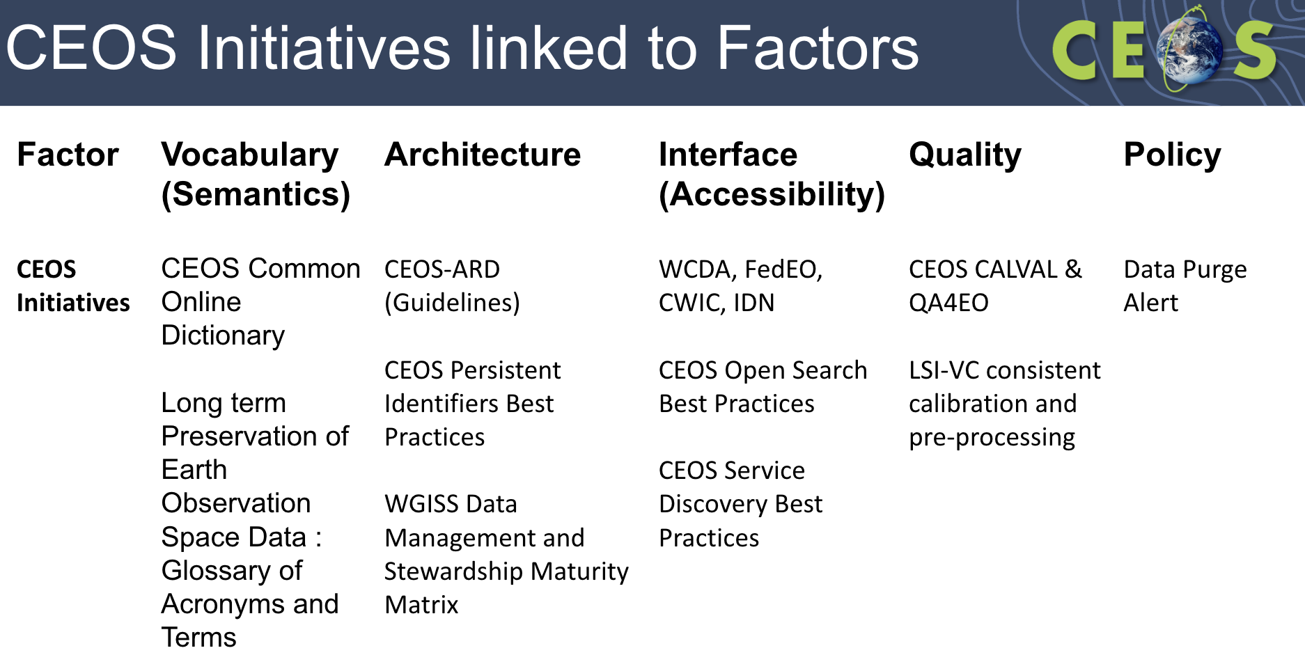
- LSI-VC will play a key role in the Vocabulary, Architecture and Quality factors. Peter Strobl has agreed to champion the Vocabulary factor.
Discussion
- It was suggested to note support for the Interoperability Framework and Handbook in the CEOS-ARD Strategy 2024.
- Nitant Dube (ISRO, WGISS Vice Chair) noted that WGISS is not planning to develop a highly technical document but rather leverage existing work and provide recommendations about what guidance to follow to achieve better interoperability. The focus will be consolidating capabilities already available within CEOS, bringing them together in one place.
- Steve Labahn noted that LSI-VC is a key contributor to the Architecture piece. He suggested utilising and referencing the CEOS-ARD Governance Framework in the Interoperability Handbook.
- It was suggested that perhaps LSI-VC could help bring a user perspective for the Quality factor.
- Dave Borges (SEO) asked for the WGISS team’s thoughts on commercial engagement with the CEOS Interoperability Framework. For example, their input would be helpful for the EULAs section in the policy factor. Dave referenced the various related outcomes, recommendations and deliverables from the CEOS New Space Task Team. Nitant noted that further guidance is needed on the policy sections and SEO input would be very welcome.
LSI-VC-15-21 | Steve and Matt to consider how the CEOS-ARD Governance Framework can be input to the CEOS Interoperability Handbook v2.0 of WGISS. | June 2024

Thursday, April 4
Session 4: Land Surface Imaging Requirements [Slides]
Essential Climate Variables
Matt Steventon (LSI-VC Secretariat) noted there are two distinct items to cover during this session: 1) inputs to the WGClimate Coordinated Action Plan, and 2) inputs to the Space Agency Response to the GCOS Implementation Plan.
The WGClimate Coordinated Action Plan includes actions based on the ECV Inventory Development Cycle #2. There are three recommendations that are targeted directly at LSI-VC:
- Recommendation #19: The CEOS Land Surface Imaging-Virtual Constellation (LSI-VC) to coordinate on the formulation of future high resolution missions and seamless continuity of sustained Land Surface Temperature CDRs.
- Recommendation #20: The CEOS Land Surface Imaging-Virtual Constellation (LSI-VC) together with WGCV and WGClimate to devise a way forward for the combined use of past, current and future instruments to create sustained Land Surface Temperature CDRs.
- Recommendation #21: LSI-VC should assess the climate user community needs for LAI data records that are not currently being exploited from existing missions (e.g. Sentinel-2, Landsat), and inform WGClimate of their findings to enable further planning for needed LAI data records.
There are a few specific actions in the Space Agency Response to the GCOS IP for LSI-VC as well.
Wenying Su (NASA, WGClimate Vice Chair) reported [Slides]:
- The Global Climate Observing System (GCOS) was established in 1992 by WMO, IOC/UNESCO, UNEP and ICSU. GCOS was mandated to define objectives and recommend coordinated actions for a global observing system for climate, building on and enhancing existing systems.
- GCOS established the Essential Climate Variables (ECVs) in 2003. An ECV is a physical, chemical, or biological variable or group of linked variables that critically contributes to the characterisation of Earth’s climate. The concept has now been adopted by other domains as well, including Agriculture and Biodiversity.
- Identification criteria include relevance, feasibility and cost effectiveness.
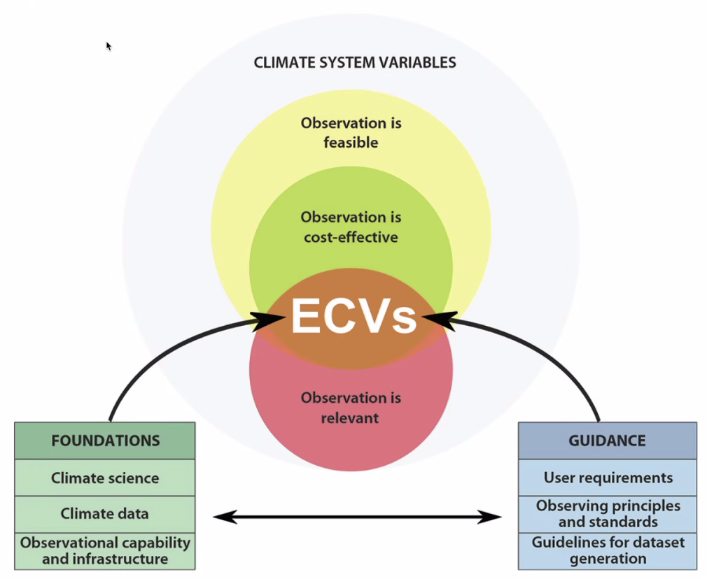

- There are currently 55 ECVs. Each ECV can include multiple parameters, meaning there are over 200 ECV parameters.
- There are 20 land ECVs, broken into four categories: cryosphere, anthroposphere, biosphere and hydrosphere.
- 38 of the ECVs are observable from space, including 16 land ECVs (in yellow below). Peter comments: I would distinguish between what is directly observable and what can be derived or inferred (indirect observation depending on other inputs). AGB is not (yet) directly observable. LC might be depending on the class definitions ('Forest' in many cases is not directly observable, meaning other data such as administrative boundaries are required).
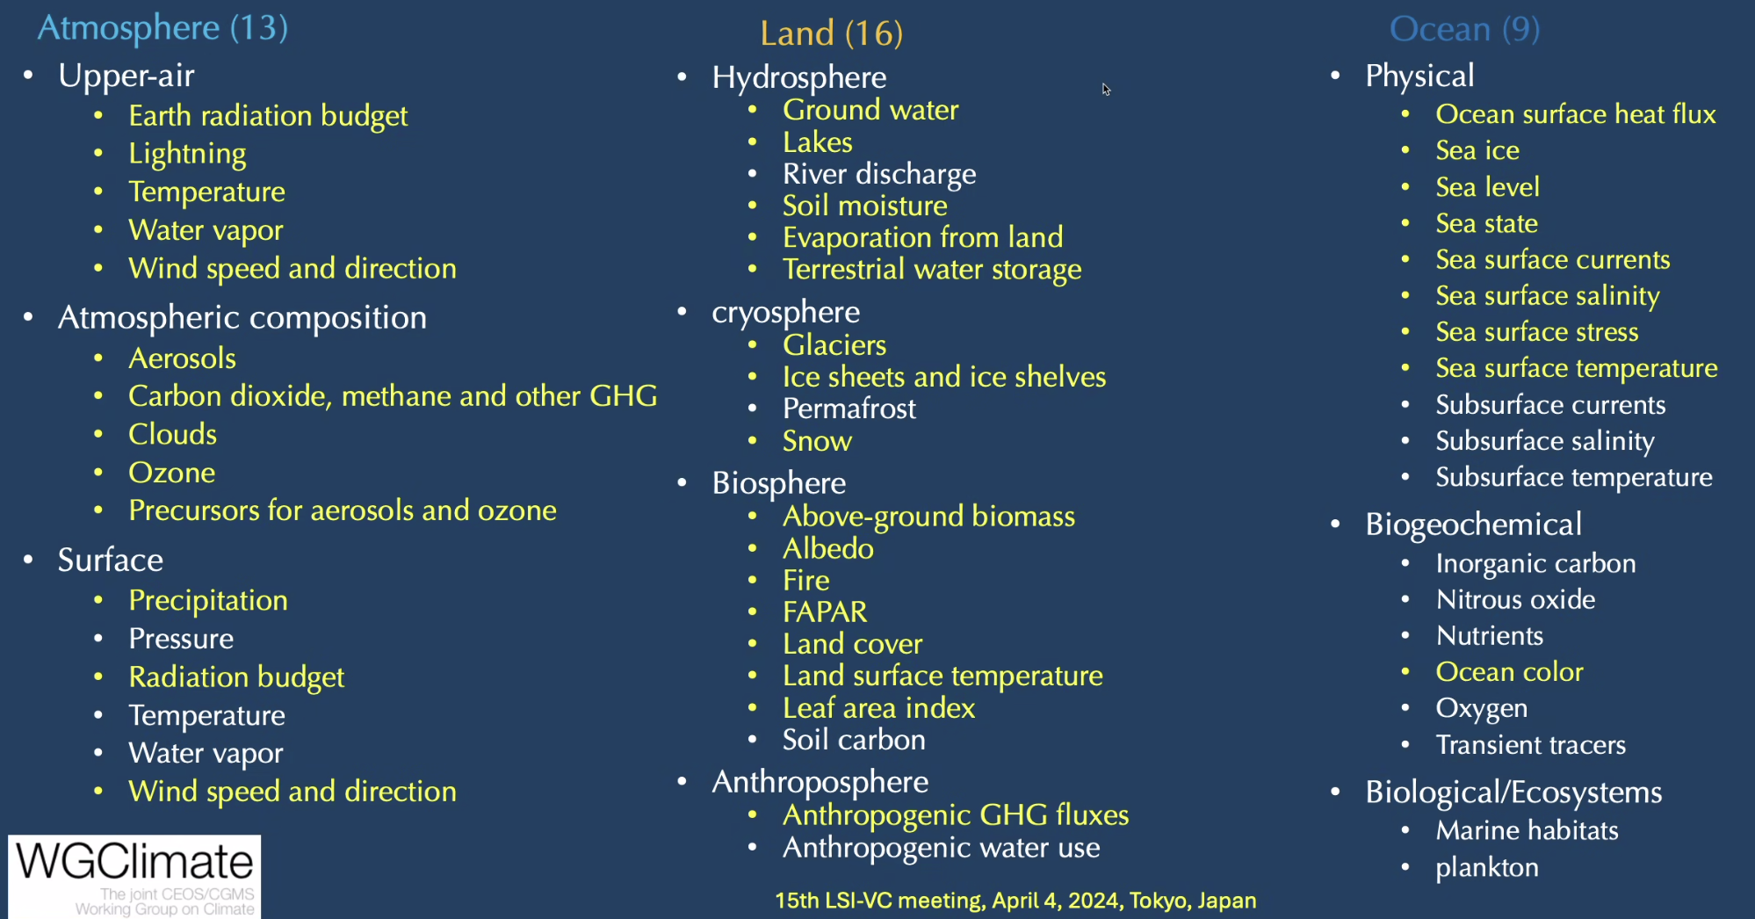
- Permafrost is not currently observable from space, but there is an action in the GCOS IP for space agencies to develop capabilities to measure permafrost.
- The overarching goal of the joint CEOS/GCMS WGClimate is to improve the systematic availability of Climate Data Records (CDRs) through the coordinated implementation, and further development of the Architecture for Climate Monitoring from Space.
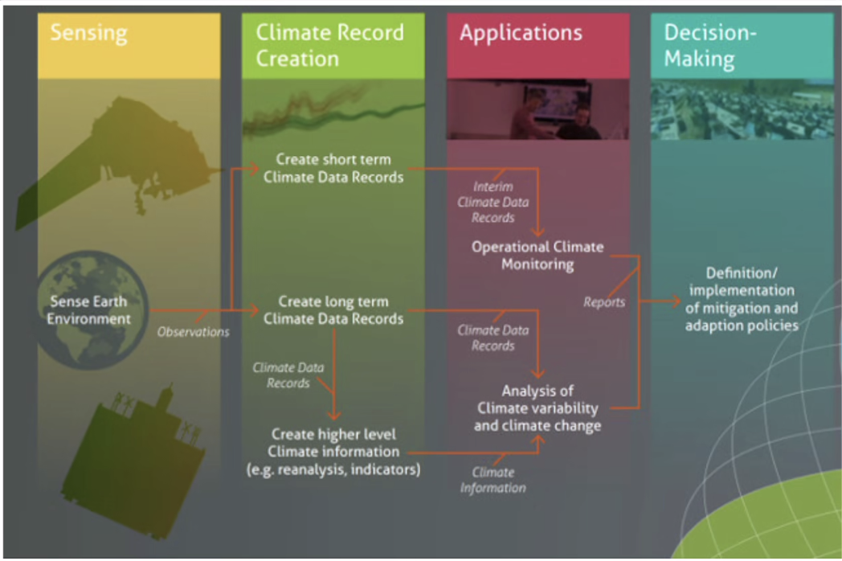
- The ECV Inventory provides a comprehensive view of existing and planned CDRs. There are over 1000 current and planned CDRs. Below are the number of CDRs for each land ECV.
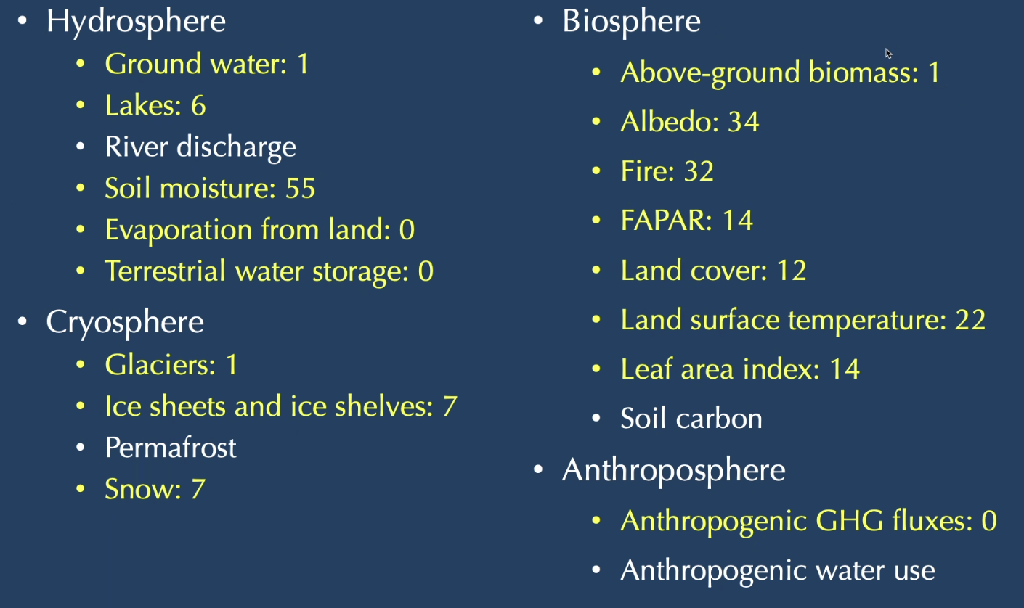
- Only one existing CDR for Land Surface Temperature has a spatial resolution fine enough to meet the GCOS requirement (30 m).
- For all land-related actions in the GCOS Implementation Plan 2022, teams are in place to address them. LSI-VC is invited to review the WGClimate responses to these actions to ensure they are accurate and comprehensive.
- The LSI-VC related actions from the GCOS IP are below:
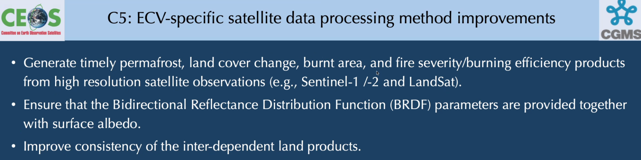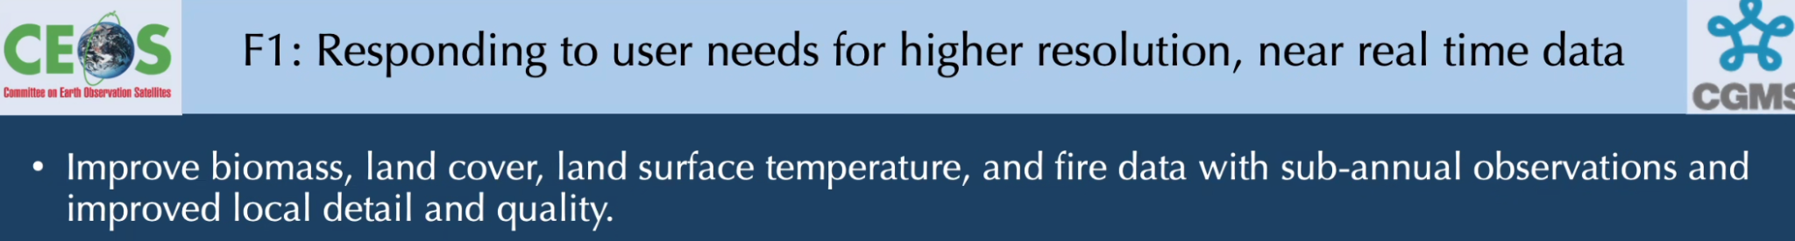
Discussion
- The resolution requirement depends on GCOS standards. High resolution is 10-30 m for these variables. Wenying was uncertain about the latency definition for NRT.
- Steve Covington (USGS) asked about the quality metrics associated with these measurements and their definitions. Surface reflectance products could contain different types of corrections. He asked whether the definitions were clear on what constitutes an ECVs, and if quality metrics were included.
- Wenying noted GCOS maintains a dedicated page for each ECV on their website, outlining requirements for baseline, threshold and target. These requirements include specifications for temporal and spatial resolution. The ECV Inventory compares the GCOS requirement to the outputs from the satellite products, facilitating detailed analysis. Wenying suggested that expert analysis on specific parameters would be beneficial.
- Wenying Su noted that there has been advocacy towards making GCOS requirements application-specific, catering to the needs of decision-makers. While more accurate datasets may be desirable, they may not require high resolution or low latency.
- Darren Ghent (NCEO/University of Leicester) added that when GCOS set the requirements for each ECV, they consulted with the user community. A user survey involving nearly 100 users was conducted and requirements had to be backed up by a publication. While the ECV requirements document initially specified 1 km resolution for surface temperature, the implementation plan acknowledges emerging needs for higher resolution data. Space agencies are asked to determine the future missions that will address these needs.
- Tim Stryker (USGS) noted that there are intersecting circles between what is achievable and what is cost effective. He noted that the ideal may not be achievable with existing technologies.
- Stephen Ward (LSI-VC Secretariat) noted that IPCC requires 30 m resolution for biomass data.
- All requirements are traceable on the GCOS ECV website. The three requirements, threshold, baseline and target are progressively more difficult to achieve.
- GCOS requirements are sometimes aspirational. Addressing all of the requirements may not be within scope or feasibility of missions.
- Steve Labahn (USGS, LSI-VC Co-Lead) asked whether there has been a reverse mapping of how the different satellites support each observational requirement. Wenying noted that while some ad hoc efforts have been made, there had not been a systematic approach to such an analysis. There are some specific actions to address observational gaps and this is where WGClimate does most of the mapping. It would be beneficial to see how future missions like Landsat Next might be able to support ECVs.
- Wenying noted that there is a lack of high resolution LST datasets to meet the stated GCOS requirement. Landsat Next would be part of the conversation. Wenying proposed that LSI-VC review and comment on WGClimate’s draft response.
- Eric Vermote (NASA) stressed the importance of advocating for data continuity, especially with MODIS nearing the end of its operational life.
- Wenying added that data continuity is part of the GCOS discussion, with five to six categories of actions focused on filling gaps and continuity. Consistency of land datasets is important.
- WGClimate is in the process of drafting a response to the GCOS IP. Some sections have been drafted and reviewed by the GCOS panel. It can be shared already. Permafrost is one area where more effort is needed to develop remote sensing techniques from space. Satisfactory response has not yet been achieved and expert input on this matter would be appreciated. A full draft of response is expected by the 2024 SIT Technical Workshop.
- Steve Labahn (USGS) asked about the distribution of gaps across the different levels of requirements. Wenying noted that the gap analysis has been conducted for certain variables, with a report published in 2018. Although plans for a subsequent gap analysis were made, it has not yet been completed. However, efforts to resume this work have commenced recently, with the aim of completing it in the coming months. Prioritisation of these gaps will also need to be addressed.
- If there are specific variables which LSI-VC would like to see considered in the ECV Inventory Gap Analysis Report, suggestions are welcomed.
LSI-VC-15-22 | Wenying to share the latest ECV Inventory Gap Analysis Report with LSI-VC for review. LSI-VC input to prioritise the gaps would be helpful. | May 2024
LSI-VC-15-23 | Wenying to share WGClimate’s draft responses to the GCOS Implementation Plan that relate to LSI-VC for review by the team. | May 2024
Land Surface Temperature Climate Data Records & GCOS Implementation Plan Response [Slides]
Darren Ghent (NCEO/University of Leicester) reported:
- There are two recommendations in WGClimate’s Coordinated Action Plan for LSI-VC related to the fact there are currently no sensors at 10-30 m resolution for the thermal channels, even future ones.
- Climate Data Records (CDRs) are robust, sustainable, and scientifically sound climate records that provide trustworthy information on how, where and to what extent the land, oceans, atmosphere and ice sheets are changing. These datasets are thoroughly vetted time series measurements with the longevity, consistency and continuity to assess and measure climate variability and change. CDRs can be broken into three categories:
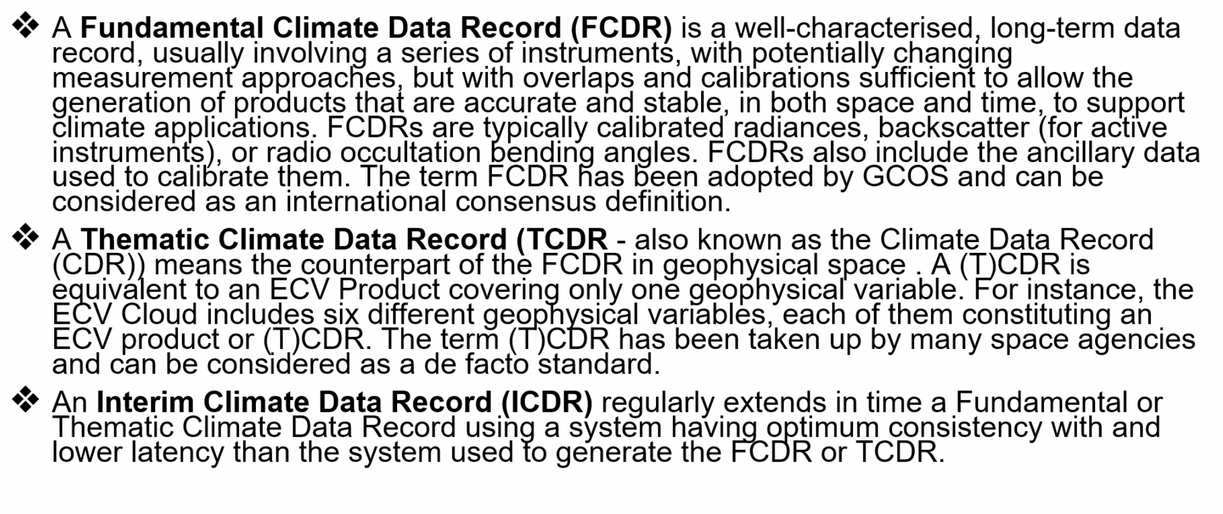
- For Land Surface Temperature (LST), the CDR requirements are as below (G = goal, B = breakthrough, T = threshold).
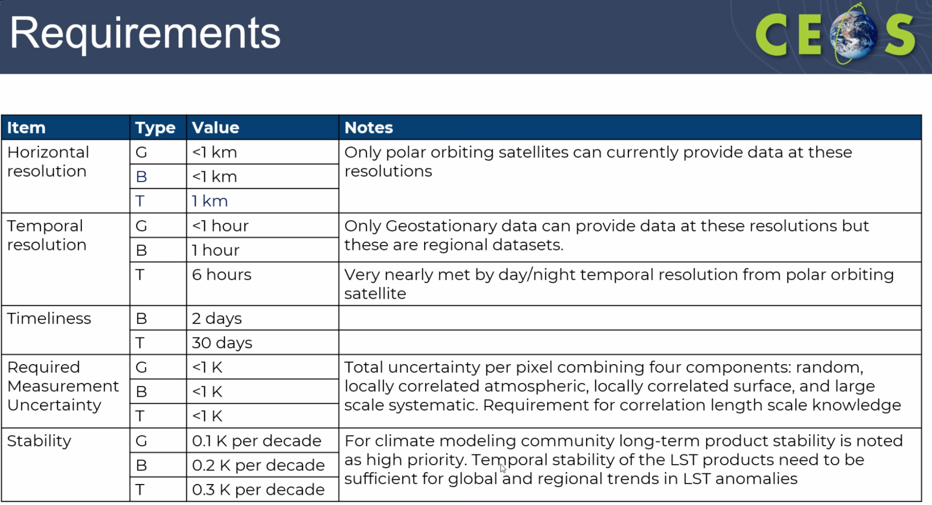
- Urban applications often need higher resolutions to determine how climate is impacted on a block-by-block basis.
- It is often needed to combine different sensors to meet all the requirements - e.g. one sensor may meet the horizontal resolution requirement, but not the temporal. GCOS is aware this cannot be met by single sensors.
- To build a CDR for LST, data records from multiple sensors need to be consistently processed and harmonised. Consistency in processing includes retrieval algorithms, auxiliary data, cloud masking and uncertainty models.
- Assessments for stability are very important. The CDR needs to be assessed against an independent reference source. For LST this is often homogenised near-surface air temperature anomalies.
- The ESA Climate Change Initiative (CCI) LST CDR uses measurements from GOES, SLSTR, Merged IR, ATSRs, SSM/I, GOES.
- There is no independent assessment of the quality of the CDRs reported in the ECV Inventory. LST data products are usually validated but not assessed for long term-stability.
LSI-VC-15-24 | LSI-VC to consider adding a long-term stability parameter to future iterations of the Surface Temperature/Combined Optical PFS. | LSI-VC-16
Discussion
- Darren noted that the CCI version of the MODIS LST product is a CDR, as it has been assessed and homogenised across the dataset. Spatial resolution is 1 km at nadir, but not at the edge of the swath.
- For a dataset to qualify as a CDR uncertainties must be assessed, the uncertainty model must be validated against ground truth data, and all documentation must be traceable.
- Kelly Bruno (USGS) noted that USGS is working on a response to F1:
- Eric Vermote asked whether this is a clear definition of stability, suggesting that assessing it per decade may not be the most effective approach.
- Matt Steventon (LSI-VC Secretariat) asked how these measurement gaps and issues are communicated to space agency leadership. Darren noted that responses from space agencies will be forwarded to GCOS. Effectively it will be a CEOS reply to GCOS. Matt acknowledged this but suggested that more needs to be done to communicate the findings in the response back up to CEOS leadership. He noted for example that these types of issues with measurement continuity would be ideal topics for next week’s SIT-39 meeting, but these topics are not given visibility at CEOS leadership level meetings.
- Tim Stryker (USGS) agreed that the information needs to be connected to agencies’ planning for next generation system architectures. More could be done to ensure these requirements that come up in the frame of CEOS are suitably connected to agency mission planning.
- Steve Covington (USGS) noted that USGS considers stability over the orbit (minute scale) rather than decades. USGS is not currently measuring stability in the way GCOS is thinking. USGS does not include a long-term stability metric for their products.
- A joint action for WGClimate and LSI-VC was suggested to establish a mechanism to regularly get these requirements into SIT discussions and raised for awareness of CEOS Principals.
- In the context of the GCOS requirements, threshold is what we should be aiming for, breakthrough is the next level of requirement, and goal is more of a future ambition.
- Copernicus uses Fiducial Reference Measurements (FRM) and there is an ongoing effort within WGCV to establish a network of thermal reference sites (TIRCalNet).
LSI-VC-15-25 | LSI-VC Leads to consider a joint initiative with WGClimate to increase communication of observation gaps (starting with the LST CDR case) to CEOS Principals, including via discussion at SIT / other CEOS leadership meetings. These types of issues are underrepresented at CEOS leadership level meetings. These findings, achieved in the frame of CEOS, need more opportunities to impact agency mission planning processes. | June 2024
CEOS Ecosystem Extent Task Team (EETT) Demonstrators [Canada] [Australia] [Costa Rica]
Shaun Levick (CSIRO, EETT Co-Lead) reported:
- CSIRO is leading one of the three demonstrators initiated under the CEOS Ecosystem Extent Task Team (EETT).
- The Great Western Woodlands project is an “arid zone” case study to complement the Hudson Bay Lowlands (wetlands) and Costa Rica (tropical forest) demonstrators.
- The project will integrate multiple sensors, including multi-spectral, SAR and lidar.
- GWW is the largest remaining area of temperate woodlands on Earth with significant biodiversity and cultural values, covering 160,000 km².
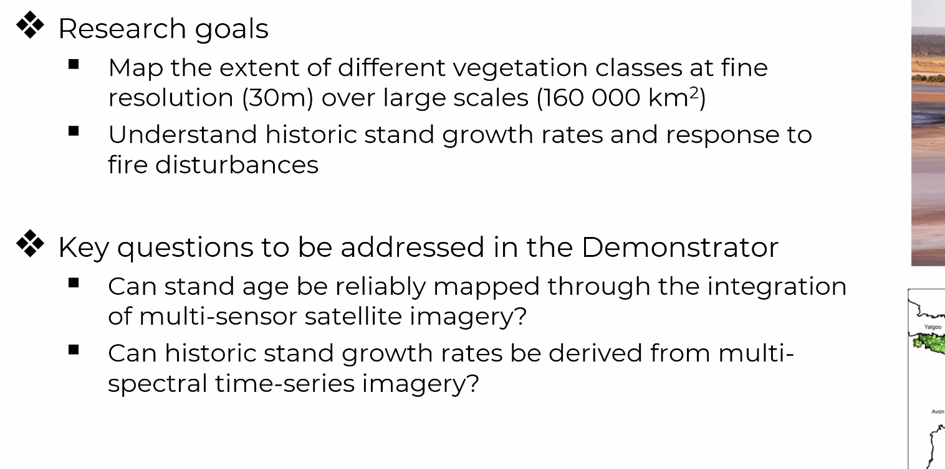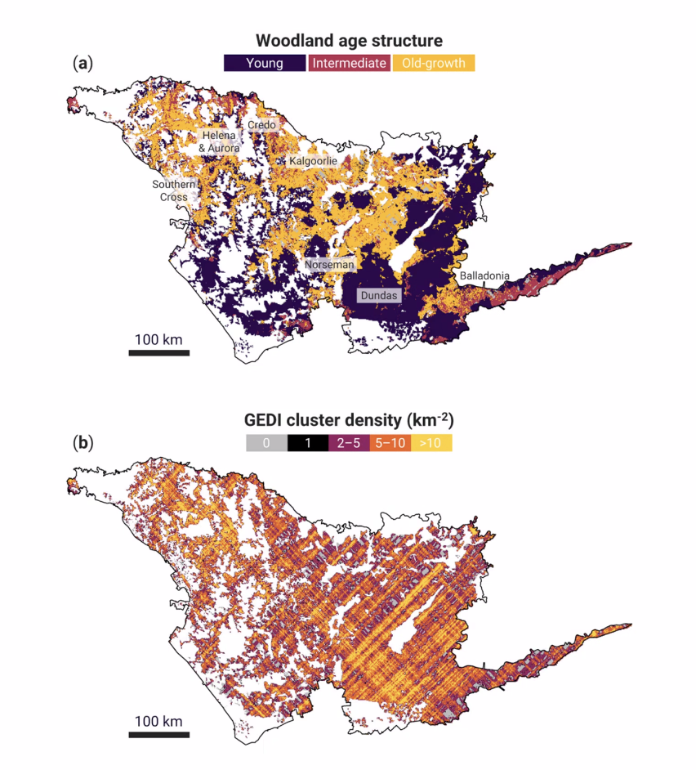
- The project will use the EASI platform, which is underpinned by the Open Data Cube. They are exploring the use of Landsat, Sentinel, GEDI and ALOS data. Would also like to use multi-wavelength SAR to classify vegetation.
- Funding extends beyond the 2024 CEOS Plenary, and will shift to other components of biodiversity – including measures of structural and floristic diversity.
Discussion
- NovaSAR-1 data is part of the longer term plan for the multi-wavelength SAR work.
- EETT is using Sentinel-1 data sourced from Digital Earth Australia.
- It was noted that EnMAP hyperspectral data is also CEOS-ARD compliant.
- Shaun noted that for the initial workflow development, the pixel size is 90 m. It will be 30 m when doing the final product. Over the course of 25 years, this amounts to approximately 150-200 GB of data for the entire area.
- Shaun noted that CEOS-ARD products aid ingestion pipelines into Data Cube format. Having data in CEOS-ARD format is particularly beneficial.
- Shaun has been using ALOS PALSAR global mosaics, which are CEOS-ARD compliant, making it easy to ingest. Shaun confirmed this and explained that the mosaics simplify things greatly. A postdoc will be in contact with the JAXA team for more information about non-mosaic ALOS CEOS-ARD products.
- Ake mentioned the JAXA team is in contact with the Canadian Hudson Bay Lowlands Demonstrator team, providing all available data over the area.
- Shaun noted there is not much cohesion between the three demonstrators at the moment but expressed hope for improvement.
- From JAXA's side, there is an interest to provide more guidance on how best to use the ALOS datasets.
- Eric Vermote (NASA) asked how the usage of the CEOS-ARD dataset is tracked. Ake noted that for JAXA, there are statistics available on the number of downloads, etc.
- Dave Borges (SEO) noted that the CEOS communications team work to promote CEOS-ARD, including via the CEOS-ARD social media presence. Chris Barnes (USGS) suggested that it would be beneficial to highlight examples of CEOS-ARD aiding the researching community, e.g., via Digital Earth Africa.
LSI-VC-15-26 | Matt to ask agencies to report on uptake of CEOS-ARD products at LSI-VC-16. The goal is to try to understand the impact of CEOS-ARD. Looking at download metrics, trends following release of a CEOS-ARD product, or user survey could be some approaches. Qualifying direct impact will be challenging and should be considered aspirational. | LSI-VC-16
LSI-VC-15-27 | CEOS Communications Team to include a CEOS-ARD example in the work to demonstrate the impact of CEOS. Quotes from users will need to be provided. | July 2024
- Steve Covington (USGS) suggested promoting CEOS-ARD to data providers, emphasising the benefits and reasons why they should do it.
- Examples showing where money was saved and science excelled because input data was CEOS-ARD formatted would be ideal.
- Dave Borges noted that commercial companies like Maxar and Planet sell ‘ARD’ products. It is an appealing marketing strategy. Steve Labahn mentioned having discussions with these companies about it. Maxar customers are often more interested in higher level products, rather than Level 2, which are the focus of CEOS-ARD.
- There is a role for CEOS in helping the commercial sector clarify what they are doing with ‘ARD’. CEOS-ARD provides a concrete definition. It would be interesting to see how these ‘ARD’ products compare.
JAXA Update on Ramsar Scientific and Technical Review Panel (STRP) [Slides]
Ake Rosenqvist (JAXA) reported:
- The Ramsar convention on Wetlands was established in 1971 in Ramsar, Iran. It includes 172 contracting Parties, and the Parties meet every three years.
- The convention has four strategic goals:
  - Address the drivers of wetland loss and degradation;
  - Conservation and management of the Ramsar Site Network;
  - Wise use of all wetlands (conservation and sustainable use of wetlands and all the services they provide, for the benefit of people and nature);
  - Enhancing implementation of the Convention.
- One of the four bodies includes the Scientific and Technical Review Panel (STRP), which has a similar function to the UNFCCC SBSTA.
- JAXA and ESA are observer organisations to STRP with Osamu Ochiai and Ake as representatives from JAXA, and Marc Paganini from ESA.
- The Ramsar List is a list of wetlands designated by the contracting parties, and includes 2400 Ramsar sites in 172 countries. However, information is lacking or outdated, with geospatial information on wetland extent lacking or inadequate. There is no information on wetland loss/degradation over time.
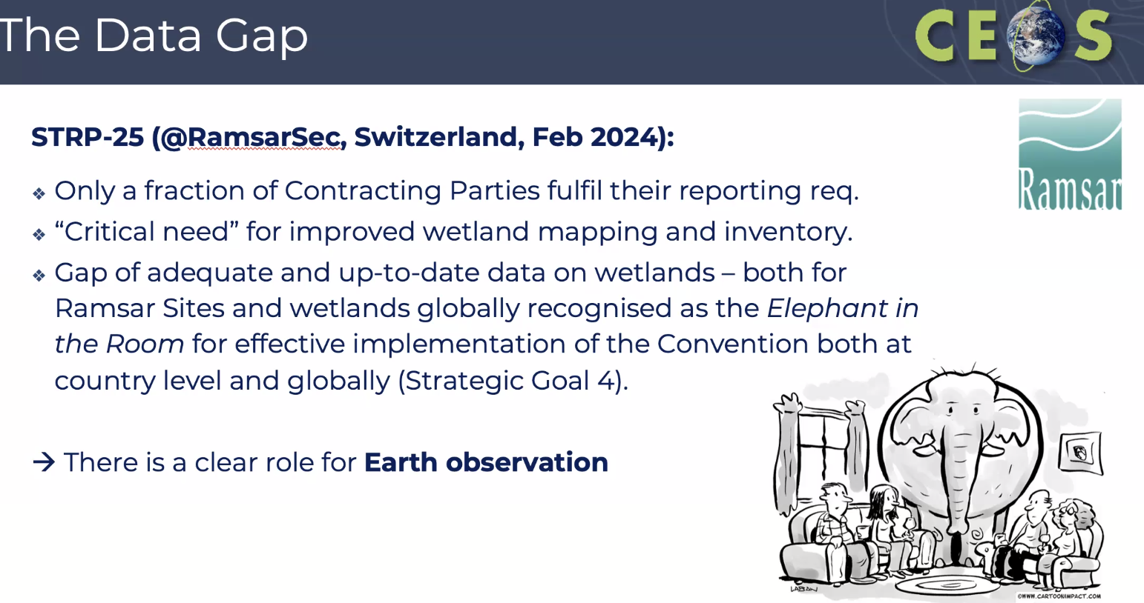
- There have been several discussions around how the convention can become more efficient.
- There are links to ongoing efforts in CEOS and GEO which are linked to wetlands, including the SDG work (Indicator 6.6.1), biodiversity and ecosystem extent work, AFOLU Roadmap, and GEO-Wetlands. The Global Mangrove Watch is used as a pilot product for the GEO Global Ecosystem Atlas.
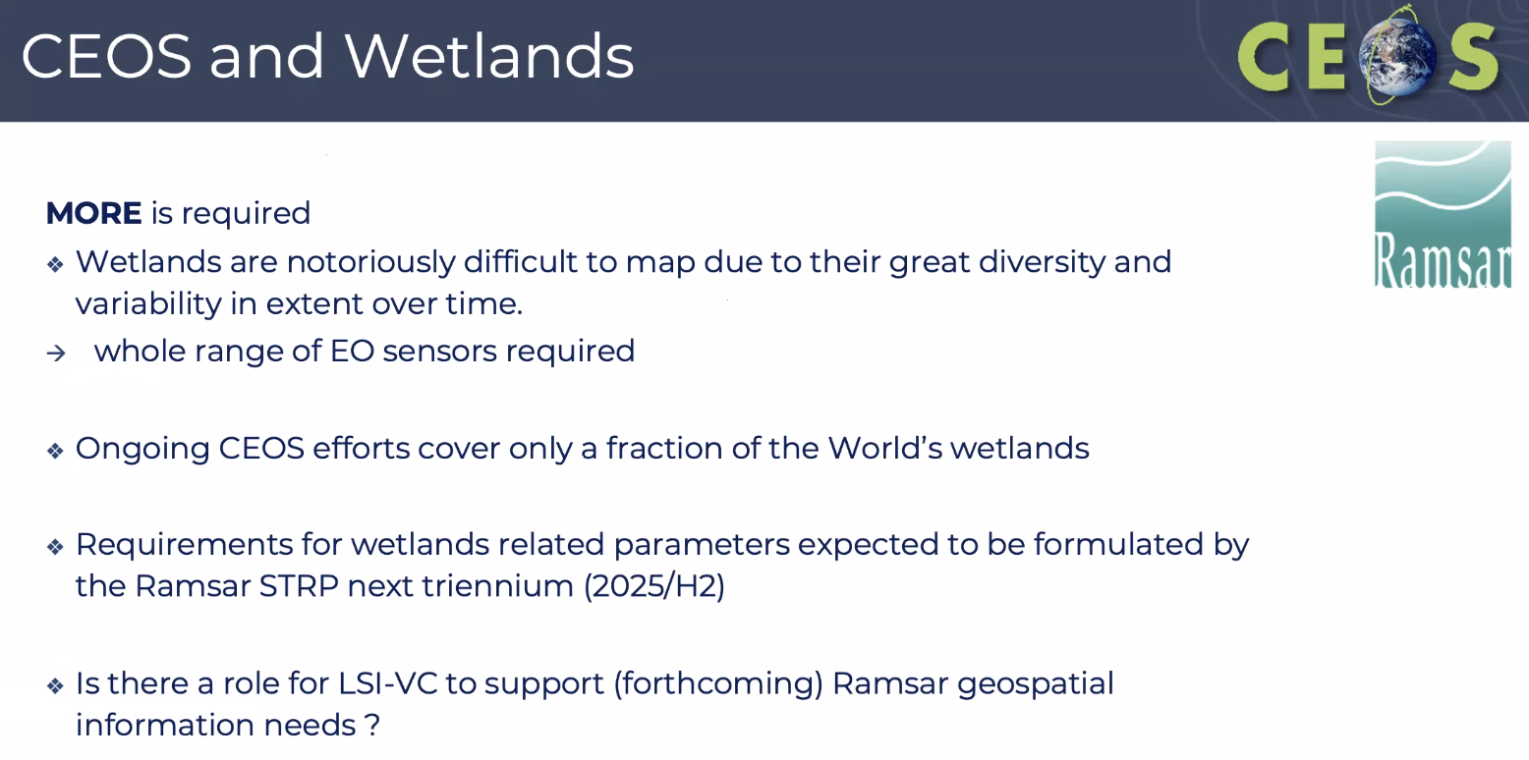
- Ramsar COP will meet in Zimbabwe in 2025.
Discussion
- Steve Labahn (USGS, LSI-VC Co-Lead) noted that South Dakota is a significant location for migratory birds. In the wetland area the local government has a good grasp of the situation. However, he pointed out that only one such area is marked on the map.
- Ake Rosenqvist (JAXA) noted that while developed countries have better tracking of many of the wetlands, not all are adequately monitored. He mentioned that the issue was raised at STRP about the lack of data, with more than 50 % of signatories failing to report. Understanding that this is partly due to lack of information and how they are changing over time.
- This is a clear multi-modal problem and CEOS-ARD could help facilitate. The exact role of LSI-VC would need to be clarified.
- The STRP might request input from CEOS. Ake foresees that in the next Ramsar work plan the lack of data over wetlands will be a headline. There needs to be some concrete requests from the convention, probably in the wording in the next Ramsar work plan. It would not be an ask for CEOS directly but, more likely, brought by JAXA and ESA to CEOS. LSI-VC might be able to influence the work plan. If there is some specific wording for CEOS to be able to act, LSI-VC could probably include it some way.
- From the Ramsar side, the approach is more bottom up. Global mangrove watch was started to support the Convention. Peatlands are challenging to map. ESA has a research announcement at the moment to support peatlands.
- Kelly Bruno (USGS) asked whether the sites have to meet all nine criteria to be considered a wetland, noting that there are only 41 marked wetlands in the US, which seems low.
- Ake suggested that information on spatial extent and changes over time would be something CEOS could very helpfully provide for the convention.
- There are clear linkages between wetlands and climate variables and the Global Biodiversity Framework.
- Dave Borges (SEO) noted that there will be a dedicated biodiversity side meeting about coordinating biodiversity activities in CEOS on 9 April next week. EETT will not necessarily disappear entirely at the Plenary, but its future form is uncertain.
- Matt Steventon (LSI-VC Sec) suggested focusing on the wetlands topic within LSI-VC and mentioned the COAST Virtual Constellation (TBC) may also be interested in this topic.
- Ake noted that wetlands are 90% land, so this is highly relevant to LSI-VC.
- Danilo Dadamia (CONAE) asked about wetlands monitoring over South America. Ake noted that all the South American countries are contracting parties of the convention and are supposed to be reporting, and participating in the COP meetings. There is currently no activity supporting the Ramsar convention in the region. At the agency level, JAXA is working on both the Global Mangrove Watch, and regional inundation using L-band SAR. There are a lot of activities going on in South America, but there is a need for more collective effort. Danilo expressed Argentina’s willingness to host a site. Danilo will discuss this with the appropriate government agency to propose new sites. CONAE participation in this activity would be welcomed.
LSI-VC-15-28 | Ake to work with Marc Paganini (ESA) to write a short report on how EO and CEOS can support the Ramsar Convention. This could include suggestions for wording to be included in the future Ramsar Work Plan revision. These inputs will be presented at LSI-VC-16. An LSI-VC Wetlands Subgroup might be a possible construct to formalise support. Matt to ensure there are wetlands sessions on future LSI-VC agendas. | LSI-VC-16
Session 5: Beyond ‘Level 2’ [Slides]
Matt Steventon (LSI-VC Secretariat) provided some context for this session. A number of groups have requested support from LSI-VC regarding higher level products – from domains including agriculture (GEOGLAM), biodiversity (Ecosystem Extent Task Team) and climate (WGClimate). There is a lot of overlap with the Essential Agriculture Variables (EAVs), Essential Biodiversity Variables (EBVs) and Essential Climate Variables (ECVs).
We have intentionally restricted the scope of LSI-VC to be Level 2 products, but all of these similar requests coming our way requires a re-examination of this scoping, as the current lack of clarity is confusing to partners and stakeholders.
Land related requests need a ‘home’ in CEOS. If not in LSI-VC Subgroups, where do these discussions happen in a coordinated manner? How do we avoid duplication of effort and interoperability and complementarity of the results?
If CEOS Principals agree that there is a role for CEOS in supporting higher level products such as these, LSI-VC will need to be the group to respond for land aspects.
We need to have clarity on our own scope, what it is we can feasibly do, what agency representation we need, and how our efforts fit into a broad, coherent hierarchy – to avoid overlaps, duplication, and to promote interoperability and complementarity of products.
Biodiversity Community Needs for Derived (Level 3 and 4) Products [Slides]
Gary Geller (NASA, Ecosystem Extent Task Team Co-Lead) reported:
- The biodiversity community has limited remote sensing technical capacity, and derived, higher level products are needed. EBVs and Indicators are always L3 or L4.
- A key finding/recommendation of the Ecosystem Extent Task Team was that: "CEOS agencies should support research and development of value-added biodiversity products and release the corresponding open source software. While agencies routinely produce Level 2 products such as surface reflectance, biodiversity users generally need higher level products--none of the EBVs or GBF indicators are Level 2 products, for example."
- Biodiversity is about the variety of life on Earth, covering Genes, Species and Ecosystems.
- The Essential Biodiversity Variables (EBVs) are analogous to the climate and agriculture variables. They are the set of measurements to capture the major dimensions of biodiversity and how it is changing.
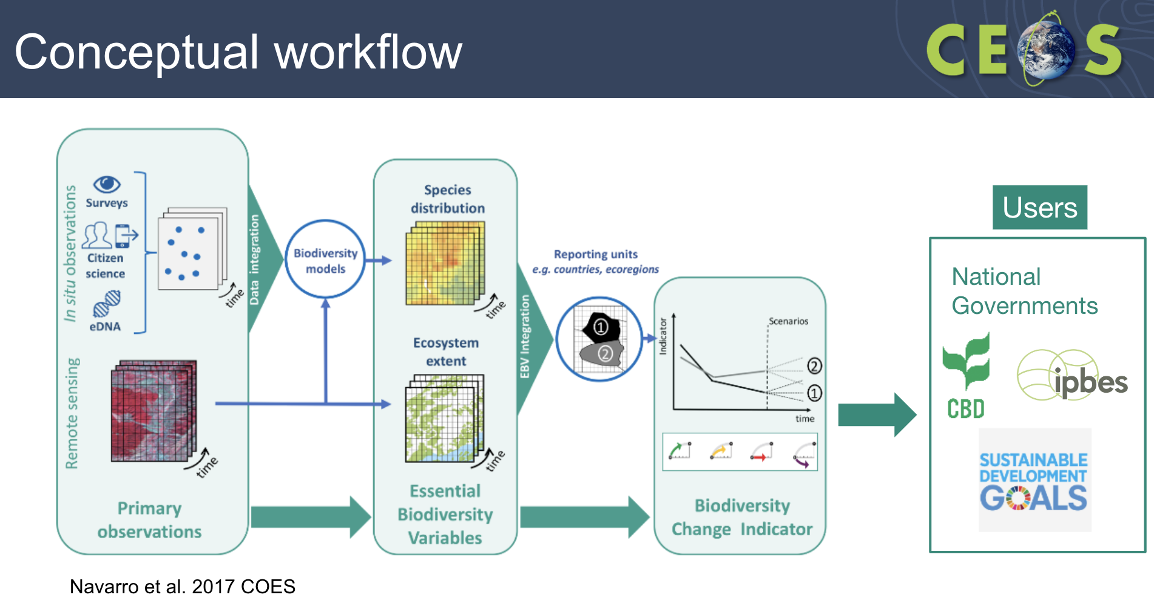
- Ecosystem condition is a good example, as it is a key input to many other products. Ecosystem condition is assessed via ecosystem components, including structure, function and composition.
- Workflows are mostly not operationalised, and product algorithms are often not available.
- One of the recommendations made in the Ecosystem Extent Task Team white paper was regarding support for R&D. This includes developing algorithms for value-added biodiversity products, released as open source software.
- However, this is only a partial solution, as there is limited technical capacity for processing and code updates etc.
- In an ideal world, CEOS Agencies would generate all EBVs and indicators. However, this is not feasible or within their mandates.
- Some product generation support would be good, with CEOS Agencies generating selected products and providing production options.
- Would LSI-VC be the appropriate group in CEOS to coordinate this for the land domain?
Discussion
- It was noted that LSI-VC as a coordination function seems to make sense.
- Alyssa Whitcraft (NASA, GEOGLAM) and Sven Gilliams (GEOGLAM) were surprised to see the similarities between the points raised in the context of agriculture and biodiversity. She suggested coordinating the messaging. If both are being presented to SIT then making the message the same would be helpful.
- Gary noted the clear connection with the Ramsar work related to mapping and condition.
GEOGLAM Essential Agriculture Variables [Slides]
Alyssa Whitcraft (NASA, GEOGLAM) reported:
- GEOGLAM has been in a close relationship with CEOS since the beginning. CEOS has previously provided responses to the GEOGLAM observation requirements. An updated set of requirements are now available, in the form of Essential Agriculture Variables (EAVs).
- Sven Gilliams is the new GEOGLAM Secretariat Director.
- The GEOGLAM community was surveyed in 2018. The results shown below are outdated but nonetheless interesting.
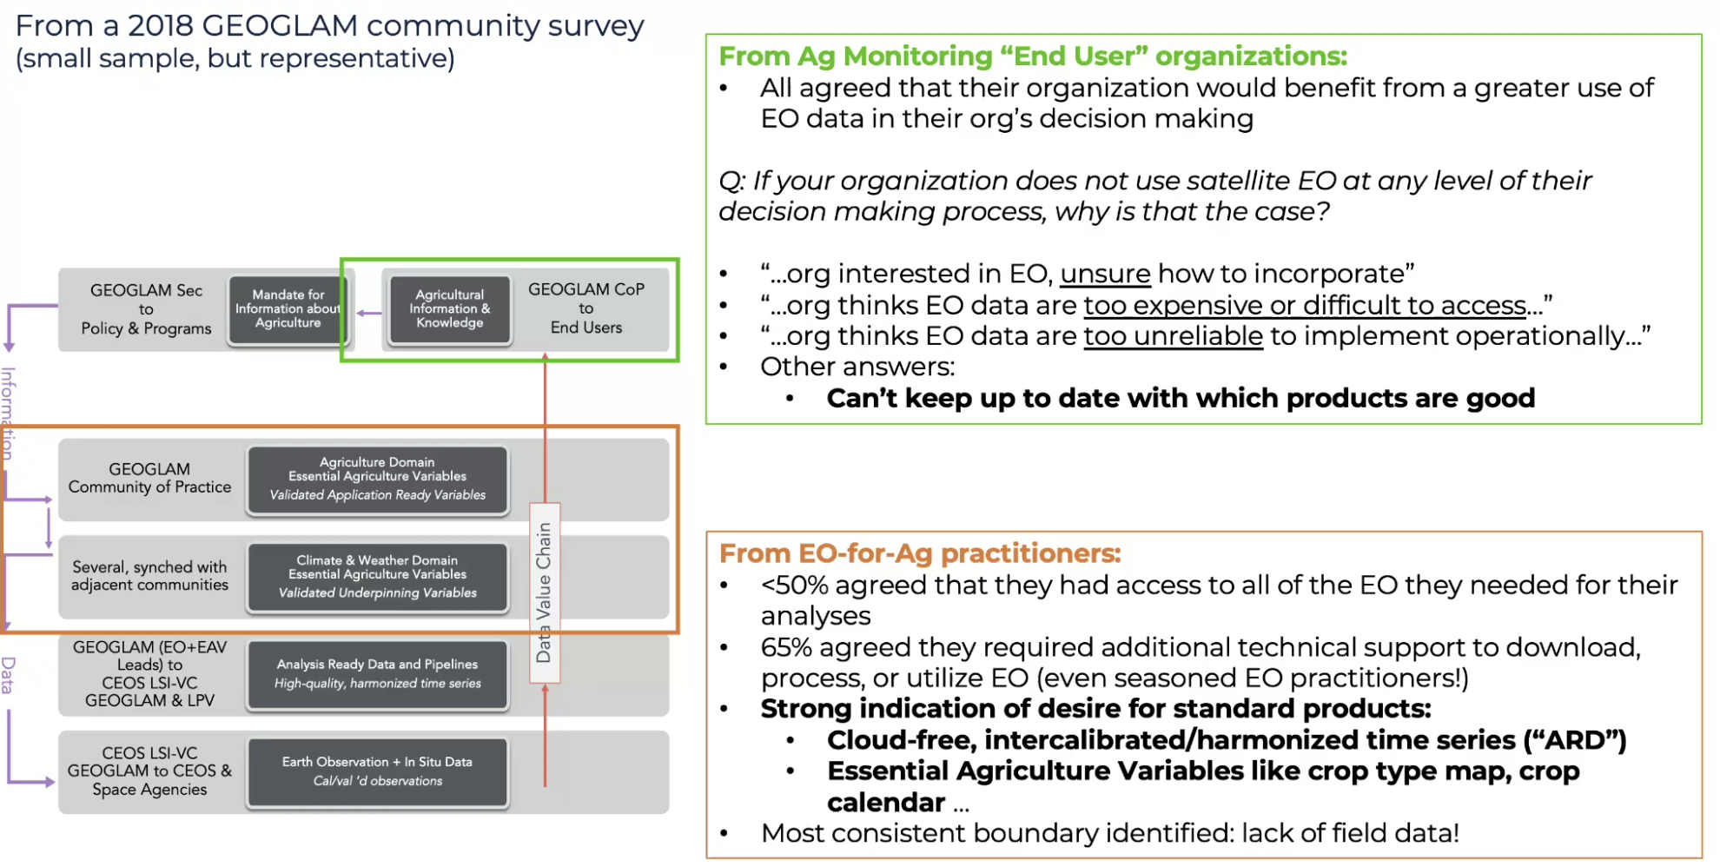
- After this survey, Essential Agriculture Variables (EAVs) were identified as a priority. It emerged as a unifying framework to maximise EO value and meet multiple information and decision needs.
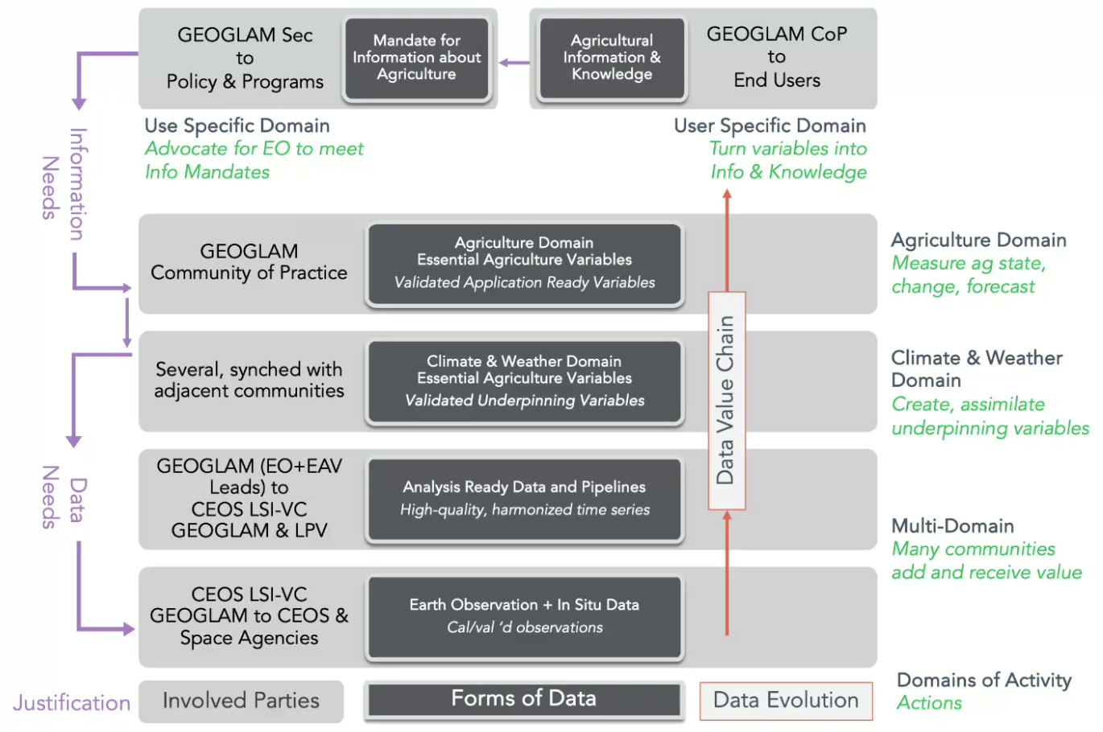
- EAVs are satellite-based building blocks that in combination with one another and/or other non-EO information support actionable, policy-required information on the state, change and forecast of agricultural land use and productivity.
- The first version of the EAVs were published in 2022, and in 2023 community priorities and supporting work areas were identified.
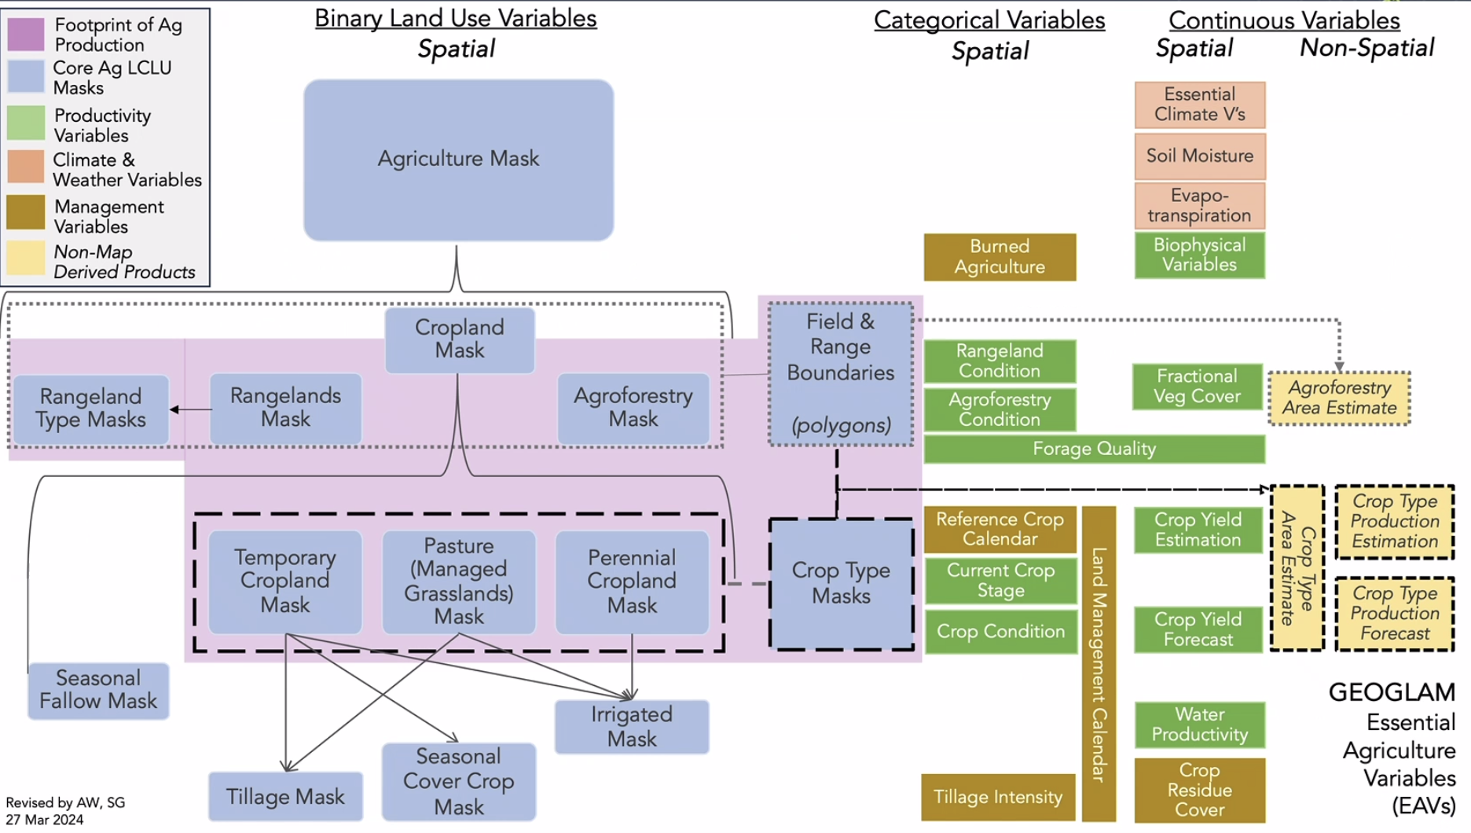
- The work areas include:
  - Defining EAVs – completed
  - Corresponding data requirements (satellite and in situ) – completed
  - Initiative of product quality – one workshop completed, another planned
  - Harmonisation with other communities (there is a need to align essential variables between agriculture and climate (done), biodiversity, etc.)
  - Gap analysis
  - Production of variables
- GEOGLAM has always been supported by community, bottom-up activities, with cross-cuts that address community needs and priorities. Multiple community projects are contributing.
- There remain critical gaps in the production of EAVs.
- The gap analysis work (below) informs observations and analysis platforms, as well as “science team” funding priorities.
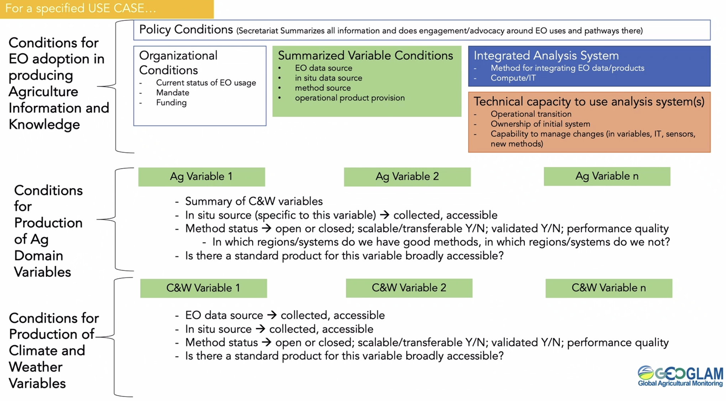
- Key areas for LSI-VC and GEOGLAM collaboration include:
  - Assessing gaps in satellite EO capabilities, with the SEO, MIM Database, USGS-RCA;
  - Identifying gaps and opportunities for easing access and utilisation of satellite data in the production of EAVs, including with WGISS;
  - Assessing methods status and quality, in cooperation with the WGCV Land Product Validation (LPV) subgroup.
- This work needs to be underpinned with strong space agency membership in the GEOGLAM Subgroup of LSI-VC.
- The following chart provides an overview of all the necessary connections between GEOGLAM and CEOS:
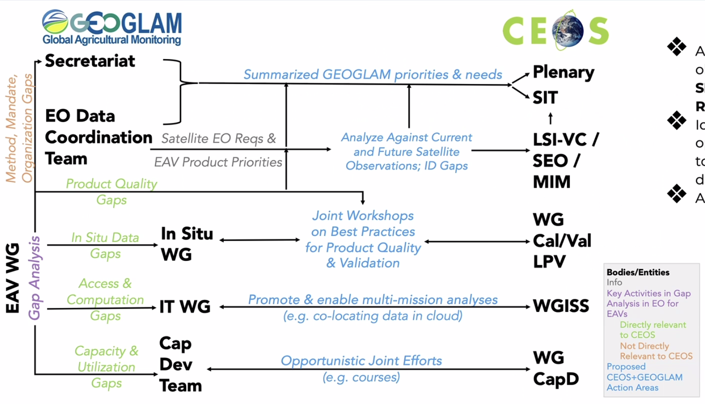

Discussion
- Alyssa noted validation efforts often involve training on data from previous years, and sometimes require in situ data from the year being validated to ensure accuracy. She mentioned that calibration/validation workshops focus on ensuring the correct validation of products and that there are various models available for running these validations.
- Alyssa noted that this is the first time since GEOGLAM was absorbed into LSI-VC that there is something for CEOS to respond to.
- Steve Covington (USGS) mentioned LCMap, which includes 25,000 validation sites in CONUS, produces a highly validated product.
- Alyssa emphasised the importance of ensuring quality in validation efforts. Some products currently available are of poor quality, particularly in the context of carbon credits and assessing the climate impact of agriculture. Alyssa suggested that efforts should also be directed towards improving the commercial aspect of validation work.
- GEOGLAM work in Japan is supported by the Asia-RiCE initiative and is a prominent working area within GEOGLAM.
- The process of creating an agriculture mask depends on the specific objectives you aim to achieve. Typically, it involves training satellite data on in situ data and applying standard classification methodologies. Agriculture masks may require more intricate considerations due to the significant seasonality within agricultural landscapes, particularly in regions where crops such as rice are cultivated with multiple growing seasons per year.
- Alyssa mentioned the availability of commercially available tillage mapping products, which provide around 70% classification within the same year.
- Steve Labahn highlighted that the focus of this core LSI-VC team has been to deliver tangible outcomes for CEOS-ARD. He believes there is an opportunity for higher level product work to happen within the subgroups and suggested that the core LSI-VC team could oversee some of the overlapping work. He suggested being open to taking a higher level approach in the subgroups specifically.
- There is uncertainty about the success of appealing to Principals for support. One option would be formation of other subgroups within LSI-VC to address different areas, e.g. wetlands, potentially through a bottom-up approach. It would be important to populate the subgroup, and start there.
- Stephen Ward (LSI-VC Secretariat) noted that to get CEOS to do something requires individual champions and motivated individuals. He suggested finding two or more agency champions to lead the GEOGLAM Subgroup and drive the work forward. He emphasised the need to keep things simple and start with the Principals next week at SIT.
- Alyssa mentioned having agency support for producing certain variables but highlighted the importance of cross-cutting efforts that enable the generation of high-quality data. She emphasised CEOS's role as a cross-cutting body.
Decision 09 | General agreement that it makes sense for LSI-VC to be the home for land related ‘beyond level 2’ thematic product discussions – specifically in the LSI-VC Subgroups, of which there could be more established. However this all hinges on staffing and having a couple of CEOS Agency champions for each theme.
- Matt suggested starting with a couple of EAVs that could be easily achievable targets.
- Sven Gilliams (GEOGLAM) noted that mapping products are already being worked on across various agencies, incorporating a mix of datasets. Efforts are being made to populate a common cloud with all the various data sources.
- While progress has been made in mapping, the next steps involve transitioning to interseasonal mapping and incorporating crop type information.
- There was discussion about the usage of platforms like Google Earth Engine (GEE), Copernicus Data Space Ecosystem (CDSE), and Amazon Web Services (AWS) within the agricultural community. Concerns were raised about dependency on GEE and potential vendor lock-in issues. The pricing tiers for cloud services were also highlighted as opaque, with uncertainty about future project costs. Alyssa emphasised the importance of establishing clear pricing principles with cloud providers to mitigate risks.
- Regarding prioritising needs, Alyssa inquired whether it pertained to products, mission observables, workflows, or other factors. Steve mentioned collaborating with Alyssa on seasonal crop mask requirements and mapping them to core missions with the USGS RCA-EORES system. This approach helps identify mission or product gaps in meeting variable requirements. A sample output from a 2023 pilot analysis is shown below.
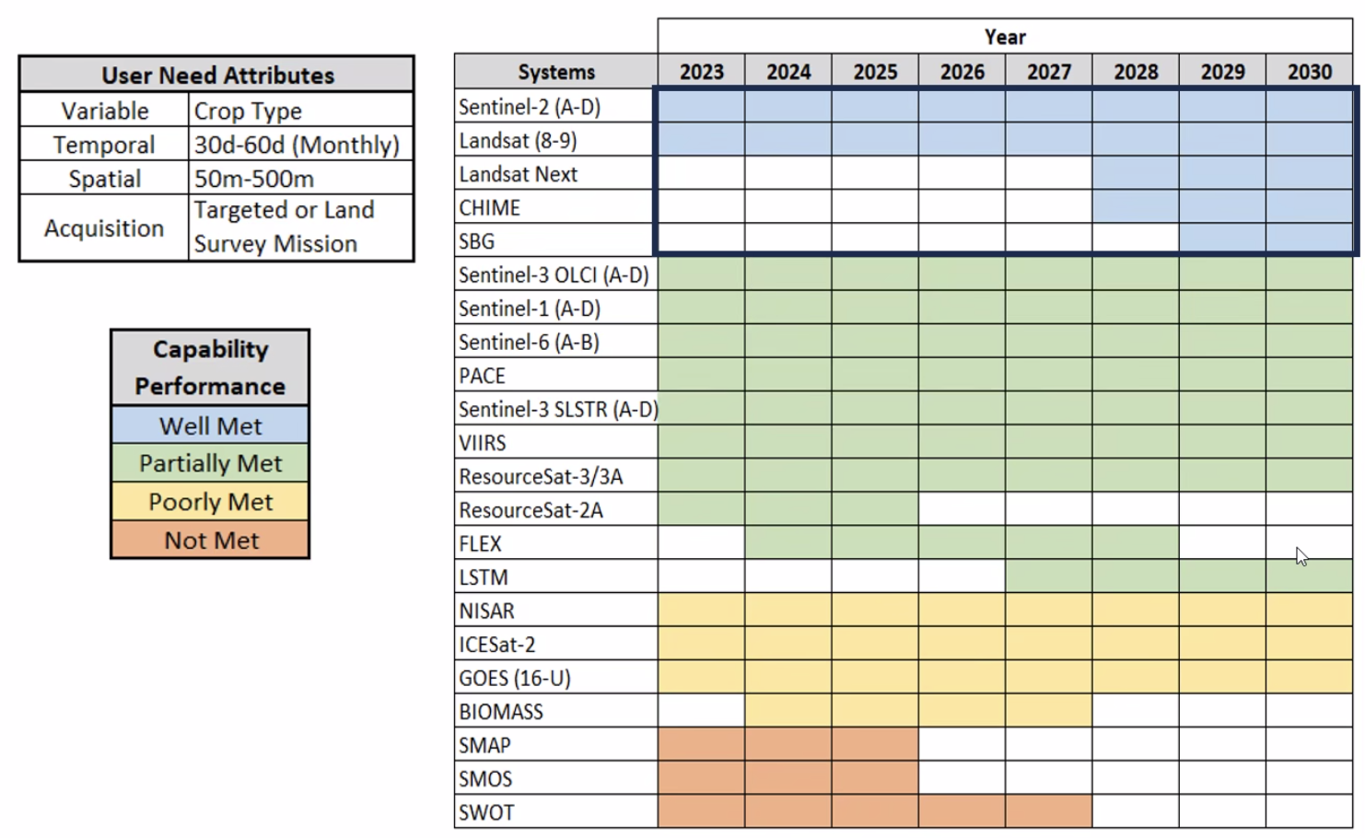
- Sven noted that when we are talking about information gap analyses it will always be a combination of mission, product, and availability/accessibility gaps. GEOGLAM is creating a shortlist of priorities to tackle within LSI-VC.
- Alyssa noted that some variables are high impact, but would require high investment. A matrix of investment vs impact could be helpful to guide LSI-VC effort.
- Ake noted that missions included in the USGS RCA-EORES study are solely based on observations and suggested including ALOS-4 and NISAR. USGS want to add more missions, but haven’t gotten there yet.
- Quad pol observation could potentially provide new information. Will discuss more later today.
- Sven raised concerns about the size of the task compared to the size of the team.
- Alyssa mentioned having detailed requirements for some variables and the next step being to map the capabilities of missions to how the EAVs are defined. She also highlighted data policy and radiometric calibration as key issues.
- Steve Labahn noted that it would be useful to prioritise both products and observables.
- Alyssa noted that HLS has been very helpful. Perhaps EAVs are a driver to do this for more missions.
- Steve Labahn noted that with CEOS-ARD we are trying to get closer to sensor agnostic measurements. ESA and USGS are actively discussing how best to bring together the next generation Sentinels and Landsats to help address some of these issues.
- Peter Strobl (EC-JRC, LSI-VC Co-Lead) pointed the direction of how a complex system is organised. All are pointing back to the same issue of discrete data. Talk about sensor specific information on one side, and also the products on the other side (EAVs, etc), and the sensor agnostic datasets in the middle. We have to talk seriously about the ‘Level’ definition. Semantic information in the level classifications - semantic data cube. Peter hopes to talk about this in more detail in Sydney.
- This LSI-VC core group lacks the necessary expertise to address this agriculture thematic work. Working out what CEOS Agencies are doing and where their priorities lie is key. We need to identify champions from across CEOS to populate the Subgroup and work on the issues identified by GEOGLAM.
- USGS, ESA, EC, NASA, and JAXA are central to the agriculture requirements. Zolti Szantoi of ESA would be a great contact to start with, and may be able to help identify other key people across CEOS agencies. Sven has tried to engage Zolti in the past, but top-down direction from ESA management is needed in order to allow him to work on something like this. SIT-39 provides an opportunity to brief all CEOS Principals on this matter and perhaps provide this direction in response.
- Steve Labahn expressed willingness to help build a robust GEOGLAM Subgroup. He noted a broader effort needed to work out what the user needs evaluation should look like for this group to capture user needs and requirements systematically.
- There is a key cross-over here with the issues faced by satellite uptake for forestry.
- Steve Labahn suggested demonstrating to CEOS Principals that their involvement is crucial for addressing the identified gaps, which might draw them into the conversation.
LSI-VC-15-29 | LSI-VC and GEOGLAM Subgroup co-leads to follow up with Zolti Szantoi (ESA) for his perspective on how to build the membership of the LSI-VC GEOGLAM Subgroup. Identifying a few CEOS Agency champions is critical to enabling a CEOS response to the Essential Agriculture Variables. Zolti would be a great candidate to serve for ESA.  A CEOS response to the EAVs should be done with a view to ensuring efficiencies in the CEOS responses to multiple thematic requirements (EAVs, EBVs, ECVs). | LSI-VC-16
Refining GEOGLAM Input to SIT-39
- It appears that LSI-VC is the place to coordinate this activity, but there is a need for an active subgroup to carry out the work.
- Steve Labahn suggested having a POC for the products would be beneficial.
- Alyssa noted that while there is visibility of what is happening within ESA, NASA, USGS and JAXA, and a general idea of the appropriate POCs from those agencies, they are missing a lot of details on smaller agencies’ activities. There is a need for more communication and coordination.
- Should seek to demonstrate to CEOS Principals at SIT-39 the potential efficiency gains of a more integrated approach to EAVs, EBVs, ECVs, and other thematic products.
- There is a recognition of the relevance of country-to-country cooperation, with many countries relying on larger space agency data. Asia-RiCE was initiated to ensure access to the data for smaller Asian countries, particularly focusing on rice cultivation.
- Danilo Dadamia (CONAE) noted that CONAE has an agriculture program in Argentina. There are many sensors providing measurements that can contribute to GEOGLAM. He asked if there was an agriculture POC who could become involved. SMAP data is used and a number of variables are available through GEOPortal de Servicios Web (conae.gov.ar). Danilo expressed interest in participating in the LSI-VC GEOGLAM Subgroup.
- There were no CONAE instruments included in the RCA-EORES analysis. GEOGLAM was missing this contribution. This CONAE work is just over the Pampas region:
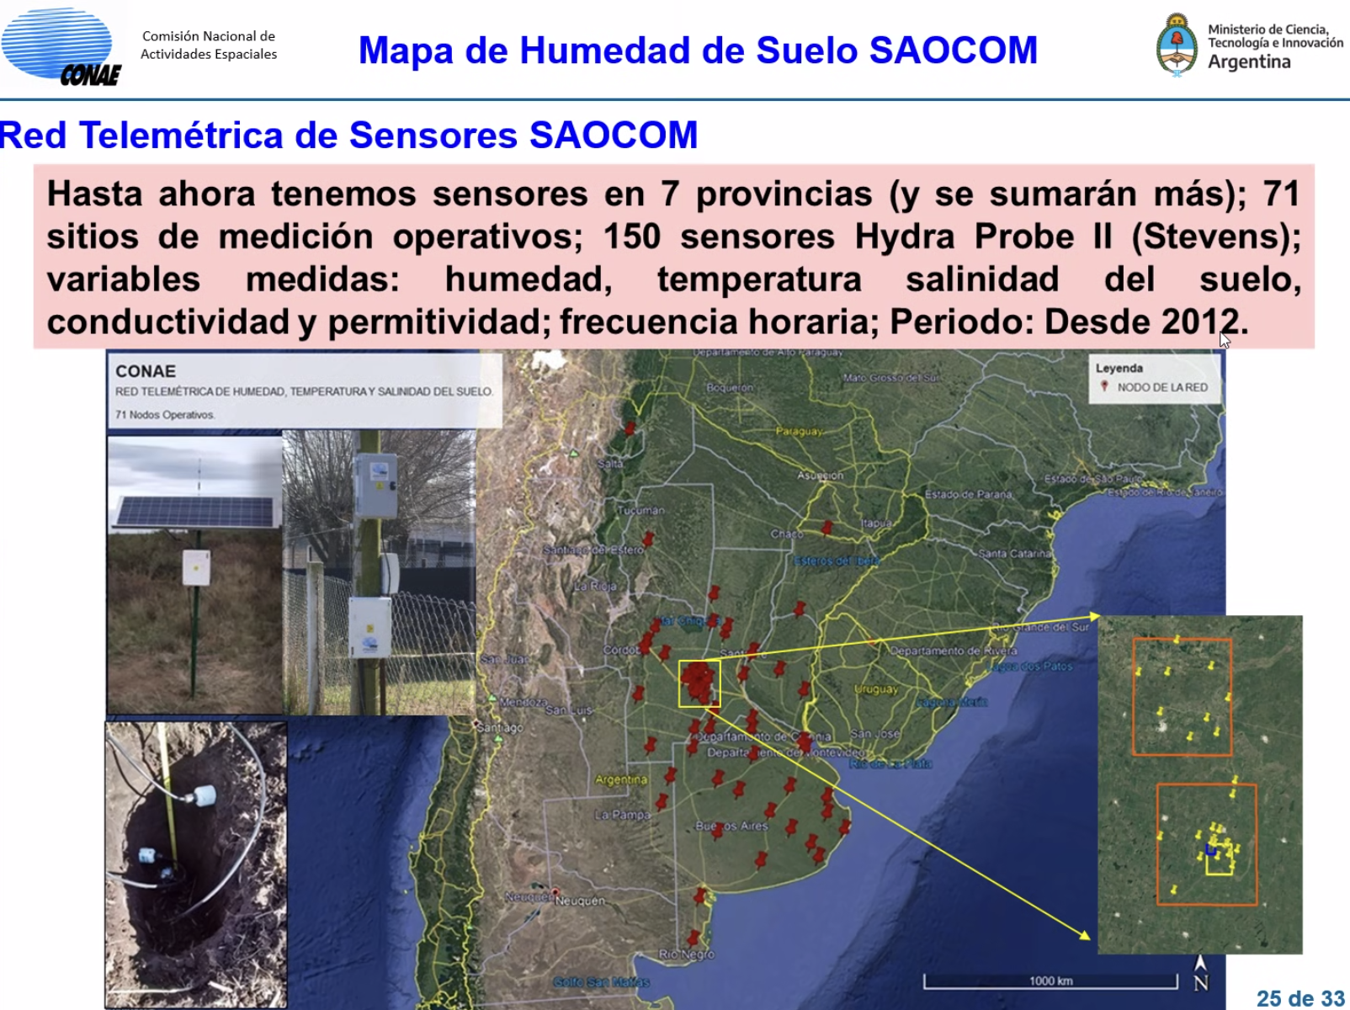

LSI-VC-15-30 | GEOGLAM team to engage CONAE in the LSI-VC GEOGLAM Subgroup, via Danilo Dadamia. | LSI-VC-16
- Message to the CEOS SIT should be that the LSI-VC GEOGLAM Subgroup will work on making these connections to agencies and Principal support would be appreciated.
- Matt Steventon (LSI-VC Sec) suggested that the agriculture case can serve as a demonstrator for addressing other cases. The right people are needed in the subgroups to drive progress.
Agency Updates (cont.)
ESA [Slides]
Ferran Gascon (ESA) reported:
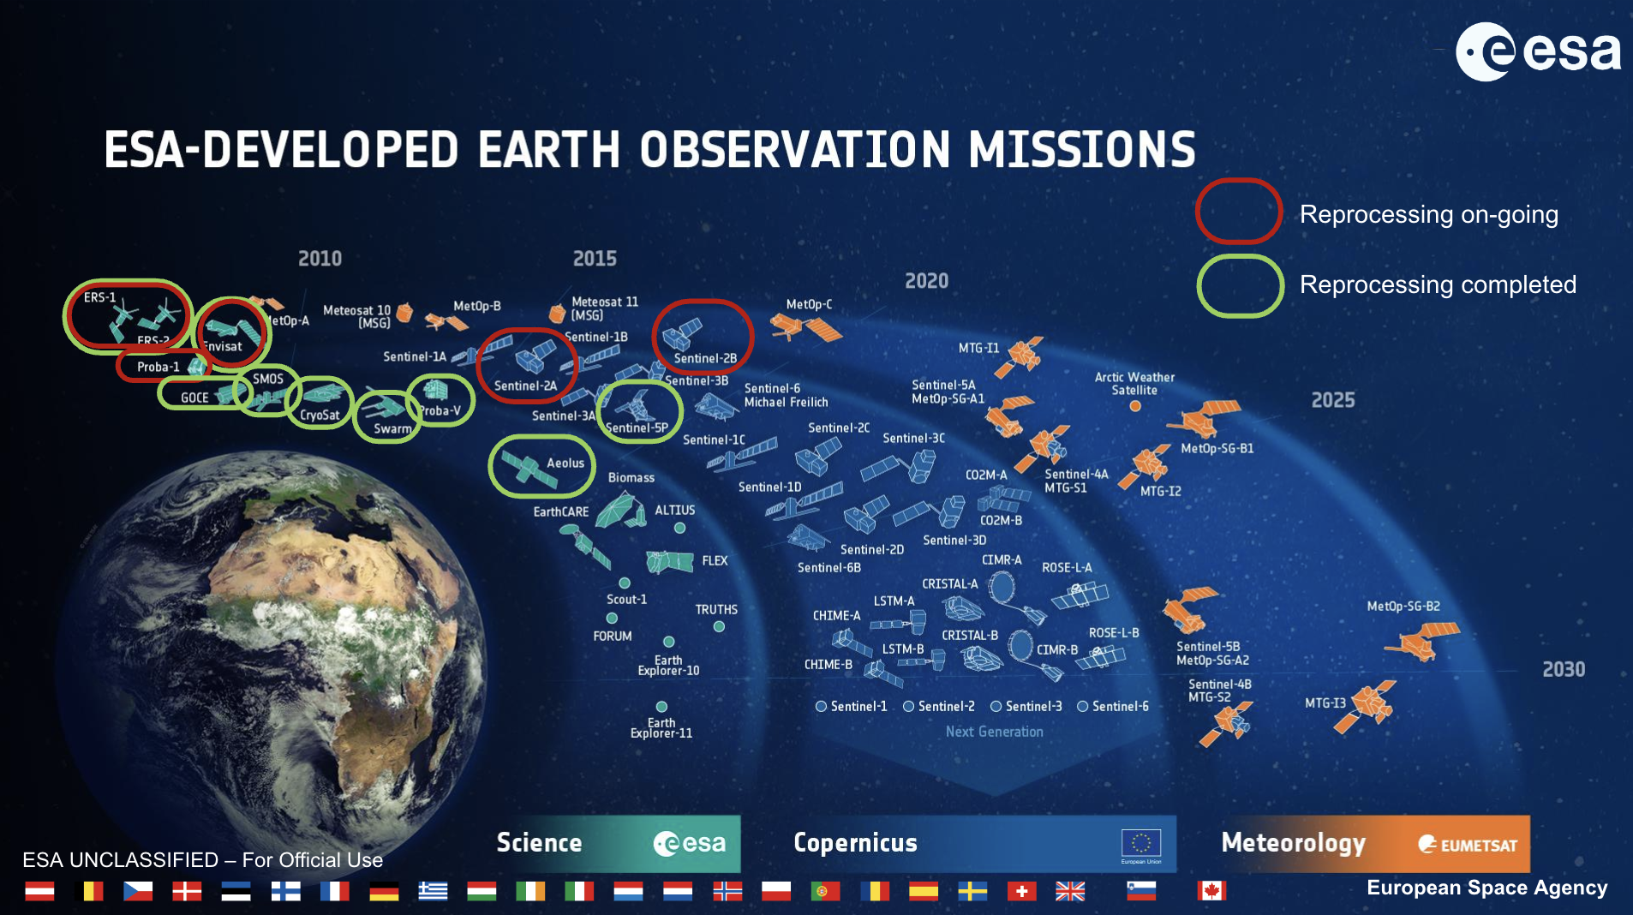
- The Copernicus Expansion missions most relevant for LSI-VC are CHIME (hyperspectral), ROSE-L (L-band SAR) and LSTM (Land Surface Temperature). There are also the next generation Sentinel missions, for Sentinel-1, -2, -3 and -6.
- ESA has two current CEOS-ARD compliant datasets: Sentinel-2 and PROBA-V.
- Copernicus Sentinel-2 Collection 1 provides consistent time series with a uniform processing baseline. The collection has improved data radiometry and geometry, and includes both Level 1C and Level 2A. Ingestion will be completed in Q2 2024, and older data will be removed six months later in Q4 2024.
- ESA is providing collections for most of its past and present missions. Scientific applications, such as for climate change, have underlined the importance of collections management.
- There are currently heterogeneous approaches for collections management within ESA (and across space agencies in general). There is a need for further coordination between space agencies to define harmonised and improved collection management practices. This is being discussed in WGISS.
LSI-VC-15-31 | Libby to ensure the LSI-VC team has an opportunity to review the WGISS Collections Management Practices White Paper. Libby will also share the related presentations from WGISS-57. LSI-VC Secretariat to consider inviting Mirko Albani to present on this topic at LSI-VC-16. LSI-VC is interested to see how this might guide CEOS-ARD collection management practices. | LSI-VC-16

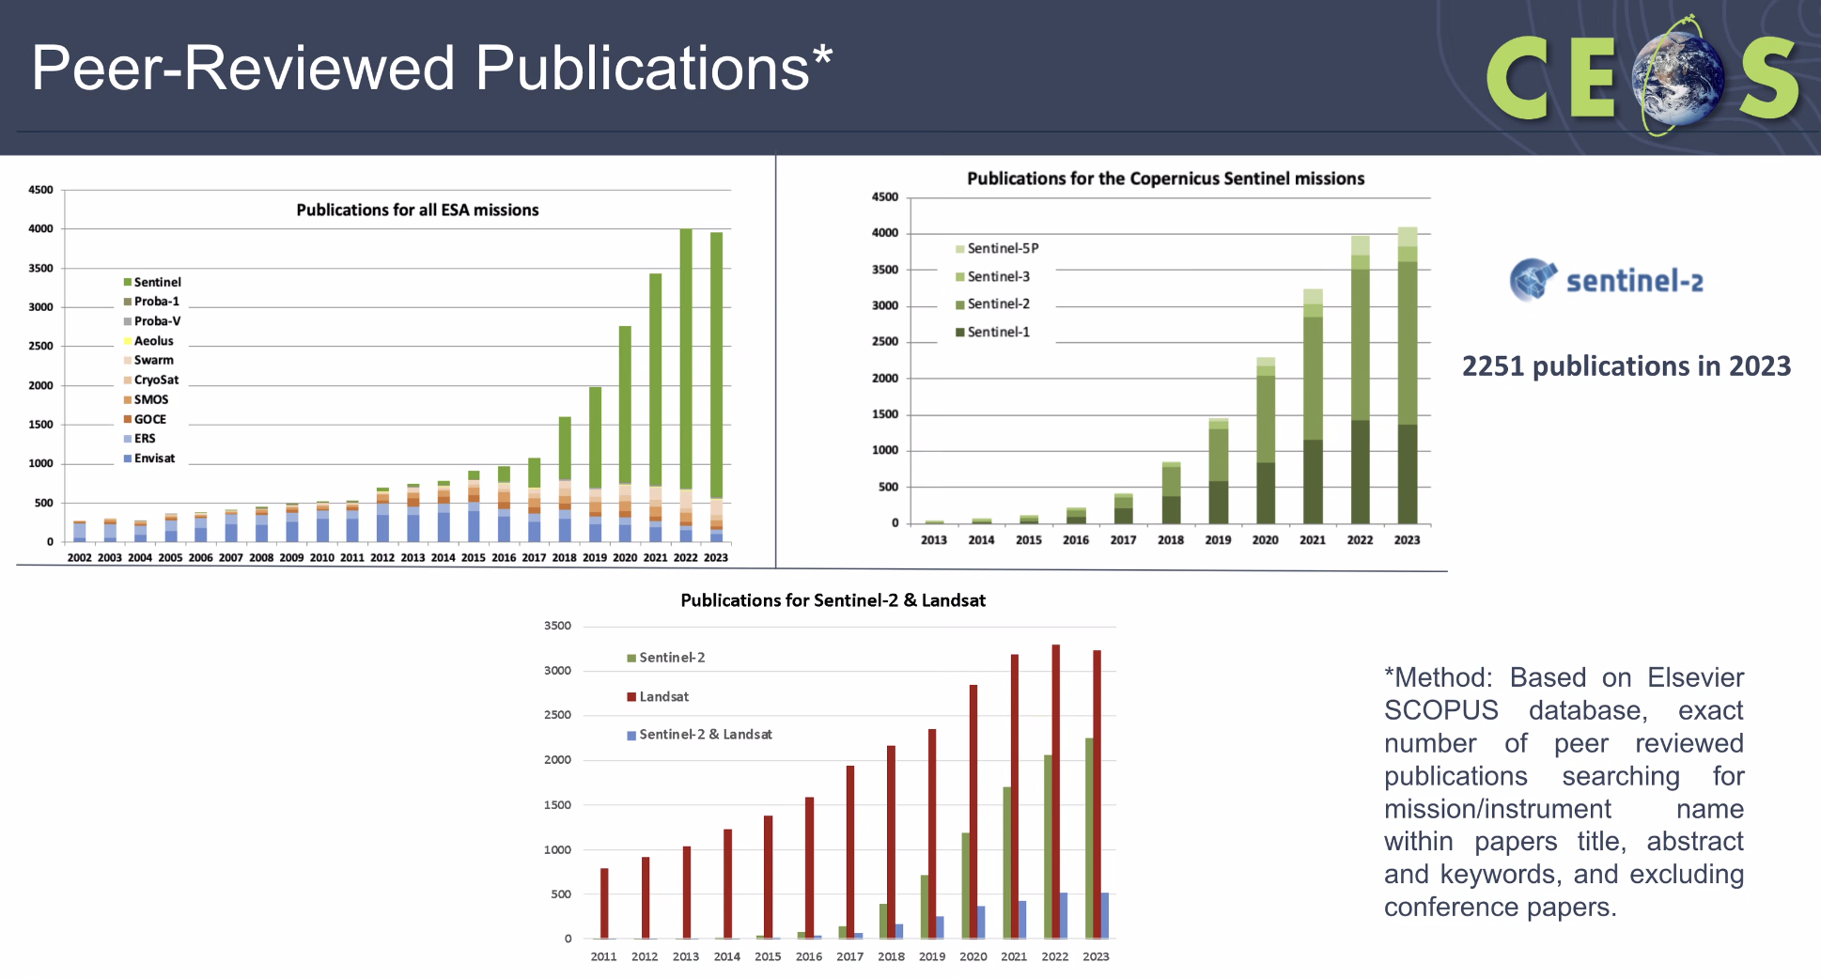
- It is difficult to identify the impact of CEOS-ARD compliance, as only two requirements from the original Sentinel-2 dataset were missing, so not much has changed before and after CEOS-ARD compliance. Sentinel-1 CEOS-ARD when available might show a clearer trend and result.
- The bottom chart includes a bar for where both Sentinel-2 and Landsat were referenced in the paper.
- Hoping to also offer a full Landsat archive through the Copernicus Data Space Ecosystem platform. The platform enables access to the different Sentinel datasets, Copernicus Contributing Missions, Federated data sets and Complementary data.
- The list of datasets will become simplified once Sentinel-2 Collection 1 is released.
- CDSE has several APIs for streamlined data access, as well as a number of applications to explore the use of data.
LSI-VC-15-32 | Matt to submit a support ticket through CDSE to see whether the CEOS-ARD logo (or a CEOS-ARD ‘tag’) could be added to pages / entries related to CEOS-ARD compliant datasets. | June 2024
Discussion
- Tim Stryker (USGS) asked about the functionality of the ESA and USGS sites regarding data access. Ferran Gascon (ESA) noted that while there may be differences in the interfaces there are common APIs that allow the sites to communicate with each other. For example, AWS does not host the full S2 archive but just references.
- ESA is no longer involved in the old DIAS but they may still continue to operate in some fashion.
- USGS received a request from Grega at Sinergise about the Landsat Archive. It was suggested to check whether there is a link to existing ESA-USGS dialogue about Landsat archive data sharing.
Session 6: ESA PolInSAR Workshop Follow-up
ESA PolInSAR Workshop Recommendations Follow-up [Slides]
Ake Rosenqvist (JAXA), Magdalena Fitrzyk (ESA), Francesco Sarti (ESA) reported:
- In June 2023, ESA hosted the 11th International Workshop on Science and Applications of SAR Polarimetry and Polarimetric Interferometry and BIOMASS Workshop. There were a series of recommendations resulting from the workshop, and LSI-VC was engaged at LSI-VC-14 as a means for bringing the requirements from the SAR community to the space agency community in CEOS.
- ESA is getting close to the BIOMASS mission launch, the first P-band full pol mission. The scientific community is becoming very interested in this topic. Future missions will include quad pol considerations in acquisition strategies.
- Recommendations were presented regarding agencies acquiring data over supersites for full polarimetry. To demonstrate the advantage of using full pol:
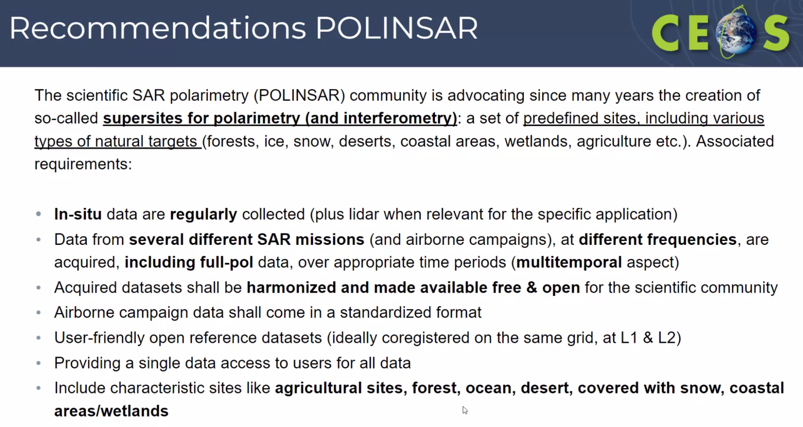
- The benefits of using full/quad polarimetric (QP) data include significantly higher thematic content provided by the QP data compared to dual polarimetric (DP) data. However, there is a trade-off involved, as the swath width of QP data is typically half that of DP data. This scarcity of full polarimetric data is directly related to this trade-off.
- When utilising fully polarimetric data, the narrower swath width means that regional coverage requires twice as many observations compared to DP data. This trade-off also affects temporal resolution, as more cycles are needed to cover the same area regionally with QP data compared to DP data. However, newer missions like ALOS-4 have better QP capabilities, so the trade-off may not be as significant, although it is still necessary to demonstrate the benefits of QP.
- One challenge in demonstrating the benefits of QP data is the lack of good time series data.
- While the space segment costs remain more or less the same for QP data, there are higher processing costs associated with polarimetric processing. Polarimetric processing is more complex and requires more computational resources. There is a greater quantity of data generated per acquisition with QP data, further increasing processing costs.
- Agencies cannot do QP systematically everywhere, so need to work together to acquire data over key sites. This is the purpose of the approach to CEOS – establishing supersites and getting agencies acquiring together.
- Better target detection over wetlands is a priority.
- Proposed way forward for longer-term CEOS coordination:
  - Collect information regarding ongoing/planned QP/CP acquisitions over specific sites;
  - Find common (geographically overlapping) areas;
  - Coordinate future acquisitions (taking into account in situ measurements);
  - Find a mechanism to share data with the community from a single data sharing point.
- A global network of forest reference sites (forest census, airborne and terrestrial lidar) is currently established under GEO-TREES. All data will be open and free. Systematic EO data acquisition of these sites would foster R&D.
- Following the meeting at ESRIN, there was the first attempt to present this idea. Efforts have begun to collect some information from different agencies about planned and existing datasets. A master table has been collected which is still being updated. CONAE, JAXA and ISRO have contributed. The idea is to collect information about the site locations and status of QP (and Compact Pol) observations, and then find some common areas where multiple QP data are available.
- Small exercise from ISRO over forest area, will be acquired in 2024. There are some overlapping areas with the GEO-TREES initiative. Data from this project is open and free, and it would be nice to have more data from other sensors acquired over the same areas. The plan is to undertake this exercise over other areas as well.
- The idea could be to identify sites where a campaign is already planned, and then ask other agencies to acquire over that area as well.
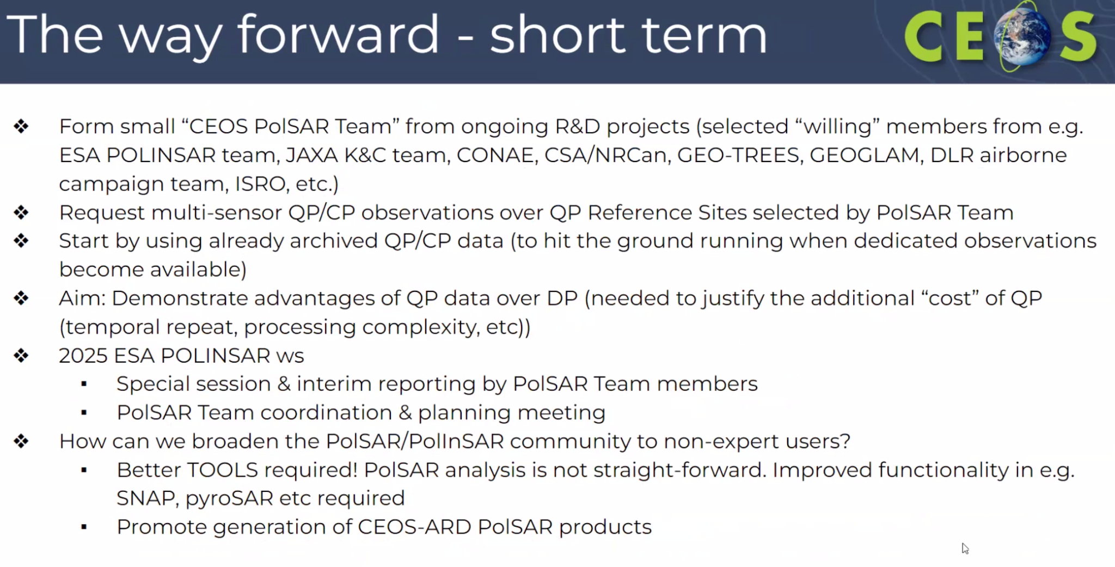
- Future ESA SAR missions include S1NG and ROSE-L. Both of these missions will have full polarimetric capabilities. It is important to note that while these missions have the capability for full polarimetry, it does not necessarily mean that such data will be acquired everywhere, but rather that the capability exists.
- Magdalena Fitrzyk (ESA) highlighted that the requirement for full polarimetric SAR data has been a long term demand from the community. Although formally documented in 2023, it has been recognised as a necessity by the community for some time prior to being formalised in the 2023 workshop recommendations.
- There is a desire to create a comprehensive database containing data from various wavelengths, including polarimetric data.
Discussion
- A request to the CEOS SIT-39 meeting for space agencies would be to collect polarimetric data over several reference sites, on a best-efforts basis. The goal then is to establish a common mechanism to share this data with the wider community. There was agreement that this seems to be a suitable request for SIT consideration.
- Alyssa Whitcraft (GEOGLAM) noted a SAR intercomparison that GEOGLAM's JECAM (experiment site network) did a few years ago. Methods and guidance are also available. Colleagues from Agriculture Canada could serve as valuable contact points.
- ESA has projects with JAXA to acquire data over sites and there is a desire for more acquisitions, requiring coordination efforts.
- Last year at ESRIN, presentations were made by ESA, JAXA, NASA, ASI, DLR, ISRO and CONAE, all of whom have missions capable of acquiring QP data. While Compact Pol data have advantages, such as not halving the swath, there is still limited understanding of their applications. Multi-frequency data over different sites could advance multi-sensor aspects and be framed around CEOS-ARD.
- Steve Labahn (USGS, LSI-VC Co-Lead) asked if anyone was trying to do a self assessment for POL data.
- Ake Rosenqvist (JAXA) noted that perhaps RCM is doing it since the work mode for RCM is compact pol. POL ARD specs were more or less developed by Francois. JAXA is also considering developing research products for ALOS-4, including QP.
- The connection to GEO-TREES, where in situ data is being collected, was discussed. It was noted that while time series of QP data over different regions are desired, in situ data is lacking for most sites. Initiating data acquisition and modelling at these sites would be beneficial.
- Magdalena noted there are two aspects to navigate: The first is the acquisition of data and the second is agency agreements to share the data. WGDisasters provides a good framework along these lines. Noted volcanic supersites and G-VEWERS. There is precedence for these data sharing agreements for scientific applications.
- Alyssa noted the JECAM data sharing policy from 2014 which might also be a useful reference.
- Peter Strobl (EC-JRC, LSI-VC Co-Lead) highlighted a similar request made at the WGCV-53 meeting for optical data. The request was to identify joint sites and relevant data. Initiatives like SARCalNet are all in the same direction. Peter suggested linking with WGCV as it has various thematic networks that align with this initiative.
LSI-VC-15-33 | LSI-VC Leads and Ake to refine input for SIT-39 on the POLINSAR workshop recommendations and consider a targeted follow-up to ESA, JAXA, NASA, ASI, DLR, ISRO and CONAE. The aim is to get some names and licence to follow up based on Principal agreement to the quad-pol/multi-frequency supersites concept.  Need to remain aware of the potential connections to the ICGS-SAR and the WGCV SAR Subgroup. | July 2024
LSI-VC-15-34 | Matt to ensure a standing agenda item at future LSI-VC meetings for follow-up on the PolInSAR Workshop recommendations and QP/multi-frequency supersite activity. | LSI-VC-16

Friday, April 5
Session 7: Commercial Engagement Workshop
The occasion of LSI-VC-15 in Japan provided an opportunity to hold a dedicated workshop with representatives from the Japanese commercial EO sector, including ‘New Space’ companies – both data providers and distributors (e.g., cloud platform operators). The aim was to encourage CEOS-ARD self-assessments and other collaborations and explore opportunities to improve the discovery, access and utilisation of data, particularly CEOS-ARD.
The outcomes of this special session are captured in a standalone document.
Session 8: LSI Forests and Biomass Subgroup
CEOS AFOLU Roadmap and Actions Supplement
Stephen Ward (SIT Chair Team) reported:
- Ben Poulter has been leading this work, but he has been seconded to work a 12-month detail at the White House Office of Science and Technology Policy (OSTP). Lola Fatoyinbo will replace Ben as the lead.
- JAXA is supporting Stephen Briggs to develop an actions supplement to the AFOLU Roadmap endorsed at CEOS Plenary 2023.
- An update will be given at SIT-39 next week, but the document will remain a living document.
- Thematic leads are:
  - Above-Ground Biomass (AGB) - Laura Duncanson and Neha Hunka (UMD)
  - Land Cover (LC) - Martin Herold
  - Wetlands and Mangroves - Ake Rosenqvist and Richard Lucas
  - Agriculture (supported through GEOGLAM)
- Actions broadly fall into three categories:
  - Those pertaining to presently available data to support AFOLU procedures as in the 2006 IPCC Guidelines for National GHG Inventories vol.4, and their 2019 refinement.
  - Actions to develop new or improved products that would allow more accurate and/or easier implementation of the Guidelines.
  - Actions to facilitate greater interaction with the GHG Roadmap and hence improve characterisation of land management emissions through MVS based on satellite-based atmospheric inversions.
- CEOS is also starting an Aquatic Carbon Roadmap, led by OCR-VC. This forms the third leg of the CEOS carbon roadmaps (with GHG and AFOLU).
- It is important that the agencies investing in underlying observations keep control of these topics within CEOS. A conversation is needed in CEOS about how to track these actions.
- There is a thematic dimension which is growing and needs more agency influence in these groups.
Discussion
- Stephen noted that the CEOS AFOLU Roadmap Actions Supplement will be a living document. It will be added to the CEOS Work Plan in future.
- The same questions exist regarding getting engagement from Agencies as with the GEOGLAM Subgroup. There are thematic experts present, but further engagement from CEOS agency experts would go a long way.
- Agriculture, Forestry and Other Land Use (AFOLU) is by definition a combination of the activities of both the LSI-VC Forests & Biomass and GEOGLAM Subgroups.
- LSI-VC Forests & Biomass Subgroup members should be biomass/land cover experts – to complement the agriculture side from GEOGLAM.
Session 9: Closing
Action Review and Wrap-up
Matt Steventon (LSI-VC Secretariat) reviewed the actions. Edits were made directly to the text of the actions.
LSI-VC-16 will be held the week before/after the 2024 SIT Technical Workshop in Canberra, Australia.
LSI-VC-15-35 | Matt to poll the LSI-VC team regarding preferences for the week before or after the 2024 SIT Technical Workshop for LSI-VC-16 in Canberra, Australia. | May 2024
Dave Borges (NASA, SEO) is planning to attend the ARD24 workshop, Cody Anderson from USGS will probably attend as well. Dave proposed to organise a substantial CEOS-ARD session again as it would be beneficial for commercial engagement. Ferran Gascon (ESA) will try and attend the meeting. GA will likely also try and attend, likely Simon Oliver.
LSI-VC-15-36 | Matt to email Ignacio Zuleta regarding the possibility of a CEOS-ARD session at ARD24. | May 2024
Departure of Steve Labahn, USGS LSI-VC Co-Lead
Steve Labahn (USGS, LSI-VC Co-Lead) shared his retirement news. Steve will be retiring at the end of June 2024 and taking some annual leave before then.
Everyone thanked Steve for his enormous contribution to the LSI-VC and CEOS in general. The importance of Steve’s intellectual leadership cannot be overstated. His friendly and energetic presence will be sorely missed and the LSI-VC now has some big shoes to fill. The LSI-VC team all wished Steve the very best for his retirement.
USGS will seek to provide continuity for the agency’s leadership of LSI-VC.
Meeting Close
Steve Labahn and Matt Steventon thanked everyone for their participation, including those who joined online. The meeting was extremely productive, with the commercial sector engagement session being a highlight.

