Committee on Earth Observation Satellites (CEOS)
Atmospheric Composition Constellation (ACC)
Draft
System Requirements Document

Draft Version
November 5, 2007

Introduction

The satellite constellation concept consists of a series of projects initiated by the Committee on Earth Observation Satellites (CEOS) to bring about technical and scientific cooperation and collaboration among space agencies that broadly meets the objectives of the international Group on Earth Observations (GEO) as well as the CEOS agencies. The constellation concept promotes missions or data products that serve the broader science and applications community and has been endorsed by the “GEO Work Plan, 2007-2009”. The purpose of the constellations is not to develop a new set of mission requirements but to develop a “virtual” system consisting of space and ground segments meeting endorsed end-user requirements. The constellation referenced in this document is the Atmospheric Composition Constellation (ACC), which is one of four constellations teams initiated by CEOS in late 2005. The ACC is supported by the following agencies: CNES, CSA, EC, ESA, EUMETSAT, JAXA, NASA, NIVR, NOAA and USGS.

Scope

The CEOS Systems Engineering process is based on 3 focus areas: (1) Requirements – establish baseline verifiable system requirements, (2) Assessments – conduct assessments of current, in-development and planned systems against requirements to identify critical gaps, and
(3) Architectures – develop solution architectures that address identified gaps and optimize systems to achieve the established requirements.

Establishing baseline verifiable requirements is the foundation of systems engineering. In order to adequately assess the state of a system, it is essential to measure its state against a known set of goals and requirements. Only then can one develop future solutions and architectures that meet the stated requirements. It is recognized that this process is complex, involves the participation of many CEOS agencies, and requires continuous adjustment to reflect the latest information and priorities. Once established, it is anticipated that this process will be a great benefit to the CEOS Constellations.

The source of the ACC system requirements is based on existing information from the many CEOS supporting agencies. These resources will be used to formulate a combined set of requirements for the assessment of current, in-development and planned ACC missions, as well as for the development of future ACC architectures. These references are listed at the end of this document.

Requirements Outline

The CEOS Constellation Requirements Taxonomy (shown below) starts with the needs of Decision-Makers for societal benefit and flows (upper row) toward Instrument and Mission requirements. It is recognized that the needs of decision-makers, the developers and users of informational products and services, and the science community all contribute to the primary requirements of a future mission and its set of required measurements. This document does not thoroughly address Requirements Assessment or Constellation Architectures, as these will be addressed in more detail in other ACC documents and reports. A preliminary concept for completing assessments and architectures will be presented.

Decision Makers: Decision-Makers are individuals and groups that use informational data products to make decisions and take action for societal benefit. Examples include local and national governmental officials, policymakers, lawmakers, organizational and business leaders, and the general public.

Information Products and Services: Information products and services are products that provide direct benefit to society as articulated in one of the GEO Societal Benefit Areas (SBA). These products are developed by combining Measurements, Knowledge and Models of the Earth system and other data to provide decision makers the ability to choose a course of action. Some examples include forecasts, assessments, and reports.

Knowledge and Models: Knowledge and Models are the understanding of geophysical processes and interactions representing geophysical parameter behavior or future geophysical states. This includes typical Level-3 data products or Level-4 model output derived from lower level data products. Level 3 data products are retrieved environmental variables which have been spatially and/or temporally resampled (derived from level 1 or 2 products), and Level 4 data products are model output or results from analyses of lower level data (variables that are not directly measured by the instruments, but are derived from these measurements). Some examples include global maps, long-term trend data, and modeled parameters.
Measurements: Measurements are direct observations of specific geophysical parameters. These correspond to typical Level-1 or Level-2 data products such as, corrected and calibrated data or retrieved environmental variables. Some examples include radiance, ocean height, soil moisture, relative humidity.

Instruments and Missions: Instruments and Missions are the implementation method for making space-based measurements typically accomplished by world space agencies under strict technical and cost constraints.

ACC Requirements

(1) Decision-Maker Requirements

The requirements for decision-makers are not explicitly defined in this document since they vary widely. However, it is known that the decision-makers for atmospheric composition will depend on 5 of 9 GEO Societal Benefit Areas (SBAs): Disasters, Climate, Health, Energy and Ecosystems. It is likely that government officials, business leaders and the public will require information to support decisions addressing the ACC science focus areas of: Stratospheric Ozone, Air Quality, and Climate Change. The ACC plans to address observational requirements from each of the following SBA’s, according to the IGACO report (2004). A summary of the SBAs and ACC Themes is shown in the following table.

Disasters: Reducing loss of life and property from natural and human-induced disasters
Disaster-induced losses can be reduced through observations relating to hazards such as: wildland fires, volcanic eruptions, earthquakes, tsunamis, subsidence, landslides, avalanches, ice, floods, extreme weather, and pollution events. GEOSS implementation will bring a more timely dissemination of information through better coordinated systems for monitoring, predicting, risk assessment, early warning, mitigating, and responding to hazards at local, national, regional, and global levels.

Health: Understanding environmental factors affecting human health and well-being
Health issues with Earth-observation needs include: airborne, marine, and water pollution; stratospheric ozone depletion; persistent organic pollutants; nutrition; and monitoring weather-related disease vectors. GEOSS will improve the flow of appropriate environmental data and health statistics to the health community, promoting a focus on prevention and contributing to continued improvements in human health worldwide.

Energy: Improving management of energy resources
GEOSS outcomes in the energy area will support: environmentally responsible and equitable energy management; better matching of energy supply and demand; reduction of risks to energy infrastructure; more accurate inventories of greenhouse gases and pollutants; and a better understanding of renewable energy potential.

Climate: Understanding, assessing, predicting, mitigating, and adapting to climate variability and change
The climate has impacts in each of the other eight societal benefit areas. Coping with climate change and variability demands good scientific understanding based on sufficient and reliable observations. GEOSS outcomes will enhance the capacity to model, mitigate, and adapt to climate change and variability. Better understanding of the climate and its impacts on the Earth system, including its human and economic aspects, will contribute to improved climate prediction and facilitate sustainable development while avoiding dangerous perturbations to the climate system.

Ecosystems: Improving the management and protection of terrestrial, coastal and marine resources
Observations are needed on the area, condition, and natural-resource stock levels of ecosystems such as forests, rangelands, and oceans. GEOSS implementation will seek to ensure that methodologies and observations are available on a global basis to detect and predict changes in ecosystem condition and to define resource potentials and limits. Ecosystem observations will be better harmonized and shared, spatial and topical gaps will be filled, and in situ data will be better integrated with space-based observations. Continuity of observations for monitoring wild fisheries, the carbon and nitrogen cycles, canopy properties, ocean color, and temperature will be set in place.

(2) Information Products and Services Requirements

The following table represents the key information products and services addressed by ACC. These requirements are divided among the three ACC science focus areas:

- Stratospheric Ozone – related to the depletion of stratospheric ozone, dynamics and the impact to UV surface radiation.
- Air Quality – related to the globalization of air pollution, transport processes and forecasting.
- Climate Change - related to greenhouse gas and aerosol impact on radiation as well as the coupling of key atmospheric chemical parameters to climate change.

It should be noted that data accessibility and compatibility are key issues for ACC to achieve its goals. The CEOS Working Group on Information Systems and Services (WGISS) will work with the ACC team to improve data sharing among CEOS agencies and address compatibility of data products to optimize usage. The completion of the listed data products and services depends on the efficient functionality of these data services.

(3) Knowledge and Model Requirements

The following table represents the general science knowledge and models addressed by ACC.

- Scientific Understanding – developing fundamental scientific knowledge consistent with the science questions posed by CEOS nations and agencies.
- Model Validation – specific requirements of ground-based models required to assimilate science parameters and develop data products.

(4) Measurement Requirements

The key ACC atmospheric parameters and their relationship to the ACC Science Themes are summarized in the table below.

The detailed measurement requirements for each ACC atmospheric parameter are well presented in the document “The Changing Atmosphere, An Integrated Global Atmospheric Chemistry Observation Theme for the IGOS Partnership, Report of the Integrated Global Atmospheric Chemistry Observation (IGACO) Theme Team”, September 2004, commonly known as the “IGACO Theme Report”. This document includes tables for key atmospheric species, spatial and temporal resolution, and accuracy. In addition, the tables also include a list of critical ancillary parameters required to characterize the atmospheric state. These are temperature, pressure, wind, cloud height and coverage, albedo, lightning flash frequency, fires, and solar radiation.
It should be noted that calibration and validation of the required measurements is critical to meeting the goals of ACC. The ACC team plans to work closely with the CEOS Working Group on Calibration and Validation (WGCV) to plan ground and space calibration and validation efforts in support of ACC data.

(5) Instrument and Mission Requirements

The key ACC atmospheric parameters and their relationship to science instrument type is summarized in the table below. Accomplishing the goals of the ACC will require a variety of instrument types (imagers, spectrometers, lidars), wavelengths (UV-Vis, IR, Sub-mm), and orbit types (LEO, GEO, nadir viewing, sounding).

ACC Assessments

The ACC team has funded a detailed requirements assessment and gap analysis to be conducted by the Rutherford Appleton Laboratory (RAL) in England. In addition, the CEOS Systems Engineering Office (SEO) has started an assessment of ACC Societal Benefit Area (SBA) impacts and gathered data on existing, in-development and planned missions directly related to measuring ACC atmospheric parameters. The results of these two studies will also be available in early 2008 and compiled in a separate report. A current summary of the ACC missions and instruments is shown the “ACC Architectures” section of this document. A summary of the SBA Observational Requirements addressed by the ACC missions is shown in the table below. The preliminary results of the SBA impact assessment are also found below.

The following graphs summarize the impact of the ACC missions on each GEO Societal Benefit Area (SBA). The assessment considered these analysis steps:

- SBA Observational Requirements (ORs) relevant to the ACC science themes were selected from each SBA.
- ACC atmospheric parameters were rated (3-point scale) according to their relevance to the selected SBA ORs and then normalized by the maximum available score.
- ACC atmospheric parameters were matched to instruments and missions to determine the total score in any given year.

The impact to Climate is the greatest and the impact to Ecosystems is the smallest. In addition, there is a strong dependency on extended missions (blue) beyond 2008 and a substantial reduction in under-development (yellow) and planned missions (red) after 2012. These two preliminary conclusions signify the risk of a potential gap in addressing the atmospheric composition science goals and societal benefits for the future.

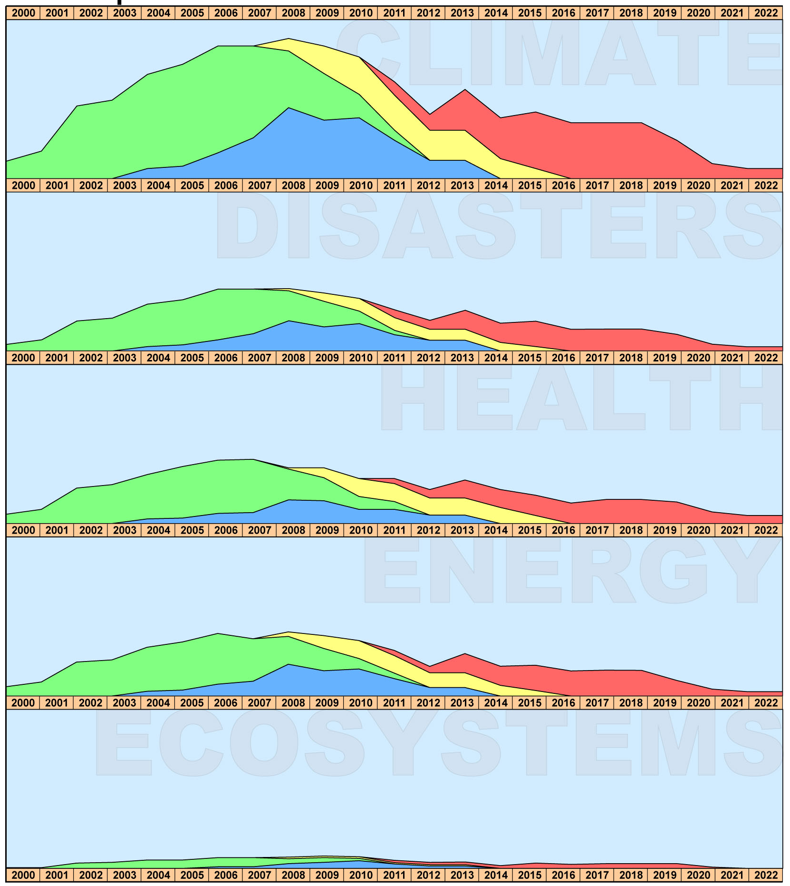
Climate
Disasters
Health
Energy
Ecosystems

ACC Architectures

Architecture planning is one of the key products of the CEOS Constellation teams. Solution options that address critical identified gaps, optimize systems while meeting established requirements, and engage the member nations and space agencies of CEOS are critical to the future success of CEOS. This long-term goal will require significant coordination and cooperation.

To date, only preliminary gap analyses have been completed for the existing and planned ACC instruments and missions. The following chart shows the current in-development and future missions. Future architecture reports will present long-term instrument and mission goals along with potential options for implementation.

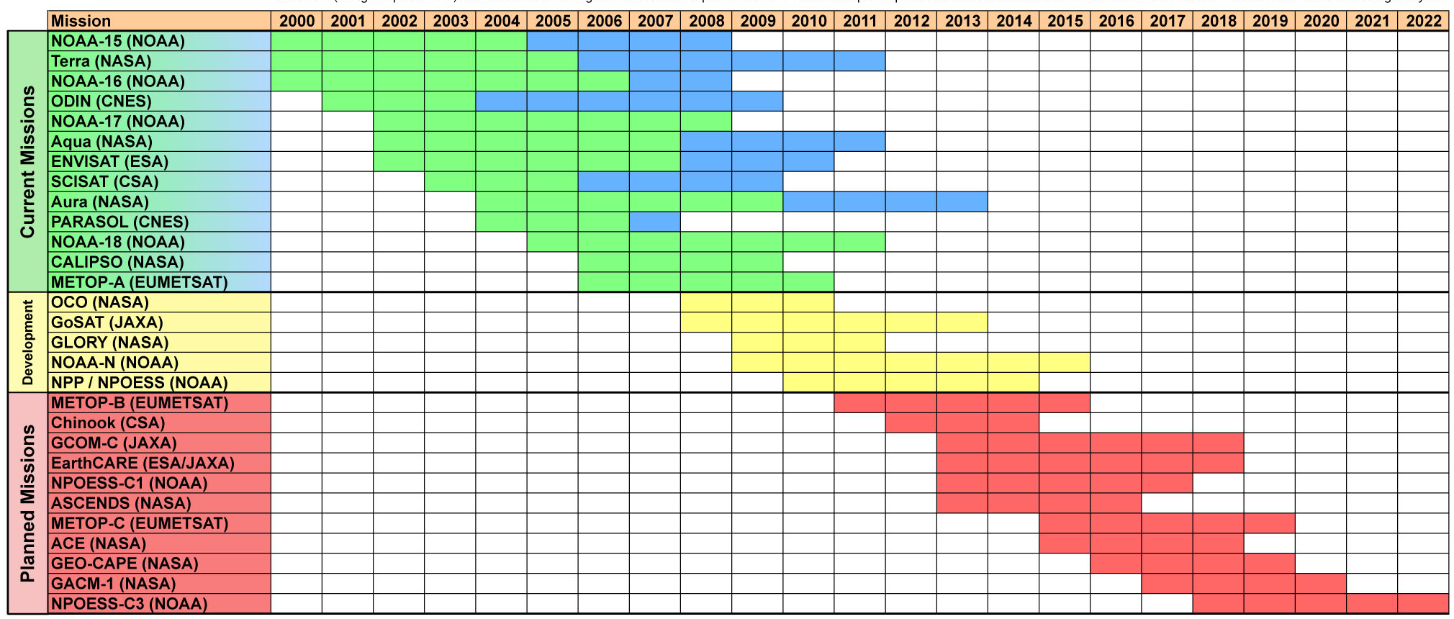

References

The Global Earth Observation System of Systems (GEOSS) 10-Year Implementation Plan, February 16, 2005

The Changing Atmosphere, An Integrated Global Atmospheric Chemistry Observation Theme for the IGOS Partnership, Report of the Integrated Global Atmospheric Chemistry Observation (IGACO) Theme Team, September 2004
Global Earth Observing (GEO) 2007-2009 Work Plan, Date ???

Implementation Plan for the Global Observing System for Climate in support of the UNFCCC, October 2004, GCOS-92

Systematic Observation Requirements for Satellite-Based Products for Climate, September 2006, GCOS-107 (WMO/TD No.1338)

Satellite Observation of the Climate System, The Committee on Earth Observation Satellites (CEOS) Response to the Global Climate Observing System (GCOS) Implementation Plan (IP), September 2006

Composition of the Atmosphere: Progress to Applications in the user CommunITY (CAPACITY), Operational Atmospheric Chemistry Monitoring Missions, October 2005

Earth Science and Applications from Space: National Imperatives for the Next Decade and Beyond (Decadal Survey), National Research Council for the National Academies, January 2007

GMES Service Element - PROMOTE, U5 Core User Needs Dossier, Version 12, Paliouras, E. et al., May 2006.

MTG Mission Requirements Document, EUM/MTG/SPE/06/0011, Issue: v2B, October 2006

Position Paper on Post-EPS Atmospheric Chemistry Data User Requirements for Operational Atmospheric Chemistry Monitoring in the Post-EPS Time Frame beyond 2020, H. Kelder, KNMI, the Netherlands, B. Kerridge, Rutherford Appleton Laboratory, U.K., I. Isaksen, University of Oslo, Norway, B. Carli IFAC, CNR, Italy, N. Harris University of Cambridge, U.K., E. Hilsenrath University of Maryland, U.S.A, , Issue 0 Draft H, March 2006.

Post-EPS Mission Requirements Document (Initial Version), P. Schlüssel, P. Phillips, C. Accadia, R. Munro, S. Banfi, J. Wilson, Issue v1J Draft, January 2007.

GMES Sentinels 4 and 5 Mission Requirements Document (Initial Version), J.Langen, Issue 1, Revision 0, April 2007.

