SDCG-5 Logistics

Staying in Frascati

You can contact ESRIN Travel office for booking hotels in Frascati at the ESA rate and as well to arrange taxi transport from the airport to the Frascati area.

Esrintravel.Office@esa.int

For staying in the centre of Frascati I recommend:
Hotel Flora (single room 110 Euro incl. breakfast) and
Hotel Colonna (single room 80 + 5 Euro breakfast)

For hotel reservation you have to provide your credit card details to secure the booking, but the payment will be done directly in the hotel. If you want a pick up at the airport please provide as well your flight number, date and hour of arrival. Taxi cost from FCO airport to Frascati area is 72 Euro.

Shuttle buses should be arranged with the hotels (e.g. Flora offers this service). As back-up, the ESA staff shuttle bus leaves at 08:05 and 08:30 at the traffic island between the station steps and the newspaper stand in Piazza Roma.
For the Country Day at FAO on 25 February you can take the train from Frascati to Roma Termini (2.10 Euro) and then the Metro B (1.50 Euro) in direction of Laurentina to “Circo Massimo” (3rd stop, about 10 min ride), which is directly at FAO.

7:33 – 8:06 Frascati – Roma Termini
8:36 – 9:06 Frascati – Roma Termini

I recommend not to take a car or taxi down to Rome during rush hour.

Staying in Rome

If you want to stay in Rome, you can take the Leonardo train from FCO airport “Fiumicino Aeroporto” to Roma Termini every half hour (x:08 and x:38) for 14 Euro. (see also www.trenitalia.it)

ESRIN is easy to reach by train from Roma Termini to Tor Vergata (200 m to ESRIN). Tickets are sold at kiosks “tabaccaio” and the vending machines for 1.50 Euro.

8:00 - 8:15 platform “binario” 18 destination Cassino
8:35 - 8:55 platform “binario” 22 destination Cassino
9:14 - 9:31 platform “binario” 22 destination Frosinone

Please check the announcement tables, as the platform (“binario”) indication is only tentative and might change. The direction is Cassino or Frosinone, but be careful there are more trains with this destination which will not stop at Tor Vergata.!!! (see also www.trenitalia.it).

For the Country Day at FAO on 25 February take Metro B (1.50 Euro) to “Circo Massimo”, which is directly at FAO.

Access to ESRIN

For access to ESRIN you will be required to bring your passport and make reference to the GFOI/SDCG-5 meeting at the gate. The meeting will take place in the Magellan Room in building B01 (see map below) straight ahead after the gate until the old reception on the left hand side.

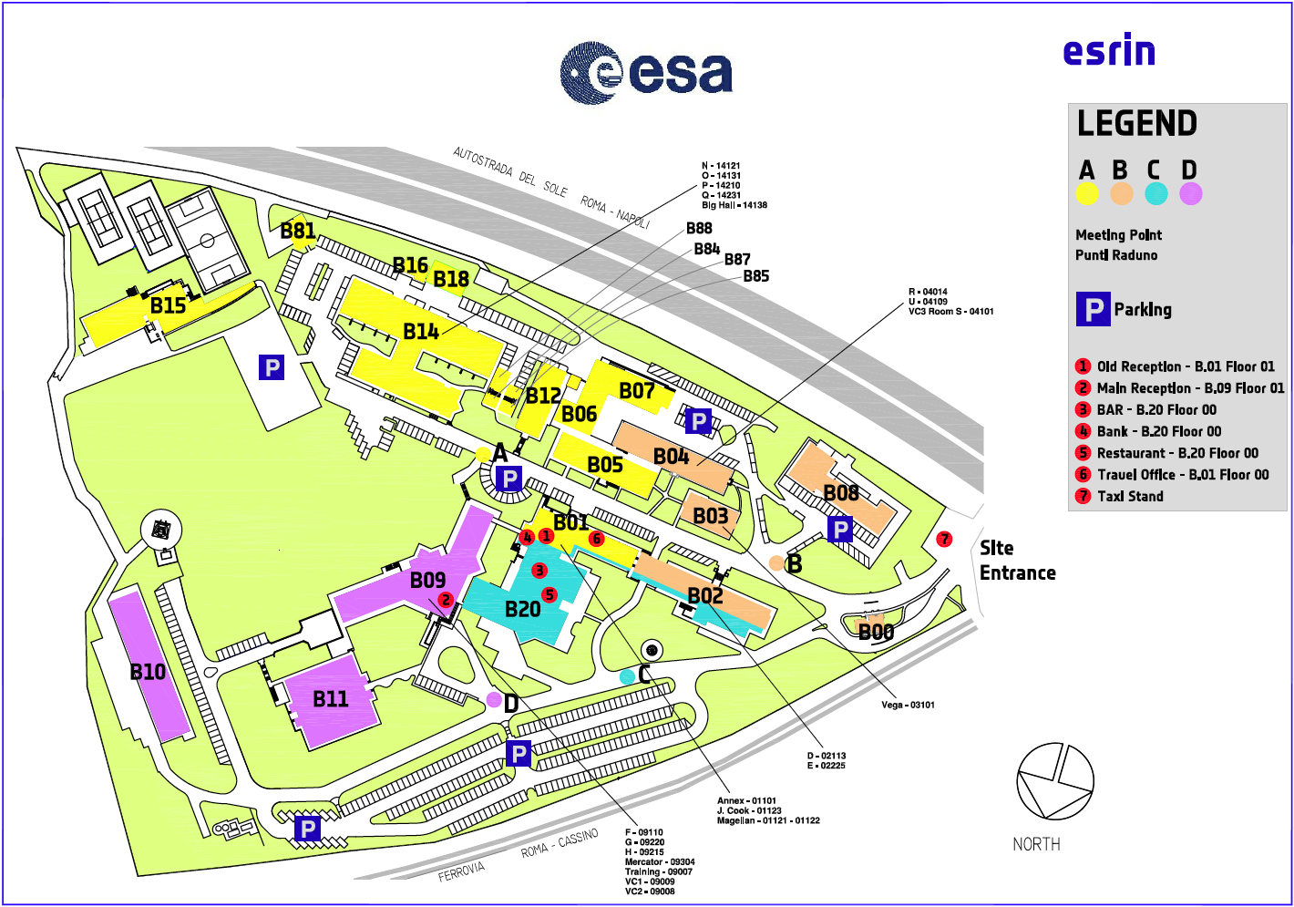

For further information on how to access ESRIN, please see http://www.esa.int/About_Us/ESRIN/Getting_to_ESRIN
- here you can find details on how to get to ESRIN by car, train or taxi.

